|  |  |
| --- | --- |
|  | **MINISTRY OF EDUCATION AND TRAINING** |

|  |
| --- |
| **FPT UNIVERSITY** |
| Capstone Project Document |
| Gunpla World Application |
|  |
| |  |  | | --- | --- | | **Team 15** | | | **Group Members** | Hoàng Ngô Minh Tùng – Role 1 – SE62231  Nguyễn Bảo Khánh – Role 2 – SE61978  Lê Nguyễn Ngọc Sang – Role 3 – SE61647 | | **Supervisor** | Phạm Công Thành | | **Ext Supervisor** |  | | **Capstone Project code** |  | |
| – TP.HCM, 09/2018 – |
|  |

**A. Report No.1: Introduction**

1. **Project Information**

* Project name: **Gunpla World Application**
* Project code:
* Product Type: **Web app, Mobile app**
* Start Date: 10-Sep/2018
* End Date: 18-Dec/2018

1. **Introduction**

In this document, we introduce a hangout place for Gunpla builders community and fans. Gundam models, as well as the hobby of assembling and painting them, is known in Japan as **Gunpla**, aportmanteau of "*Gun*dam *pla*stic model".

The number of people who take up Gunpla as a hobby is increasing rapidly day by day, as well as the hobby of assembling and painting plastic models. Based on our researches and analysis, we realized that it is inconvenient for users to find information about Gunpla or to search for already-built Gunpla model or a specific part from it, which have been built or painted by other Gunpla builders.

We build a system to make it easier and more convenient for people who want to purchase Gunpla from other hobbyist or to find useful information about Gunpla. We have searching mechanism to search for users who need to exchange their products within the required or nearest range, so that buyers can seek for sellers easier. We also create a playground for Gunpla builders to share their achievements as well as experience, provide information of the Gunpla world and especially attend events, contests, or even propose them. We believe this system will attract lots of Gunpla builders and bring them closer together.

This document contains our perspective in the system, requirement analysis, component design and detailed core workflow. Our hope is that the system will bring the Gunpla community and people looking into the hobby information and new experiences .

1. **Current Situation**

People who have just taken up the hobby will have to search for information from many resources to resolve their questions about what Gunpla is, how to assemble or to paint them. They may also want to look for a particular Gunpla model's information, or guides and tutorial. Many Gunpla builders also look for forums to share their experience and events or contests to express their talents.

Gunpla owners may also want to exchange their models or parts with other people. There are few e-markets for exchanging Gunpla, the most popular one being Facebook groups.

1. **Problem Definition**

Inconvenience in searching exchangeable Gunpla: when people wants to purchase certain Gunpla parts or a finished Gunpla model assembled by other builders, they will usually post their intentions on certain Facebook groups. The sellers will comment on that post and offer their price. The same situation will happen when people want to sell their products, with the buyer commenting on the sellers’ post. However, in the case of when there are a large number of posts, without searching mechanism using filters it maybe difficult for the buyers to search for what they want, this also could lead to spamming. This could leads to a lot of problems like misinformation or scam due to the way Facebook groups are moderated.

1. **Proposed Solution**

We proposed a solution is to build a system named "Gunpla World Application" to resolve the current situation and also continue to develop the application, making it more convenient, improving user experience and satisfying the customers.

GWA includes a web application and a mobile application with following functions:

**5.1 Feature functions**

Web/Mobile Application:

* Search for exchangeable Gunpla models or parts filtered by name and location suggestion
* Proposals to open events/contests
* Create events/contests
* Search for events, contests with location suggestion
* Crawl data from Gundam corporations’ websites

**5.2 Advantages and disadvantages**

Advantages:

* It's now easier and more convenient for people who need to exchange Gunpla through the exchange forum when there are filters and location suggestions.
* Gunpla fans can propose to open events, contests by their creative opinions.
* Provide integrated Gunpla information: each Gundam model may have guides and detailed information. This is convenient for newbies who have just taken up the hobby.

Disadvantages:

* Don’t have anti-spam mechanism
* Top rating may not be accurate

1. **Functional Requirements**
2. **Gunpla model:**

User component:

* Search for gunpla model’s information

Staff component:

* Crawl data
* Add/modify/delete gunpla model’s information

1. **Information article (tutorial, sharing experience):**

User component:

* Search for information article
* Add/modify/delete the user’s own information article

Staff component:

* Approve/modify/delete member’s information article
* Add/modify/delete staff’s own information article

1. **Event:**

User component:

* Search events/contests using filters and location suggestion
* Proposals to open events/contests, prizes
* Register events/contests
* Evaluate by star ratings & feedback for events/contests
* View own proposals history

Staff component:

* Approve proposals to open events/contests, prizes
* Manage event calendar, location
* Add/modify/delete events/contests and rewards
* View all members’s proposals history

1. **Exchange:**

User component:

* Search exchangeable gunpla by filters and location suggestion
* Evaluate by star ratings & feedback for the exchange
* Add/modify/delete post for exchanging gunpla
* Report the exchange post
* View own exchange history

Staff component:

* Approve/modify/delete seller’s post for exchanging gunpla
* View member’s reports on exchange post
* View all members’s exchange history

1. **Report:**

* List proposals sort by time
* List exchange sort by time and good rating/feedback
* List events/contests with winners sort by time and good rating/feedback

1. **Role and Responsibility**

|  |  |  |  |  |
| --- | --- | --- | --- | --- |
| No | Full Name | Role | Position | Contact |
| 1 | Phạm Công Thành | Project Manager | Supervisor | thanhpc3@fe.edu.vn |
| 2 | Hoàng Ngô Minh Tùng | Developer | Leader | tunghnmse62231@fpt.edu.vn |
| 3 | Nguyễn Bảo Khánh | Developer | Member | khanhnbse61978@fpt.edu.vn |
| 4 | Lê Nguyễn Ngọc Sang | Developer | Member | sanglnnse61647@fpt.edu.vn |

**B. Report No.2 Software Project Management Plan**

1. **Problem Definition**

**1.1. Name of this Capstone Project**

* Official name: Gunpla World Application
* Vietnamese name: Thế giới Gunpla
* Abbreviation: GWA

**1.2. Problem Abstract**

Currently in Vietnam, most people use Facebook as their primary form of communication with one another in the Gunpla community. While there are many Facebook groups that can act as a platform for trading, these “groups” are mostly moderated by volunteers. This can lead to many potential problems such as moderation quality, they might not have the skills or the tools to deal with complicated situations such as spamming or when there is a scammer.

We provide a software to act as a platform of information, hosting events and trading. We have many advanced features to heighten user experience, such as the accurate user location system we use in our trading platform. Our administrator site will also have many important feature to manage the entire system effectively.

**1.3. Project Overview**

**1.3.1. Current Situation**

Below are the problems encountered in this project:

* **Security**: While spamming can be minimized with the use of filters and admin system, an attack can create many accounts to attack the sites with spam.
* **Legal issues:** There maybe legal issues regarding the information we use on our website.
* **Absence of team members**: team members can get sick or unexpected problems.

**1.3.2. The Proposed System**

To help the administrator get hold of the latest and most accurate information and news, we get data from many popular and trusted sites and show them to the admin. This data includes individual Gunpla info and articles written from other websites. The admin can then use that information to help them write their articles and manage the current data.

Our website will have disclaimers about the validity of our articles and their sources to avoid any legal issues.

We also build a high available web server to maintain the main system to work 24/7 to make sure that if mobile applications need access to the information there will be always available.

We assign responsibility in vertical to make sure if any member in this problem cannot continue to work in our team there will be the least harmful to the project processes.

Our system includes three main subsystems: an administrator website to manage the system for the admins, the main web application that will be the final product, and a mobile application.

**1.3.2.1 Website**

The website is the main platform of our system, it is used by the admin staffs and the users (customers). The website provides the following features:

* For users (customers):
* Users can view any Gunpla’s info.
* Users can read any articles posted.
* Users can view the trade market.
* Users can register a new account.
* User with an account can write new articles and post them, the article will need admin approval to be posted.
* User with an account can post trade requests to buy or to sell on the market, the request will need admin approval to be posted.
* User with an account can write an event proposal.
* User can report an article or a trade request to the admin
* For staffs:
* Staffs can write new Gunpla info and post them
* Staffs can post new Gunpla info using the crawled data
* Staffs can write new articles and post them.
* Staffs can post new articles using the crawled data.
* Staffs can edit or delete any Gunpla info or article
* Staffs can approve requests to post articles or trade request from users.
* Staffs can edit or delete any article or trade request.
* Staffs can check event proposal sent by users
* Staffs can post info for an event.
* Staffs can see reports from users.
* Staffs can ban users.

Besides above, the website system can crawl data from other websites to get Gunpla info and articles. The system can also get the current user location to get an accurate address.

**1.3.3. Boundaries of the System**

The system is designed to serve:

* Any Gunpla enthusiast with experience or just a newbie.
* Event hosting companies.
* Traders or any person who is looking for trading anything Gunpla related.

The system is designed with the following main functions:

* Compile Gunpla related news.
* Create a community to share knowledge, experience, tutorial or just to show off to one another.
* Let people propose events with their own ideas and let the host company review those ideas to host events.
* Create an environment to trade any Gunpla related goods.
* The system can search and suggest

The system is designed to run on these platforms:

* Devices with internet connection and internet browsers supporting HTML5, Javascript
* Devices running Android Ice Cream Sandwich or newer.

**1.3.4. Future Plans**

Most event organizing model and trade markets for Gunpla players are primarily on Facebook, which has limited functionalities and not tailored for Gunpla players’ use. Our application was primarily built for Gunpla players and professionally tailored for their use.

* Gunpla players won’t have to go to different pages and groups to find information or to trade. With Gunpla World Application, everything is concentrated in one place. The user only needs to bookmark the website address or download the mobile application to access all the information and news they need on Gunpla, and all the functions they need to trade Gunpla with other players. Everything is combined on one application.
* Professional aspects:

+ Event host won’t have to worry about false information that may happen from spam or other kind of attacks. The system will have a fee system to defend against attacks, and it can provide important information like the number of attendees for an event so the company can manage that event effectively.

+ A registered user can propose an event from their idea and the host company can use that information to judge what is the best way to host an event.

+ A post about selling or trading have a locating function that accurately locates the user, the sellers can also enter the address by themselves if they choose to.

+ If you’re looking to buy something, the system can show the nearest sellers that are selling what you’re looking for based on your location.

**1.3.5. Development Environment**

**1.3.5.1. Hardware requirements**

|  |  |  |
| --- | --- | --- |
| **Windows** | **Minimum requirements** | **Recommended** |
| **Internet connection** | Cable, Wi-Fi (8 Mbps) | Cable, Wi-Fi (20 Mbps) |
| **Operating system** | Window 7 | Window 10 |
| **Computer Processor** | Intel® Core™ i3 @ 2.0Ghz | Intel® Core™ i5 (4 CPUs) @ 2.5GHz |
| **Computer Memory** | 4GB RAM | 4GB RAM or more |

|  |  |  |
| --- | --- | --- |
| **Mobile** | **Minimum requirements** | **Recommended** |
| **Operating System** | Android 4.0.3 Ice Cream Sandwich | Android 6 Marshmallow or above |
| **Processor** | CPU dual core 1.4 GHz | CPU Quad core 2.0 GHz |
| **Memory** | 1GB RAM | 2GB RAM or above |

**1.3.5.2. Software requirements**

|  |  |  |
| --- | --- | --- |
| **Software** | **Name and version** | **Description** |
| **Operating System** | Window 10 1803 | Operating system and platform for development |
| **Environment** | Java EE 8, Android SDK APIs level 15 or above | Specification for developing web and android application |
| **Modeling Tool** | StarUML 2.8.1 | Used to implement website and web service |
| **IDE** | IntelliJ IDEA 2018.2.3, Netbeans 8.0.2, Android Studio 3.1.3 | Programming tools |
| **DBMS** | MySQL 5.7.20, MySQL Workbench 6.3.9 CE | Used to create & manage the database for system |
| **Source control** | SourceTree 2.6.10 | Used for source control |
| **Web browser** | Chrome 62 or above | Testing browser |

1. **Project Organization**

**2.1. Software Process Model**

This project is developed under waterfall model. It’s the most appropriate process model that ensure the success and quality of project organization. We use this process model because of the following reasons:

* The project requirements are very well documented, clear and fixed without ambigous.
* The project technology is static and well understood by all team members, the risk of changing algorithm is low.
* The whole development process needs to be departmentalized and controlled, divided into seperate phases sequentially. Each phase must be completed and has specific deliverables for the next phase to begin. This is easy to arrange and manage task due to the rigidity of the model and clearly defined stages.

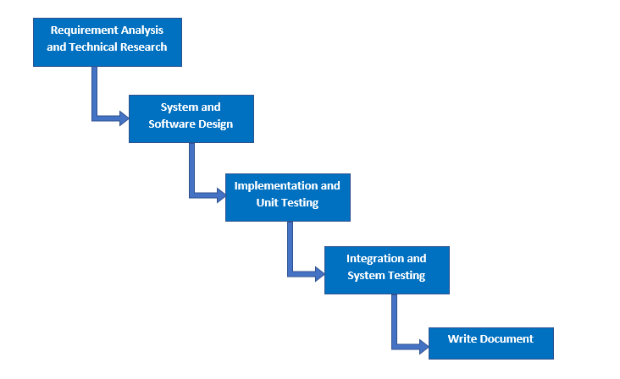

***Figure 1: Software Process Model***

**2.2. Roles and responsibilities**

|  |  |  |  |
| --- | --- | --- | --- |
| **No** | **Full name** | **Role in Group** | **Responsibilities** |
| **1** | Phạm Công Thành | Project Manager | * Specify user requirement * Control the development process * Give out technique and business analysis support |
| **2** | Hoàng Ngô Minh Tùng | Team Leader, QA, DEV, Tester | * Manage the process, quality, risk * Design database * Clarify requirements * Prepare documents, reports * Arrange meeting * Design project architect * Coding * Testing |
| **3** | Nguyễn Bảo Khánh | Team Member, BA, DEV, Tester | * GUI design * Design database * Clarify requirements, analyze business * Review documents, reports * Design project architect * Coding * Testing |
| 4 | Lê Nguyễn Ngọc Sang | Team Member, QC, DEV, Tester | * Create test plan * GUI design * Design database * Clarify requirements, analyze business * Design project architect * Coding * Testing |

**2.3. Tools and Techniques**

|  |  |
| --- | --- |
| **Tool** | **Name and version** |
| IDE | * IntelliJ IDEA 2018.2.3 * Netbeans 8.0.2 * Android Studio 3.1.3 |
| Source control | SourceTree 2.6.10 |
| Database Manager | MySQL Workbench 6.3.9 CE |

|  |  |
| --- | --- |
| **Technique** | **Name and version** |
| Front end | * HTML v5.0 * JQuery v3.2.1 * Bootstrap v3.3.7 * CSS * Javascript * Ajax * ReactJS |
| Back end | * Java EE 8 * Spring Boot v2.0.5 RELEASE * Hibernate v5.0.12 * Log4J v1.2.17 * JUnit v3.8.1 |
| Google Map API libraries | google maps |
| Web server | Apache Tomcat v8.5.15 |
| Database system | MySQL 5.7.20 |

1. **Project Management Plan**

**3.1. Software development life cycle**

|  |  |  |  |  |  |
| --- | --- | --- | --- | --- | --- |
| **Phase** | **Description** | **Deliverables** | **Resource needed** | **Dependencies and Constraints** | **Risks** |
| **Requirement analysis and technical research** | **-** Identify and clarify requirements for system  - Research for google maps api and crawling technique (StAX) | - Software Requirement Specification  - Basic knowledge Google Maps API  - Understand about StAX technique  - Introduction document  - Project Management Plan  - Prototypes | 4 weeks | N/A | **-** Lack of member share of understand  - SRS does not match user requirement  - Misunderstanding of learning |
| **System and software design** | **-** Architect design for the system  - Detail design using top-down break down | - Software Design Description Document  - Base code structure  - Technology notes | 2 weeks | Depend on “Requirement Analysis and Technical Research” | **-** Lack of experience  - Diagrams don’t match SRS  - Not fulfil requirement |
| **Implementation and unit testing** | **-** Implement the system  - Crawling data  - Building mobile application  - Prepare test plan and test cases  - Unit testing of the code | **-** System Implementation and Test Document  - Programs (web and mobile app)  - Unit test cases and results | 4 weeks | Depend on “System and Software Design” | **-** Delay in implementation  - Inaccurate programming |
| **Integration and system testing** | **-** Perform functional and non functional testing  - Make sure the system meets the requirements | **-** Test report  - Defect report | 1 week | Depend on “Implementation and Unit Testing” | - Missing of functions that need to be tested |
| **Write document** | **-** Write “Software User’s Manual”  - Review all documents  - Write paper | **-** Software User’s Manual  - A paper | 3 weeks | Depend on “System Design” and “Implementation” | -Don’t have enough time to complete paper. |

***Table <number>: Software development life cycle***

**3.2. Phase Detail**

**3.2.1. Requirement Analysis and Technical Research**

|  |  |  |
| --- | --- | --- |
| **Task** | **Description** | **Author** |
| **Identify and clarify functions** | Identify and clarify user requirements  Divide all functions into groups by concept | TungHNM, KhanhNB, SangLNN |
| **Research on Google Maps and Location** | Research on google maps api  Research on HTML5 Location, Android Location  Research on ReactJS, StAX crawling technique | TungHNM, KhanhNB, SangLNN |
| **Design application** | Design GUI for web and mobile application base on main functions  Design Use Case Diagram | TungHNM, KhanhNB, SangLNN |
| **Write document** | Write Introduction document  Write Project Management Plan  Write Software Requirement Specification | TungHNM, KhanhNB, SangLNN |

**3.2.2. System and Software Design**

|  |  |  |
| --- | --- | --- |
| **Task** | **Description** | **Author** |
| **Design ERD** | Design Entity Relationship Diagram for database | TungHNM, KhanhNB, SangLNN |
| **Design architect** | Design architect and main functions of application  Design Class Diagram, Interaction Diagram, Component Diagram | TungHNM, KhanhNB, SangLNN |
| **Write document** | Write Software Design Description | TungHNM, KhanhNB, SangLNN |

**3.2.3. Implementation and Unit Testing**

|  |  |  |
| --- | --- | --- |
| **Task** | **Description** | **Author** |
| **Implement Web Service** | Implement main functions  Implement REST api | TungHNM, KhanhNB, SangLNN |
| **Implement GUI** | Implement Web and Mobile UI | TungHNM, KhanhNB, SangLNN |
| **Implement Algorithms** | Implement location suggestion  Implement pagination  Implement data crawling | TungHNM, KhanhNB, SangLNN |
| **Unit testing** | Prepare test cases for all functions  Test each functions and provide check list of defects  Fix bugs base on the check list | TungHNM, KhanhNB, SangLNN |
| **Write document** | Write System Implementation and Test Document | TungHNM, KhanhNB, SangLNN |

**3.2.4. Integration and System Testing**

|  |  |  |
| --- | --- | --- |
| **Task** | **Description** | **Author** |
| **Prepare test plan** | Prepare overview plan for testing | TungHNM, KhanhNB, SangLNN |
| **Prepare test case** | Prepare test cases for the whole system base on user requirement | TungHNM, KhanhNB, SangLNN |
| **Integration and system test** | Perform all test cases | TungHNM, KhanhNB, SangLNN |

**3.2.5. Write document**

|  |  |  |
| --- | --- | --- |
| **Task** | **Description** | **Author** |
| **Write document** | Write Software User’s Manual Document | TungHNM, KhanhNB, SangLNN |
| **Review all documents** | Review 6 reports | TungHNM, KhanhNB, SangLNN |
| **Write paper** | Write abstract and introduction  Write about Pagination and Location Suggestion algorithm  Write comparison  Write conclusion | TungHNM, KhanhNB, SangLNN |

**3.3. All Meeting Minutes**

All meeting minutes could be found at [here](https://drive.google.com/open?id=1ACCC2tjce8m-4AyyhLiwlV_43ZZlKM96).

1. **Coding Convention**

We use Java to develop the application. Here is our specified coding convention:

* Packaging Convention:
  + Divide application into layers: presentation layer, service layer, business layer, data access layer,...
* Code block Convention:
  + No line break before the opening brace.
  + Line break after the opening brace.
  + Line break before the closing brace.
  + Line break after the closing brace, only if that brace terminates a statement or terminates the body of a method, constructor, or named class.
* Naming Convention:
  + Package names are all lowercase, with consecutive words simply concatenated together (no underscores).
  + Class names are written in UpperCamelCase.
  + Constant names use CONSTANT_CASE: all uppercase letters, with words separated by underscores.
  + Use camel-case style for variables and functions name.
  + Names should reflect a business meaning or purpose.
* Commenting Convention:
  + Place the comment on a separate line, not at the end of a line of code.
  + Begin comment text with an uppercase letter.
* Log data Convention:
  + Log fatal errors, exception to file.
  + Log URL on console before sending request.
* Documentation Convention:
  + Add java docs at the top of the class describing the purpose of the class and the responsibility of it.
  + Add a description at the top of each method describing the business flow of the method, the input/output and the success/failure scenarios it handles.
  + Add business and meaningful comments for complex algorithms or blocks written by each member.

**C. Report No.3 Software Requirement Specification**

**1. User Requirement Specification**

Our system is designed to act as a platform of information, hosting events and trading about Gunpla World. Users can use search system with nearby location through website and mobile. We also provide many advanced features to heighten user experience and make it more effective for administrator to manage the entire system. This software consists of three main user roles which are Member, Buyer/Seller and Admin with Admin are our employees.

**1.1. Member Requirement**

Member is a person who doesn’t have access to the system. Member can get gunpla’s information, publish articles, register for attending events, proposal to open events, contests, order the exchanges and evaluate. Below are functions of member:

* Register
* Login
* Search for models, get models’s detail
* Search for articles, get articles’s information
* Manipulate articles, articles
* Search for events, get events’s detail
* Search for exchange, get exchange’s detail
* Register event with payment
* Proposal to open events, contests
* Manipulate event proposals
* Order the exchanges
* Evaluate with rating and feedback

**1.2. Buyer/Seller Requirement**

Buyer/Seller is a role that is upgrade from Member, has all functions of Member and have more features about exchange, trading. Below are functions of this role which member doesn’t have:

* Post for exchange, for purchase or for sale
* Manipulate the exchange
* Confirm about the transaction

**1.3. Administrator Requirement**

Administrator is a role as an employee who is responsible for managing the entire system such as manipulating account, manipulating models, articles, events, approving requests or manipulating the crawling, includes crawl models and crawl information articles. Administrator can do the following functions:

* Manipulate account
* Manipulate crawling, includes: crawl models and information articles
* Manipulate gunpla model information system
* Manipulate articles, articles
* Approve requests to publish articles, proposal to open events, contests and to post for exchange
* Manipulate events, contests
* Manipulate buyer/seller’s exchange

**1.4. Authenticated User Requirement**

Authenticated user is a person who already logined into system. Authenticated user can do the following functions:

* Logout
* Edit profile

**1.5. Scheduler Requirement**

Scheduler is a kind of system role that run functions in the backend. Scheduler can do the following functions:

* Send notifications

**2. System Requirement Specification**

**2.1. External Interface Requirement**

**2.1.1. User Interface**

The user interface uses English for both web application and mobile application.

**2.1.2. Hardware Interface**

* **Server:**
  + Ram: 4GB
  + Computer Processor: Intel® Core™ i5 (4 CPUs) @ 2.5GHz
  + Operating system: Windows 10
  + Internet connection: Cable, Wi-Fi (20 Mbps)
* **Mobile smartphone:**
  + Ram: 2GB
  + Processor: CPU Quad core 2.0 GHz
  + Operating system: Android 6 Marshmallow

**2.1.3. Software Interface**

* Operating system: Window 10, Android 6 Marshmallow
* Environment: Java EE 8, Android SDK APIs level 15 or above
* IDE: IntelliJ IDEA 2018.2.3, Netbeans 8.0.2, Android Studio 3.1.3
* DBMS: MySQL 5.7.20, MySQL Workbench 6.3.9 CE
* Source control: SourceTree 2.6.10
* Web browser: Chrome 62 or above

**2.1.4. Communication Protocol**

* Use HTTP protocol 1.1 for communication between:
  + Web application and web server
  + Mobile application and web server

**2.2. System Overview Usecase**

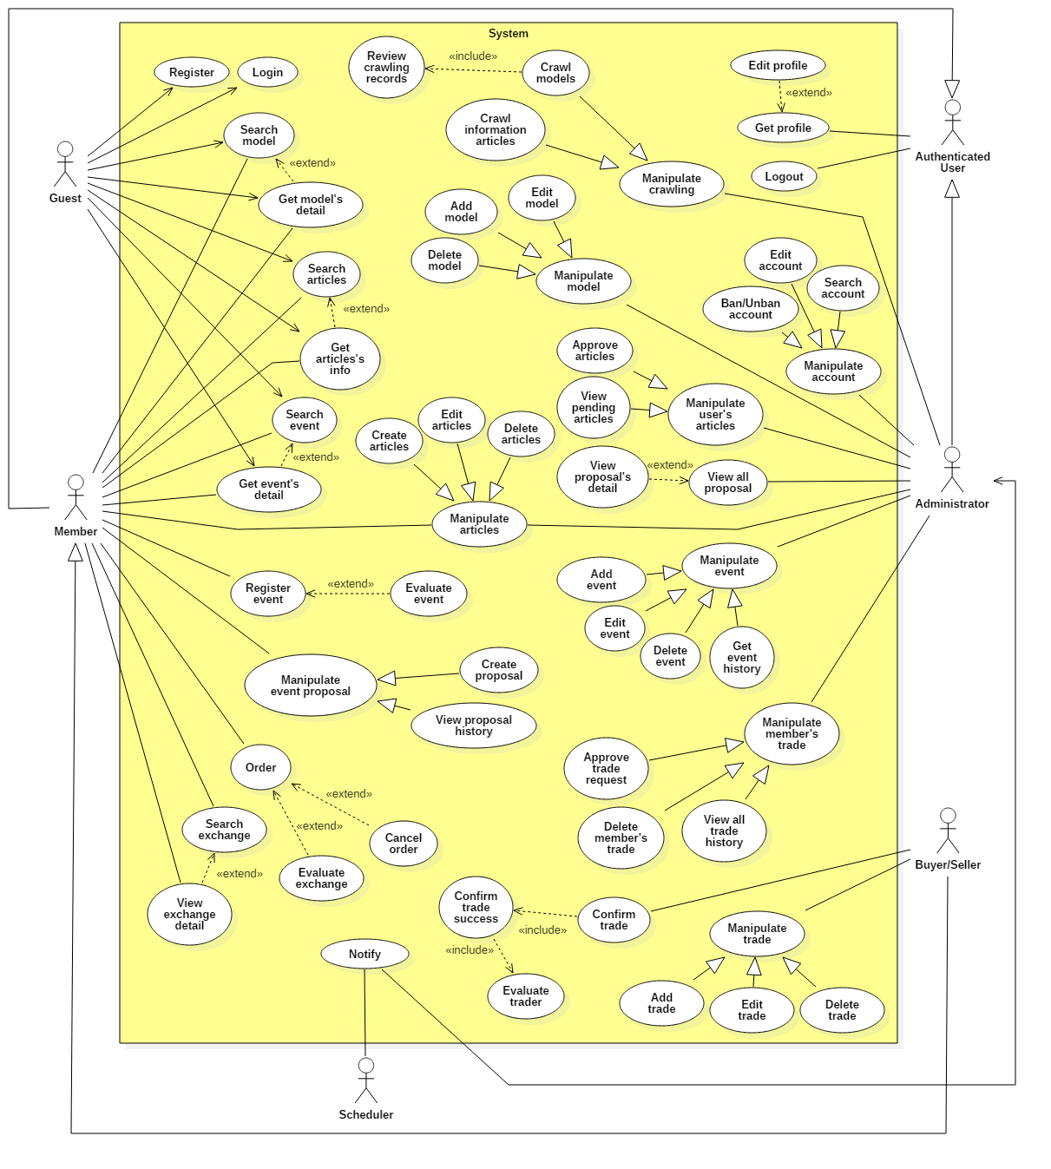

**2.3. List of Usecase**

**2.3.1. < Administrator > Overview Usecase**

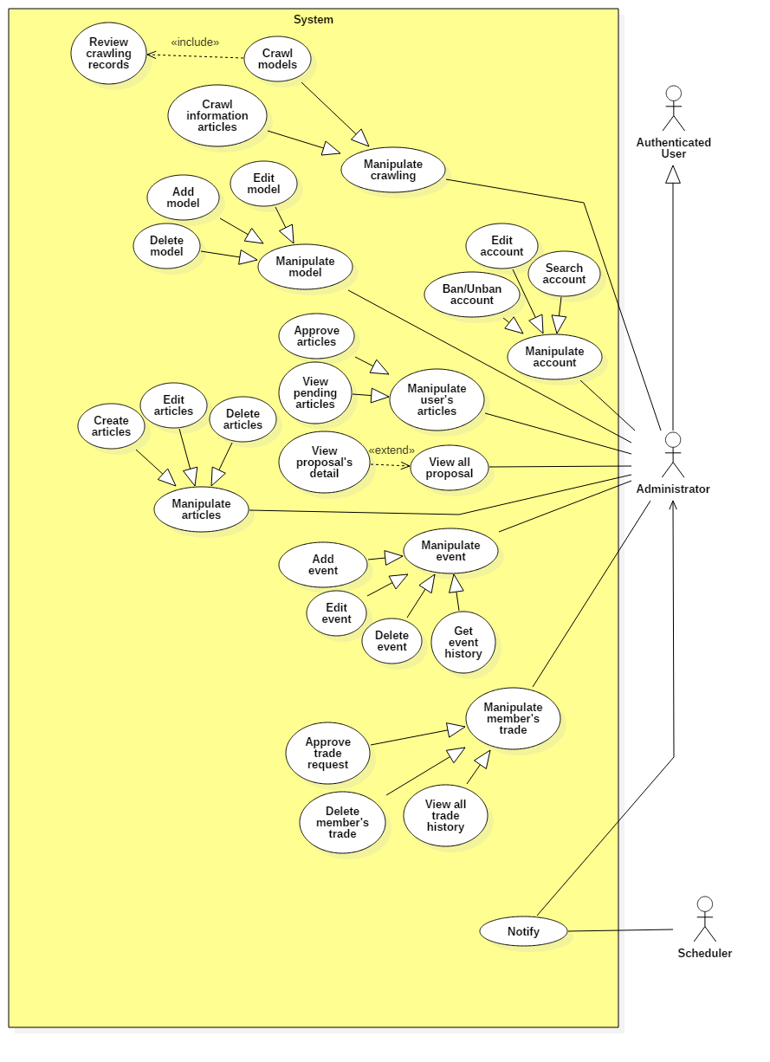

**2.3.1.1. < Administrator > Crawl models Usecase**

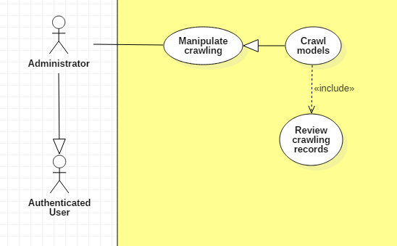

|  |  |  |  |
| --- | --- | --- | --- |
| **USE CASE – UC _A.01** | | | |
| **Usecase No.** | A.01 | **Usecase Version** | 1.0 |
| **Usecase Name** | Crawl models | | |
| **Author** | TungHNM | | |
| **Date** | 28/09/2018 | **Priority** | Normal |
| **Actor:**   * Administrator.   **Summary:**   * This use case allows administrator to crawl models from high domain: https://www.1999.co.jp/eng/gundam.   **Goal:**   * Information about models will be crawled and saved to database after administrator review.   **Triggers:**   * Administrator sends crawl models command to the system.   **Preconditions:**   * User must login into system with role Administrator. * Crawl page is displayed.   **Post Conditions:**   * **Success**: Models’s crawling records will displayed on page for administrator to review, after that save the new records to database. * **Fail**: Show error message.   **Main Success Scenario:**   |  |  |  | | --- | --- | --- | | **Step** | **Actor Action** | **System Response** | | 1 | Administrator clicks on “Crawl Models” button | A list of models’s crawling records is shown with following labels and fields:   * Code: text, required, max length: 50 * Name: text, required, max length: 250 * Product Series: text, required, max length: 250 * Series Title: text, required, max length: 250 * Manufacturer: text, max length: 100 * Price: text, max length: 20 * Released Date: text, max length: 20 * Description: text, max length: 350 | | 2 | Administrator reviews all records.  [Alternative 1, 2] |  | | 3 | Administrator clicks on “SAVE” button | Validate data.  [Exception 1]  Match new records with existed data in database.  Save new models to database.  System shows message gunpla models have been saved successfully.  [Alternative 3] |   **Alternative Scenario:**  **Alternative Scenario 1: Delete a record**   |  |  |  | | --- | --- | --- | | **Step** | **Actor Action** | **System Response** | | 1 | Administrator delete a record | Delete the selected temporary record in database. |   **Alternative Scenario 2: Click on a record**   |  |  |  | | --- | --- | --- | | **Step** | **Actor Action** | **System Response** | | 1 | Administrator clicks on a record | System displays the selected record’s detail page. |   **Alternative Scenario 3: No new records**   |  |  |  | | --- | --- | --- | | **Step** | **Actor Action** | **System Response** | | 1 | Administrator clicks on “SAVE” button | If there is no new records after matching with existed data in database, system shows message there is no new records. |   **Exceptions:**   |  |  |  | | --- | --- | --- | | **No** | **Cause** | **System Response** | | 1 | Administrator does not fill out all the required fields | System shows error message to ask administrator to enter missing required fields. | | 2 | Length of field’s value is out of range | System shows error message that notify administrator which field’s value is out of range. |   **Relationships:** N/A  **Business** **Rules**:   * In case of success scenarios, new models’s crawling data would be added to database. * All crawling records are saved in a temporary table in database before administrator review. * If administrator edit records, all required fields must be filled out. * Matching the recent crawling records with existed data in database, if new save to the main Model table. | | | |

**2.3.1.2. < Administrator > Edit Account Usecase**

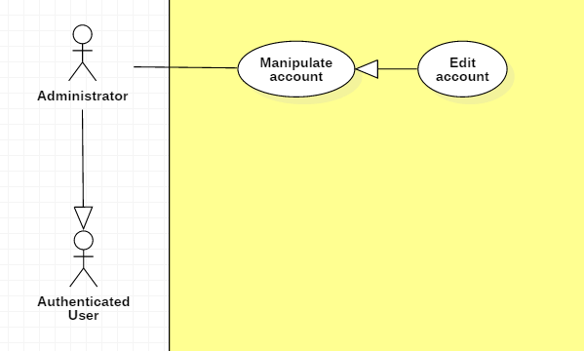

|  |  |  |  |
| --- | --- | --- | --- |
| **USE CASE – UC _A.02** | | | |
| **Usecase No.** | A.02 | **Usecase Version** | 1.0 |
| **Usecase Name** | Edit account | | |
| **Author** | TungHNM | | |
| **Date** | 29/09/2018 | **Priority** | Normal |
| **Actor:**   * Administrator.   **Summary:**   * This use case allows administrator to update Members’s information.   **Goal:**   * Information will be customized to be more reasonable.   **Triggers:**   * Administrator sends edit account command to the system.   **Preconditions:**   * User must login into system with role Administrator. * The profile page of selected account is displayed.   **Post Conditions:**   * **Success**: Member’s information is updated. * **Fail**: Show error message.   **Main Success Scenario:**   |  |  |  | | --- | --- | --- | | **Step** | **Actor Action** | **System Response** | | 1 | Administrator clicks on “Edit profile” button | Edit Account page is shown with following labels and fields:   * Email: text, required, max length: 50, RegEx: /^([a-z0-9_\.-]+)@([\da-z\.-]+)\.([a-z\.]{2,6})$/ * First Name: text, max length: 50 * Middle Name: text, max length: 50 * Last Name: text, max length: 50 * Tel: text, length: 10-11 * Address: text, max length: 250 * Birthday: DateTimePicker   System automatically fills out the form with information of the selected user’s profile in database. | | 2 | Administrator fills out the form |  | | 3 | Administrator clicks on “SAVE” button | Validate data.  [Exception 1, 2, 3, 4, 5]  Update account information to database  System displays Profile page with updated information. |   **Alternative Scenario:** N/A  **Exceptions:**   |  |  |  | | --- | --- | --- | | **No** | **Cause** | **System Response** | | 1 | Email does not match the required format: /^([a-z0-9_\.-]+)@([\da-z\.-]+)\.([a-z\.]{2,6})$/ | System shows error message: Invalid email ! | | 2 | Phone number is not string of number | System shows error message: Invalid phone number ! | | 3 | Email is duplicate in database | System shows error message: The email has been existed ! | | 4 | Missing of required fields | System shows error message that notify administrator to input the required fields | | 5 | Length of field’s value is out of range | System shows error message that notify administrator which field’s value is out of range. |   **Relationships:** N/A  **Business** **Rules**:   * Account’s information will be automatically filled out when Edit Account page is loaded or whenever an exception occurs. * In case of success scenarios, account’s information would be updated to the database and displays the profile page with updated information. * Tel must be string of numbers. * Email must not be duplicate in database. * An email address must be validated by this regular expression:   /^([a-z0-9_\.-]+)@([\da-z\.-]+)\.([a-z\.]{2,6})$/ | | | |

**2.3.1.3. < Administrator > Ban Account Usecase**

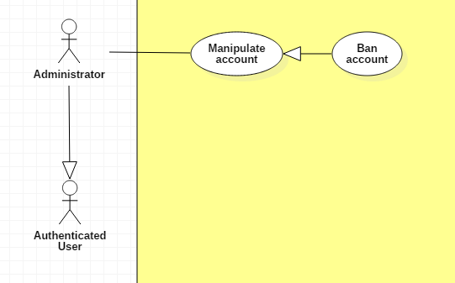

|  |  |  |  |
| --- | --- | --- | --- |
| **USE CASE – UC _A.03** | | | |
| **Usecase No.** | A.03 | **Usecase Version** | 1.0 |
| **Usecase Name** | Ban account | | |
| **Author** | TungHNM | | |
| **Date** | 29/09/2018 | **Priority** | Normal |
| **Actor:**   * Administrator.   **Summary:**   * This use case allows administrator to ban a member’s account.   **Goal:**   * Disable members who post with invalid sensitive contents and avoid fraud from exchange.   **Triggers:**   * Administrator sends ban account command to the system.   **Preconditions:**   * User must login into system with role Administrator. * The profile page of selected account is displayed. * The account’s status is active.   **Post Conditions:**   * **Success**: Member’s account is banned and can’t login the system. * **Fail**: Show error message.   **Main Success Scenario:**   |  |  |  | | --- | --- | --- | | **Step** | **Actor Action** | **System Response** | | 1 | Administrator clicks on “BAN ACCOUNT” button | A dialog is displayed for administrator to confirm with message: “Are you sure?” and two buttons: “Yes” and “No” | | 2 | Administrator clicks on “Yes” button  [Alternative 1] | The status of selected account is updated to “Banned” in database  The profile page is loaded with updated status. |   **Alternative Scenario:**  **Alternative Scenario 1: Click “No” button**   |  |  |  | | --- | --- | --- | | **Step** | **Actor Action** | **System Response** | | 1 | Administrator clicks on “No” button | The dialog is disappeared and system views the profile page. |   **Exceptions:** N/A  **Relationships:** N/A  **Business** **Rules**:   * The account’s status must be active before admin bans. | | | |

**2.3.1.4. < Administrator > Unban Account Usecase**

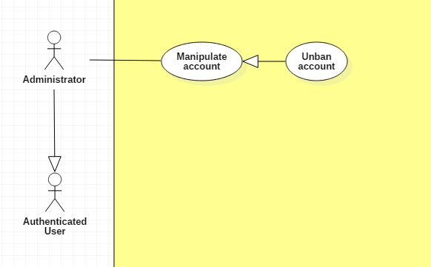

|  |  |  |  |
| --- | --- | --- | --- |
| **USE CASE – UC _A.04** | | | |
| **Usecase No.** | A.04 | **Usecase Version** | 1.0 |
| **Usecase Name** | Unban account | | |
| **Author** | TungHNM | | |
| **Date** | 29/09/2018 | **Priority** | Normal |
| **Actor:**   * Administrator.   **Summary:**   * This use case allows administrator to unban a member’s account.   **Goal:**   * Allow a member to come back to system.   **Triggers:**   * Administrator sends unban account command to the system.   **Preconditions:**   * User must login into system with role Administrator. * The profile page of selected account is displayed. * The account’s status is banned.   **Post Conditions:**   * **Success**: Member’s account is unbanned and can login the system. * **Fail**: Show error message.   **Main Success Scenario:**   |  |  |  | | --- | --- | --- | | **Step** | **Actor Action** | **System Response** | | 1 | Administrator clicks on “UNBAN ACCOUNT” button | A dialog is displayed for administrator to confirm with message: “Are you sure?” and two buttons: “Yes” and “No” | | 2 | Administrator clicks on “Yes” button  [Alternative 1] | The status of selected account is updated to “Active” in database  The profile page is loaded with updated status. |   **Alternative Scenario:**  **Alternative Scenario 1: Click on “No” button**   |  |  |  | | --- | --- | --- | | **Step** | **Actor Action** | **System Response** | | 1 | Administrator clicks on “No” button | The dialog is disappeared and system views the profile page. |   **Exceptions:** N/A  **Relationships:** N/A  **Business** **Rules**:   * The account’s status must be banned. | | | |

**2.3.1.5. < Administrator > Search account Usecase**

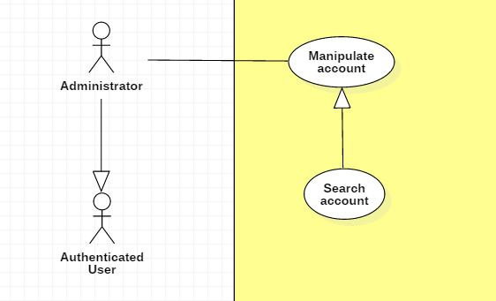

|  |  |  |  |
| --- | --- | --- | --- |
| **USE CASE – UC _A.05** | | | |
| **Usecase No.** | A.05 | **Usecase Version** | 1.0 |
| **Usecase Name** | Search account | | |
| **Author** | TungHNM | | |
| **Date** | 30/09/2018 | **Priority** | Normal |
| **Actor:**   * Administrator.   **Summary:**   * This use case allows administrator to search accounts by username.   **Goal:**   * Make it more convenient for administrator to seek for accounts.   **Triggers:**   * Administrator sends search account command to the system.   **Preconditions:**   * User must login into system with role Administrator. * The search account page is displayed.   **Post Conditions:**   * **Success**: A list of matching records are shown. * **Fail**: Show error message.   **Main Success Scenario:**   |  |  |  | | --- | --- | --- | | **Step** | **Actor Action** | **System Response** | | 1 | Administrator clicks on search navbar | The text input is displayed with blue border and placeholder: Please input keyword | | 2 | Administrator fills out the input text |  | | 3 | Administrator clicks on “SEARCH” button or press Enter  [Alternative 2] | A list of matching accounts by username will be displayed on the view  [Alternative 1] |   **Alternative Scenario:**  **Alternative Scenario 1: No matching records**   |  |  |  | | --- | --- | --- | | **Step** | **Actor Action** | **System Response** | | 1 | Administrator clicks on “SEARCH” button or press Enter | There is no matching records and system displays message No matching records ! |   **Alternative Scenario 2: List all accounts in database**   |  |  |  | | --- | --- | --- | | **Step** | **Actor Action** | **System Response** | | 1 | Administrator clicks on “SEARCH” button or press Enter with empty input string | A list of all accounts in database is shown on the view with pagination. |   **Exceptions:** N/A  **Relationships:** N/A  **Business** **Rules**:   * A list of all accounts is displayed when administrator inputs search field with empty value * System queries accounts by username which is matched with the input string | | | |

**2.3.1.6. < Administrator > Add new model Usecase**

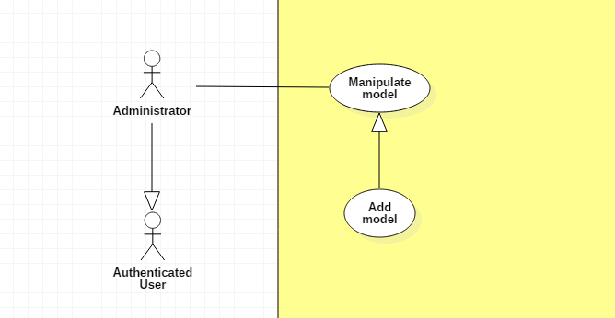

|  |  |  |  |
| --- | --- | --- | --- |
| **USE CASE – UC _A.06** | | | |
| **Usecase No.** | A.06 | **Usecase Version** | 1.0 |
| **Usecase Name** | Add new model | | |
| **Author** | TungHNM | | |
| **Date** | 30/09/2018 | **Priority** | Normal |
| **Actor:**   * Administrator.   **Summary:**   * This use case allows administrator to create a new model.   **Goal:**   * To add new model to system.   **Triggers:**   * Administrator sends add new model command to the system.   **Preconditions:**   * User must login into system with role Administrator. * The create new model page is displayed.   **Post Conditions:**   * **Success**: A model with information is created and saved to database successfully. * **Fail**: Show error message.   **Main Success Scenario:**   |  |  |  | | --- | --- | --- | | **Step** | **Actor Action** | **System Response** | | 1 | Administrator goes to create new model view | An add new model form is shown with following labels and fields:   * Code: text, required with regEx: /^[A-z]+$/ * Name: text, required, max length: 50 * Product Series: dropdown list * Series Title: dropdown list * Manufacturer: dropdown list * Price: free text input * Released Date: DateTimePicker * Description: free text input, max length: 350 * Import image: input type file * Image type: dropdown list * “+”: button | | 2 | Administrator fills out the form  [Alternative 1, 2, 3] |  | | 3 | Administrator clicks on “CREATE” button | Validate data  [Exception 1, 2, 3, 5]  New model is created and saved to database.  System displays message Model {code} is saved successfully! |   **Alternative Scenario:**  **Alternative Scenario 1: Click on “Import image” button**   |  |  |  | | --- | --- | --- | | **Step** | **Actor Action** | **System Response** | | 1 | Administrator clicks on “Import image” button | System shows dialog for administrator to choose local image | | 2 | Administrator chooses an image | Validate file type  [Exception 4]  System shows the selected image’s name on the view |   **Alternative Scenario 2: Click on “+” button**   |  |  |  | | --- | --- | --- | | **Step** | **Actor Action** | **System Response** | | 1 | Administrator clicks on “+” button | System displays 1 new row with the following lables and fields in a horizontal line:   * Import image: input type file * Image type: dropdown list * “+”: button * “-”: button |   **Alternative Scenario 3: Click on “-” button**   |  |  |  | | --- | --- | --- | | **Step** | **Actor Action** | **System Response** | | 1 | Administrator clicks on “-” button | System removes the selected rows, includes:   * Import image: input type file * Image type: dropdown list * “+”: button |   **Exceptions:**   |  |  |  | | --- | --- | --- | | **No** | **Cause** | **System Response** | | 1 | Administrator does not input all the required fields | System shows error message to ask administrator to fill all the required fields | | 2 | Administrator inputs the invalid code. | System shows error message: Invalid format of code ! | | 3 | The model’s code input from administrator is duplicate | System shows error message: This code is already existed ! | | 4 | File which is imported by administrator is not type of image | System shows error message: Invalid file, please select file image only ! | | 5 | Length of field’s value is out of range | System shows error message that notify administrator which field’s value is out of range. |   **Relationships:** N/A  **Business** **Rules**:   * Model’s code must be characters. * Each of local image which is imported by administrator must go with an image type: dropdown list and a button “+” to add multi images. * “-” button will appear when there is at least an local image that is imported by administrator. * System checks the duplicate model’s code in database. * File which is imported by administrator must be type of images: *.jpeg, *.jpg, *.png, *.gif. | | | |

**2.3.1.7. < Administrator > Edit model Usecase**

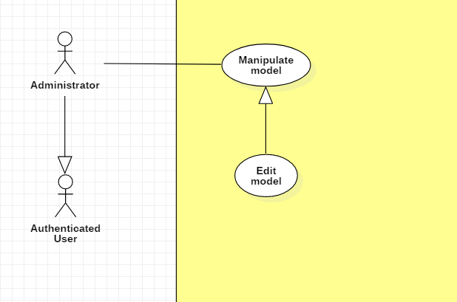

|  |  |  |  |
| --- | --- | --- | --- |
| **USE CASE – UC _A.07** | | | |
| **Usecase No.** | A.07 | **Usecase Version** | 1.0 |
| **Usecase Name** | Edit a model | | |
| **Author** | TungHNM | | |
| **Date** | 30/09/2018 | **Priority** | Normal |
| **Actor:**   * Administrator.   **Summary:**   * This use case allows administrator to edit a gunpla model’s information.   **Goal:**   * Information about gunpla models will be customized to be more reasonable.   **Triggers:**   * Administrator sends edit model command to the system.   **Preconditions:**   * User must login into system with role Administrator. * The detail page of the model which will be edited is displayed.   **Post Conditions:**   * **Success**: Information of the selected gunpla model is updated and saved to database successfully. * **Fail**: Show error message.   **Main Success Scenario:**   |  |  |  | | --- | --- | --- | | **Step** | **Actor Action** | **System Response** | | 1 | Administrator clicks on “Edit” button on the detail page | System displays Edit Model page and a form with following labels and fields:   * Code: text, required with regEx: /^[A-z]+$/ * Name: text, required, max length: 50 * Product Series: dropdown list, * Series Title: dropdown list * Manufacturer: dropdown list * Price: free text input * Released Date: DateTimePicker * Description: free text input, max length: 350 * Import image: input type file * Image type: dropdown list * “+”: button   System automatically loads the selected gunpla model’s information to the form. | | 2 | Administrator fills out the form  [Alternative 1, 2, 3] |  | | 3 | Administrator clicks on “SAVE” button | Validate data  [Exception 1, 2, 3, 5]  Model’s information is updated and saved to database.  System displays message: Model {code} is updated successfully! |   **Alternative Scenario:**  **Alternative Scenario 1: Click on “Import image” button**   |  |  |  | | --- | --- | --- | | **Step** | **Actor Action** | **System Response** | | 1 | Administrator clicks on “Import image” button | System shows dialog for administrator to choose local image | | 2 | Administrator chooses an image | Validate file type  [Exception 4]  System shows the selected image’s name on the view |   **Alternative Scenario 2: Click on “+” button**   |  |  |  | | --- | --- | --- | | **Step** | **Actor Action** | **System Response** | | 1 | Administrator clicks on “+” button | System displays 1 new row with the following lables and fields in a horizontal line:   * Import image: input type file * Image type: dropdown list * “+”: button * “-”: button |   **Alternative Scenario 3: Click on “-” button**   |  |  |  | | --- | --- | --- | | **Step** | **Actor Action** | **System Response** | | 1 | Administrator clicks on “-” button | System removes the selected rows, includes:   * Import image: input type file * Image type: dropdown list * “+”: button * “-”: button |   **Exceptions:**   |  |  |  | | --- | --- | --- | | **No** | **Cause** | **System Response** | | 1 | Administrator does not input all the required fields | System shows error message to ask administrator to fill all the required fields | | 2 | Administrator inputs the invalid code. | System shows error message: Invalid format of code ! | | 3 | The model’s code input from administrator is duplicate | System shows error message: This code is already existed ! | | 4 | File which is imported by administrator is not type of image | System shows error message: Invalid file, please select file image only ! | | 5 | Length of field’s value is out of range | System shows error message that notify administrator which field’s value is out of range |   **Relationships:** N/A  **Business** **Rules**:   * Model’s code must be characters. * Each of local image which is imported by administrator must go with an image type: dropdown list and a button “+” to add multi images. * “-” button will appear when there is at least an local image that is imported by administrator. * System checks the duplicate model’s code in database. * File which is imported by administrator must be type of images: *.jpeg, *.jpg, *.png, *.gif. | | | |

**2.3.1.8. < Administrator > Delete model Usecase**

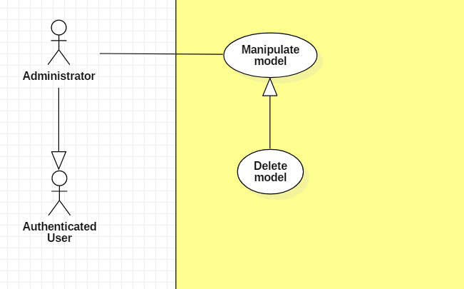

|  |  |  |  |
| --- | --- | --- | --- |
| **USE CASE – UC _A.08** | | | |
| **Usecase No.** | A.08 | **Usecase Version** | 1.0 |
| **Usecase Name** | Delete a model | | |
| **Author** | TungHNM | | |
| **Date** | 30/09/2018 | **Priority** | Normal |
| **Actor:**   * Administrator.   **Summary:**   * This use case allows administrator to delete a gunpla model.   **Goal:**   * Models which are no longer available will be removed from system and will not be displayed on the user view.   **Triggers:**   * Administrator sends delete model command to the system.   **Preconditions:**   * User must login into system with role Administrator. * The detail page of the model which will be deleted is displayed.   **Post Conditions:**   * **Success**: Model and its information are deleted from the system. * **Fail**: Show error message.   **Main Success Scenario:**   |  |  |  | | --- | --- | --- | | **Step** | **Actor Action** | **System Response** | | 1 | Administrator clicks on “Delete” button on the detail page | System displays a dialog for administrator to confirm, the dialog is displayed with message: Are you sure ?, with 2 buttons:   * Yes * No | | 2 | Administrator clicks on “Yes” button  [Alternative 1] | Model information is deleted from database.  System displays message: Model {code} is removed from system successfully ! |   **Alternative Scenario:**  **Alternative Scenario 1: Clicks on “No” button**   |  |  |  | | --- | --- | --- | | **Step** | **Actor Action** | **System Response** | | 1 | Administrator clicks on “No” button | The dialog disappears and system views detail page of the selected gunpla model, automatically fills out all fields. |   **Exceptions:** N/A  **Relationships:** N/A  **Business** **Rules**:N/A | | | |

**2.3.1.9. < Administrator > Create articles Usecase**

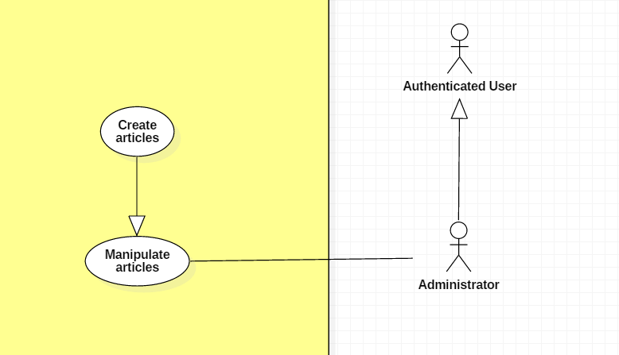

|  |  |  |  |
| --- | --- | --- | --- |
| **USE CASE – UC _A.09** | | | |
| **Usecase No.** | A.09 | **Usecase Version** | 1.0 |
| **Usecase Name** | Create articles | | |
| **Author** | KhanhNB | | |
| **Date** | 25/09/2018 | **Priority** | Normal |
| **Actor:**   * Administrator   **Summary:**   * This use case allows user to create a new article.   **Goal:**   * A new article added to the database system.   **Triggers:**   * Admin write an articles and submit it.   **Preconditions:**   * User must login into system with role Administrator.   **Post Conditions:**   * **Success**: New article is added to the database system. * **Fail**: Show error message.   **Main Success Scenario:**   |  |  |  | | --- | --- | --- | | **Step** | **Actor Action** | **System Response** | | 1 | Admin go to “Create a new article” page | “Create new article” view is shown with following labels and fields:   * Input field for article’s Title * A textarea using CKEditor library * Submit button | | 2 | Admin fills out the form. |  | | 3 | Admin submit article. | Validate data.  Add new article the database.  System shows message article has been created successfully with a link to the article. |   **Alternative Scenario:**  N/A  **Exceptions:**   |  |  |  | | --- | --- | --- | | **No** | **Cause** | **System Response** | | 1 | Admin submit article with empty content | System shows error message to ask the admin to enters missing required fields. | | 2 | Admin upload file too large. | System shows error message to ask the admin to upload correct required file size. |   **Relationships:** N/A  **Business** **Rules**:   * In case of success scenarios, a new article would be posted to the database. * Article id is automatically initialized by the system. File upload must be file type of images: *.jpeg, *.jpg, *.png, *.gif. | | | |

**2.3.1.10. < Administrator > Edit article Usecase**

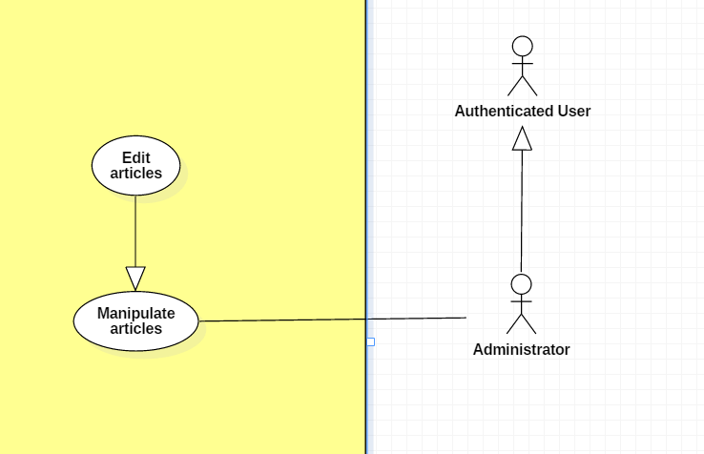

|  |  |  |  |
| --- | --- | --- | --- |
| **USE CASE – UC _A.10** | | | |
| **Usecase No.** | A.10 | **Usecase Version** | 1.0 |
| **Usecase Name** | Edit articles | | |
| **Author** | KhanhNB | | |
| **Date** | 25/09/2018 | **Priority** | Normal |
| **Actor:**   * Administrator   **Summary:**   * This use case allows admin to edit an articles.   **Goal:**   * The articles is updated in database   **Triggers:**   * Admin edit an article and submit it.   **Preconditions:**   * User must login into system with role Administrator.   **Post Conditions:**   * **Success**: New article is updated in the database system. * **Fail**: Show error message.   **Main Success Scenario:**   |  |  |  | | --- | --- | --- | | **Step** | **Actor Action** | **System Response** | | 1 | Admin go to “Edit article” page | “Post new article” view is shown with following labels and fields:   * Input field for article’s Title * A textarea using CKEditor library with the existing data * Submit button | | 2 | Admin fills out the form. |  | | 3 | Admin submit article. | Validate data.  System update the article in the database |   **Alternative Scenario:**  N/A  **Exceptions:**   |  |  |  | | --- | --- | --- | | **No** | **Cause** | **System Response** | | 1 | Admin submit article with empty content | System shows error message to ask the admin to enters missing required fields. | | 2 | Admin upload file too large. | System shows error message to ask the admin to upload correct required file size. |   **Relationships:** N/A  **Business** **Rules**:   * In case of success scenarios, the article would be updated in the database. * Article id is automatically initialized by the system. File upload must be file type of images: *.jpeg, *.jpg, *.png, *.gif. | | | |

**2.3.1.11 < Administrator > Delete article Usecase**

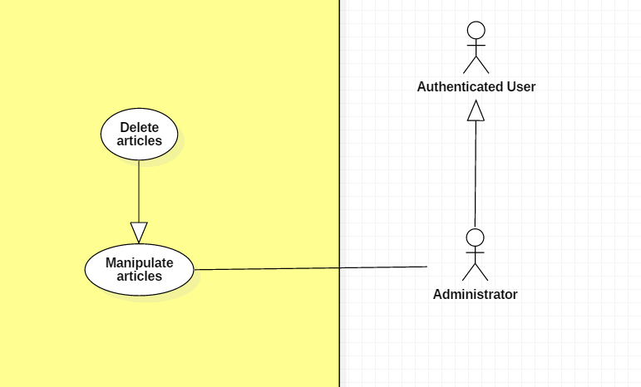

|  |  |  |  |
| --- | --- | --- | --- |
| **USE CASE – UC _A.11** | | | |
| **Usecase No.** | A.11 | **Usecase Version** | 1.0 |
| **Usecase Name** | Delete article | | |
| **Author** | KhanhNB | | |
| **Date** | 25/09/2018 | **Priority** | Normal |
| **Actor:**   * Administrator   **Summary:**   * This use case allows admin to delete an article.   **Goal:**   * The article is deleted from the database.   **Triggers:**   * Admin choose delete article   **Preconditions:**   * User must login into system with role Administrator. * The admin is viewing an article’s detail page.   **Post Conditions:**   * **Success**: The article is deleted from the database. * **Fail**: Show error message.   **Main Success Scenario:**   |  |  |  | | --- | --- | --- | | **Step** | **Actor Action** | **System Response** | | 1 | Admin select “Delete Article” | System displays a dialog for administrator to confirm, the dialog is displayed with message: Are you sure ?, with 2 buttons:   * Yes * No | | 2 | Admin selects “Yes” | System deletes the article from database.  Message saying “This article was deleted successfully” |   **Alternative Scenario:**   |  |  |  | | --- | --- | --- | | **Step** | **Actor Action** | **System Response** | | 2 | Admin selects “No” | Dialog disappears, admin can view the article’s detail again. |   **Exceptions:**   |  |  |  | | --- | --- | --- | | **No** | **Cause** | **System Response** | | 1 | Article was already deleted | System shows error message “This article has been already deleted” |   **Relationships:** N/A  **Business** **Rules**: | | | |

**2.3.1.12 < Administrator > View pending articles Usecase**

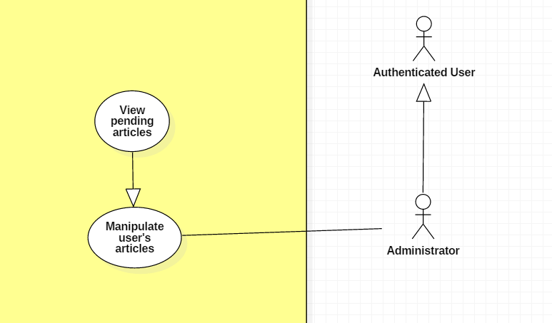

|  |  |  |  |
| --- | --- | --- | --- |
| **USE CASE – UC _A.12** | | | |
| **Usecase No.** | A.12 | **Usecase Version** | 1.0 |
| **Usecase Name** | View pending articles | | |
| **Author** | KhanhNB | | |
| **Date** | 25/09/2018 | **Priority** | Normal |
| **Actor:**   * Administrator   **Summary:**   * This use case allows admin to view a list of pending articles   **Goal:**   * Admin can see a list of pending articles that were submitted by users   **Triggers:**   * Admin go to “Pending article” view   **Preconditions:**   * User must login into system with role Administrator.   **Post Conditions:**   * **Success**: Admin can see a list of pending articles * **Fail**: Show error message.   **Main Success Scenario:**   |  |  |  | | --- | --- | --- | | **Step** | **Actor Action** | **System Response** | | 1 | Admin select “Pending article” | System redirect the admin to the “Pending article” view  A list of articles is shown |   **Alternative Scenario:** N/A  **Exceptions:** N/A  **Relationships:** N/A  **Business** **Rules**:   * These articles are shown to the admin only * The admin can select each article to see it’s detail | | | |

**2.3.1.12 < Administrator > Approve article Usecase**

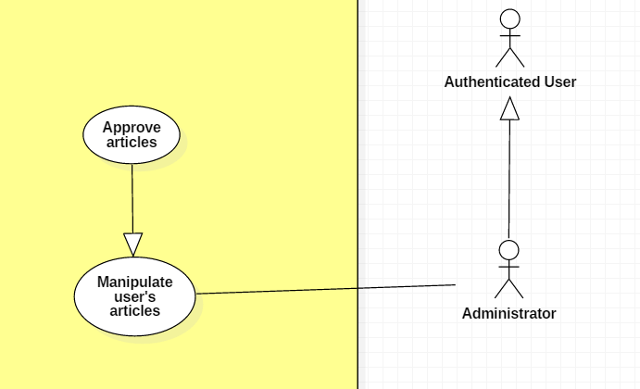

|  |  |  |  |
| --- | --- | --- | --- |
| **USE CASE – UC _A.12** | | | |
| **Usecase No.** | A.12 | **Usecase Version** | 1.0 |
| **Usecase Name** | Approve articles | | |
| **Author** | KhanhNB | | |
| **Date** | 25/09/2018 | **Priority** | Normal |
| **Actor:**   * Administrator   **Summary:**   * This use case allows admin to approve a pending article   **Goal:**   * The article is posted on the website   **Triggers:**   * Admin is viewing a pending article posted by the user * Admin choose approve article   **Preconditions:**   * User must login into system with role Administrator.   **Post Conditions:**   * **Success**: The accepted article changed its status to ACCEPTED and is posted on the website * **Fail**: Show error message.   **Main Success Scenario:**   |  |  |  | | --- | --- | --- | | **Step** | **Actor Action** | **System Response** | | 1 | Admin select “Approve article” | System changed the status of the article to APPROVED, article is now visible on website  System redirects to the “Pending articles” view |   **Alternative Scenario:**   |  |  |  | | --- | --- | --- | | **Step** | **Actor Action** | **System Response** | | 1 | Admin select “Decline article” | System changed the status of the article to DECLINED, article is not visible on website  System redirects to the “Pending articles” view |   **Exceptions:** N/A  **Relationships:** N/A  **Business** **Rules**: N/A | | | |

**2.3.1.13 < Administrator > Create new event Usecase**

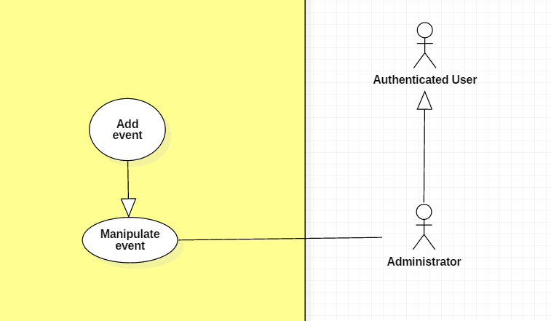

|  |  |  |  |
| --- | --- | --- | --- |
| **USE CASE – UC _A.13** | | | |
| **Usecase No.** | A.13 | **Usecase Version** | 1.0 |
| **Usecase Name** | Create new event | | |
| **Author** | KhanhNB | | |
| **Date** | 25/09/2018 | **Priority** | Normal |
| **Actor:**   * Administrator   **Summary:**   * This use case allows admin to post a new event   **Goal:**   * The event is posted on the website   **Triggers:**   * Admin fill in the event’s info and submit   **Preconditions:**   * User must login into system with role Administrator.   **Post Conditions:**   * **Success**: The event is added to the database * **Fail**: Show error message.   **Main Success Scenario:**   |  |  |  | | --- | --- | --- | | **Step** | **Actor Action** | **System Response** | | 1 | Admin go to “Create new event” page | “Create new event” view is shown with following labels and fields:   * Input field for the event’s Title * A textarea using CKEditor library * A checkbox with label saying “Check if you want this event to require a credit card” * Input field for the event’s number of tickets * Input field for the event’s start date * Input field for the event’s end date * Input field for the event’s ticket price * Submit button | | 2 | Admin fill out form |  | | 3 | Admin submit | System add the event to the database, the event is now posted on the website |   **Alternative Scenario:**  N/A  **Exceptions:**   |  |  |  | | --- | --- | --- | | **No** | **Cause** | **System Response** | | 1 | Admin submit with empty content | System shows error message to ask the admin to enters missing required fields. | | 2 | Admin upload file too large. | System shows error message to ask the admin to upload correct required file size. |   **Relationships:** N/A  **Business** **Rules**: N/A | | | |

**2.3.1.14. < Administrator > Edit event Usecase**

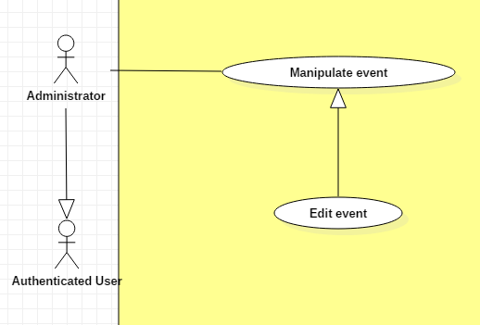

|  |  |  |  |
| --- | --- | --- | --- |
| **USE CASE – UC _A.14** | | | |
| **Usecase No.** | A.14 | **Usecase Version** | 1.0 |
| **Usecase Name** | Update event | | |
| **Author** | KhanhNB | | |
| **Date** | 25/09/2018 | **Priority** | Normal |
| **Actor:**   * Administrator   **Summary:**   * This use case allows admin to update an event’s info.   **Goal:**   * The event is updated in database   **Triggers:**   * Admin edit an event and submit it.   **Preconditions:**   * User must login into system with role Administrator.   **Post Conditions:**   * **Success**: The event is updated in the database system. * **Fail**: Show error message.   **Main Success Scenario:**   |  |  |  | | --- | --- | --- | | **Step** | **Actor Action** | **System Response** | | 1 | Admin go to “Edit event” page | “Edit event” view is shown with following labels and fields with the old data:   * Input field for the event’s Title * A textarea using CKEditor library * A checkbox with label saying “Check if you want this event to require a credit card” * Input field for the event’s number of tickets * Input field for the event’s start date * Input field for the event’s end date * Input field for the event’s ticket price * Save button * Delete event button | | 2 | Admin fills out the form. |  | | 3 | Admin submit event. | Validate data.  System update the article in the database |   **Alternative Scenario:**  N/A  **Exceptions:**   |  |  |  | | --- | --- | --- | | **No** | **Cause** | **System Response** | | 1 | Admin submit with empty content | System shows error message to ask the admin to enters missing required fields. | | 2 | Admin upload file too large. | System shows error message to ask the admin to upload correct required file size. |   **Relationships:** N/A  **Business** **Rules**:   * In case of success scenarios, the event would be updated in the database. * Article id is automatically initialized by the system. File upload must be file type of images: *.jpeg, *.jpg, *.png, *.gif. | | | |

**2.3.1.15 < Administrator > Delete event Usecase**

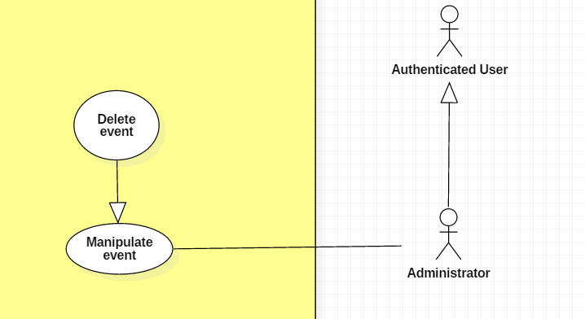

|  |  |  |  |
| --- | --- | --- | --- |
| **USE CASE – UC _A.15** | | | |
| **Usecase No.** | A.15 | **Usecase Version** | 1.0 |
| **Usecase Name** | Delete event | | |
| **Author** | KhanhNB | | |
| **Date** | 25/09/2018 | **Priority** | Normal |
| **Actor:**   * Administrator   **Summary:**   * This use case allows admin to delete an existing event.   **Goal:**   * The event is deleted from the database.   **Triggers:**   * Admin choose delete event   **Preconditions:**   * User must login into system with role Administrator. * Admin is viewing the Edit Event View of an article.   **Post Conditions:**   * **Success**: The event is deleted from the database. * **Fail**: Show error message.   **Main Success Scenario:**   |  |  |  | | --- | --- | --- | | **Step** | **Actor Action** | **System Response** | | 1 | Admin clicks “Delete event” | System displays a dialog for administrator to confirm, the dialog is displayed with message: Are you sure ?, with 2 buttons:   * Yes * No | | 2 | Admin clicks “Yes” button  [Alternative 1] | Event is deleted from database  System displays message “Event deleted successfully” |   **Alternative Scenario:**  Alternative Scenario 1: Admin clicks on “No” button   |  |  |  | | --- | --- | --- | | **Step** | **Actor Action** | **System Response** | | 1 | Admin clicks “Yes” button  [Alternative 1] | Dialog disappears and the admin can see the Edit Event View again. |   **Exceptions:**   |  |  |  | | --- | --- | --- | | **No** | **Cause** | **System Response** | | 1 | Article was already deleted | System shows error message. |   **Relationships:** N/A  **Business** **Rules**: N/A | | | |

**2.3.1.16. < Administrator > Approve trade request Usecase**

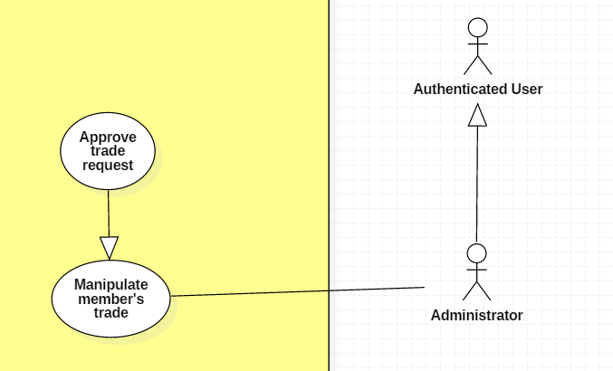

|  |  |  |  |
| --- | --- | --- | --- |
| **USE CASE – UC _A.16** | | | |
| **Usecase No.** | A.16 | **Usecase Version** | 1.0 |
| **Usecase Name** | Approve trade post request | | |
| **Author** | SangLNN | | |
| **Date** | 26/09/2018 | **Priority** | Normal |
| **Actor:**   * Administrators.   **Summary:**   * This use case allows administrator to approve a trade post request.   **Goal:**   * After administrator approved, the trade post will listing in trade market.   **Triggers:**   * Administrator sends approve trade command with trade id to the system.   **Preconditions:**   * User must login into system with role Administrator.   **Post Conditions:**   * **Success**: System show message approved successfully and the trade post will listing in trade market. * **Fail**: Show error message.   **Main Success Scenario:**   |  |  |  | | --- | --- | --- | | **Step** | **Actor Action** | **System Response** | | 1 | Administrator click “approve” button on request trade post list to sends approve trade post command.  [Alternative 1] | System show a modal to review trade post with message “Are you sure to cancel order?” and two option Y/N. | | 2 | Administrator confirm by click “Yes”  Administrator cancel by click “No”. | System show message the trade has approved.  Nothing has change. |   **Alternative Scenario:**  Alternative Scenario 1   |  |  |  | | --- | --- | --- | | **Step** | **Actor Action** | **System Response** | | 1 | Administrator click on “Reject” button on request trade post list. | System create view show a reject form with following labels and fields:   * Reason : text input, required, length 7 – 250. * Submit: button. | | 2 | Administrator fills out the form. |  | | 3 | Administrator click “submit” button on reject form to send reject trade post command. | Validate form.  [Exception 1]  System show message the trade post has been rejected and sends reason message to member who posted this trade. |   **Exceptions:**   |  |  |  | | --- | --- | --- | | **No** | **Cause** | **System Response** | | 1 | Administrator sends submit reject trade post command without fills out the form. | System shows error message to ask administrator enters missing required fields. |   **Relationships:** N/A  **Business** **Rules**: N/A | | | |

**2.3.1.17. < Administrator > Delete member’s exchange Usecase**

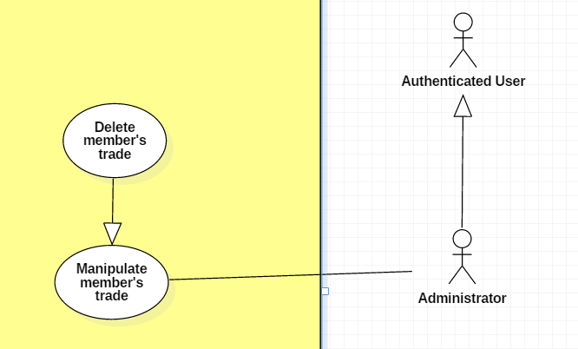

|  |  |  |  |
| --- | --- | --- | --- |
| **USE CASE – UC _A.17** | | | |
| **Usecase No.** | A.17 | **Usecase Version** | 1.0 |
| **Usecase Name** | Delete member trade post | | |
| **Author** | SangLNN | | |
| **Date** | 26/09/2018 | **Priority** | Normal |
| **Actor:**   * Administrators.   **Summary:**   * This use case allows administrator to delete a trade post.   **Goal:**   * When a trade post received to much report from users, administrator can review and delete this post.   **Triggers:**   * Administrator sends delete trade command with trade id to the system.   **Preconditions:**   * User must login into system with role Administrator.   **Post Conditions:**   * **Success**: System show message deleted successfully and show the reason to member who posted this post. * **Fail**: Show error message.   **Main Success Scenario:**   |  |  |  | | --- | --- | --- | | **Step** | **Actor Action** | **System Response** | | 1 | Administrator click “delete” button on reported trade post list. | System create view show a delete form with following labels and fields:   * Reason : text input, required, length 7 – 250. * Submit: button. | | 2 | Administrator fills out the form. |  | | 3 | Administrator click “Submit” on delete form to send delete trade post command. | Validate form.  [Exception 1]  System show message deleted successfully. |   **Alternative Scenario:** N/A  **Exceptions:**   |  |  |  | | --- | --- | --- | | **No** | **Cause** | **System Response** | | 1 | Administrator sends submit delete trade post command without fills out the form. | System shows error message to ask administrator enters missing required fields. |   **Relationships:** N/A  **Business** **Rules**: | | | |

**2.3.1.18. < Administrator > View all exchange history Usecase**

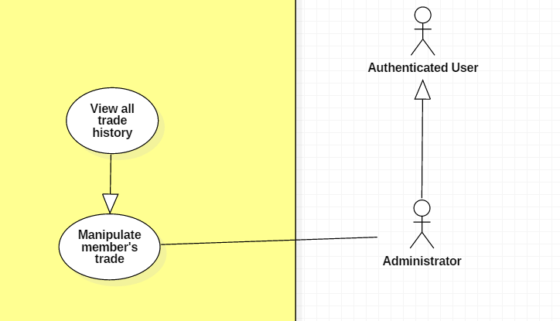

|  |  |  |  |
| --- | --- | --- | --- |
| **USE CASE – UC _A.18** | | | |
| **Usecase No.** | A.18 | **Usecase Version** | 1.0 |
| **Usecase Name** | View trade history | | |
| **Author** | SangLNN | | |
| **Date** | 26/09/2018 | **Priority** | Normal |
| **Actor:**   * Administrator.   **Summary:**   * This use case allows administrator view trade history.   **Goal:**   * Administrator will see all order history.   **Triggers:**   * Administrator sends view trade history command to the system.   **Preconditions:**   * User must login into system with role Administrator.   **Post Conditions:**   * **Success**: System show list of all order history. * **Fail**: Show error message.   **Main Success Scenario:**   |  |  |  | | --- | --- | --- | | **Step** | **Actor Action** | **System Response** | | 1 | Administrator click “view trade history” button on administrator panel to sends view trade history command. | System create view show a datatable contains all information about trade history. |   **Alternative Scenario:** N/A  **Exceptions:** N/A  **Relationships:** N/A  **Business** **Rules**:N/A | | | |

**2.3.2. < Authenticated User > Overview Usecase**

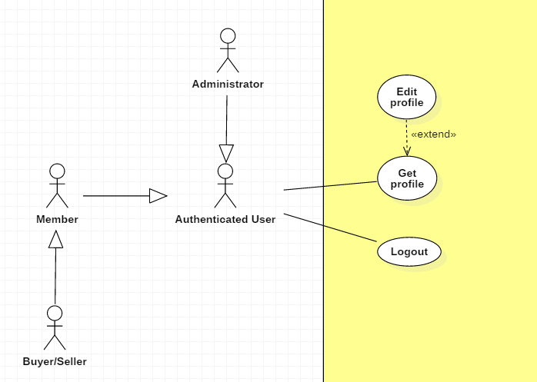

**2.3.2.1. < Authenticated User > Log out Usecase**

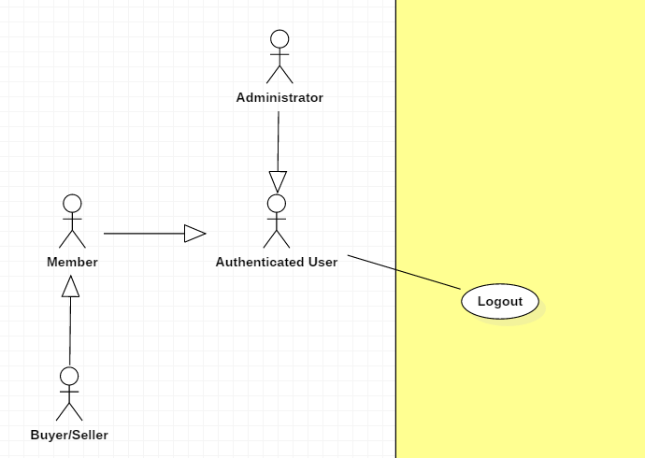

|  |  |  |  |
| --- | --- | --- | --- |
| **USE CASE – UC _AU.01** | | | |
| **Usecase No.** | AU.01 | **Usecase Version** | 1.0 |
| **Usecase Name** | Log out | | |
| **Author** | TungHNM | | |
| **Date** | 03/10/2018 | **Priority** | Normal |
| **Actor:**   * Authenticated User.   **Summary:**   * This use case allows authenticated user to logout the system.   **Goal:**   * User’s session is removed from the system.   **Triggers:**   * Authenticated user sends logout command to the system.   **Preconditions:**   * User logged in the system.   **Post Conditions:**   * **Success**: Authenticated user logs out with session is removed from system. * **Fail**: Show error message.   **Main Success Scenario:**   |  |  |  | | --- | --- | --- | | **Step** | **Actor Action** | **System Response** | | 1 | Authenticated user clicks on “Logout” button | Authenticated user exits the system |   **Alternative Scenario:** N/A  **Exceptions:** N/A  **Relationships:** N/A  **Business** **Rules**:   * If authenticated user is inactive in 30 minutes, system will automatically log authenticated user out. | | | |

**2.3.2.2. < Authenticated User > Get profile Usecase**

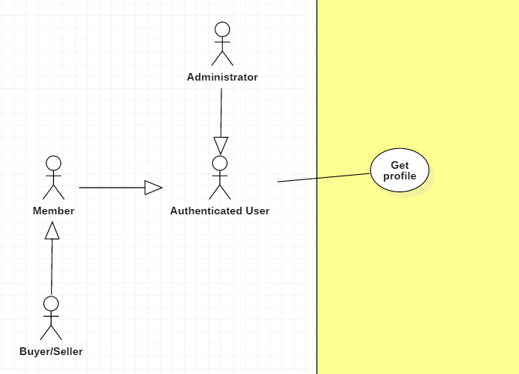

|  |  |  |  |
| --- | --- | --- | --- |
| **USE CASE – UC _AU.02** | | | |
| **Usecase No.** | AU.02 | **Usecase Version** | 1.0 |
| **Usecase Name** | Get profile | | |
| **Author** | TungHNM | | |
| **Date** | 03/10/2018 | **Priority** | Normal |
| **Actor:**   * Authenticated User.   **Summary:**   * This use case allows authenticated user to get his/her or other’s profile’s detail.   **Goal:**   * Authenticated user can get information from his/her or other’s profile’s detail.   **Triggers:**   * Authenticated user sends get profile command to the system.   **Preconditions:**   * User must login into the system.   **Post Conditions:**   * **Success**: User’s profile page is shown with information. * **Fail**: Show error message.   **Main Success Scenario:**   |  |  |  | | --- | --- | --- | | **Step** | **Actor Action** | **System Response** | | 1 | Authenticated user clicks on a user’s name | System displays the selected user’s profile page with the following labels and text:   * Avatar: img * Email: text * First Name: text * Middle Name: text * Last Name: text * Tel: text * Address: text * Birthday: text * Status: text |   **Alternative Scenario:** N/A  **Exceptions:** N/A  **Relationships:** N/A  **Business** **Rules**:N/A | | | |

**2.3.2.3. < Authenticated User > Edit profile Usecase**

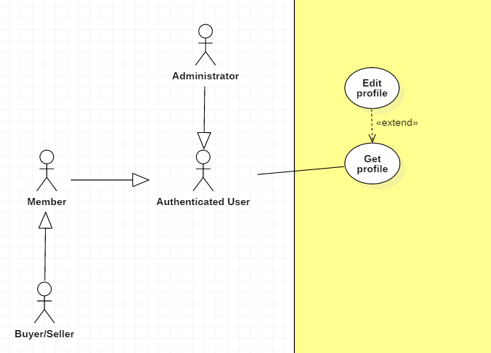

|  |  |  |  |
| --- | --- | --- | --- |
| **USE CASE – UC _AU.03** | | | |
| **Usecase No.** | AU.03 | **Usecase Version** | 1.0 |
| **Usecase Name** | Edit profile | | |
| **Author** | TungHNM | | |
| **Date** | 03/10/2018 | **Priority** | Normal |
| **Actor:**   * Authenticated User.   **Summary:**   * This use case allows authenticated user to update his/her profile information.   **Goal:**   * Authenticated User can edit his/her profile.   **Triggers:**   * Authenticated User sends edit profile command to the system.   **Preconditions:**   * User must login into system. * User’s profile page is displayed.   **Post Conditions:**   * **Success**: User’s information is updated. * **Fail**: Show error message.   **Main Success Scenario:**   |  |  |  | | --- | --- | --- | | **Step** | **Actor Action** | **System Response** | | 1 | Authenticated User clicks on “Edit profile” button | Edit Profile page is shown with following labels and fields:   * Email: text, required, max length: 50, RegEx: /^([a-z0-9_\.-]+)@([\da-z\.-]+)\.([a-z\.]{2,6})$/ * First Name: text, max length: 50 * Middle Name: text, max length: 50 * Last Name: text, max length: 50 * Tel: text, length: 10-11 * Address: text, max length: 250 * Birthday: DateTimePicker * Password: text, disabled * Status: text, disabled   System automatically fills out the form with information of the selected user’s profile in database . | | 2 | User fills out the form |  | | 3 | User clicks on “SAVE” button | Validate data.  [Exception 1, 2, 3, 4, 5]  Update account information to database  System displays Profile page with updated information. |   **Alternative Scenario:** N/A  **Exceptions:**   |  |  |  | | --- | --- | --- | | **No** | **Cause** | **System Response** | | 1 | Email does not match the required format: /^([a-z0-9_\.-]+)@([\da-z\.-]+)\.([a-z\.]{2,6})$/ | System shows error message: Invalid email ! | | 2 | Phone number is not string of number | System shows error message: Invalid phone number ! | | 3 | Email is duplicate in database | System shows error message: The email has been existed ! | | 4 | Missing of required fields | System shows message that notify user to input the missed fields | | 5 | Length of field’s value is out of range | System shows message that notify user which field’s value is out of range |   **Relationships:** N/A  **Business** **Rules**:   * User’s profile will be automatically filled out when Edit Account page is loaded or whenever an exception occurs. * In case of success scenarios, account’s information would be updated to the database and displays the profile page with updated information. * Tel must be string of numbers. * Email must not be duplicate in database. * An email address must be validated by this regular expression:   /^([a-z0-9_\.-]+)@([\da-z\.-]+)\.([a-z\.]{2,6})$/ | | | |

**2.3.3. < Guest > Overview Usecase**

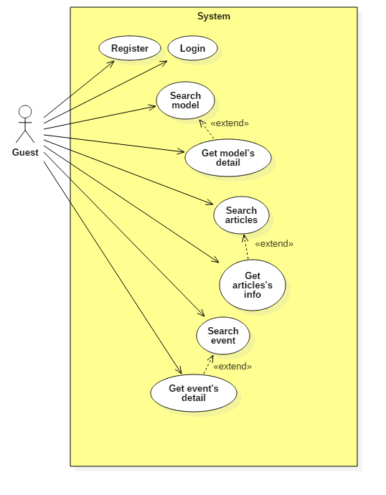

**2.3.3.1. < Guest > Register Usecase**

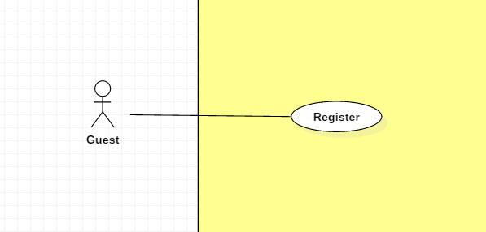

|  |  |  |  |
| --- | --- | --- | --- |
| **USE CASE – UC _G.01** | | | |
| **Usecase No.** | G.01 | **Usecase Version** | 1.0 |
| **Usecase Name** | Register | | |
| **Author** | TungHNM | | |
| **Date** | 03/10/2018 | **Priority** | Normal |
| **Actor:**   * Guest.   **Summary:**   * This use case allows guest to register to system.   **Goal:**   * System can recognize the new account. * User can login the system with role “Member”   **Triggers:**   * Guest sends register command to the system.   **Preconditions:** N/A  **Post Conditions:**   * **Success**: New account is added to the system with role “Member”. * **Fail**: Show error message.   **Main Success Scenario:**   |  |  |  | | --- | --- | --- | | **Step** | **Actor Action** | **System Response** | | 1 | Guest clicks on “Register” button | Register page is shown with following labels and fields:   * Username: tex, required, max length: 50 * Email: text, required, max length: 50, RegEx: /^([a-z0-9_\.-]+)@([\da-z\.-]+)\.([a-z\.]{2,6})$/ * Password: free text input, required, max length: 50 * Confirm password: free text input, required * First Name: text, max length: 50 * Last Name: text, max length: 50 | | 2 | Guest fills out the form |  | | 3 | Guest clicks on “SAVE” button | Validate data.  [Exception 1, 2, 3, 4, 5]  New account is added to system.  System displays message: Register successfully ! |   **Alternative Scenario:** N/A  **Exceptions:**   |  |  |  | | --- | --- | --- | | **No** | **Cause** | **System Response** | | 1 | Entered email does not match the required format: /^([a-z0-9_\.-]+)@([\da-z\.-]+)\.([a-z\.]{2,6})$/ | System shows error message: Invalid email ! | | 2 | Entered email is duplicate in database | System shows error message: The email has been existed ! | | 3 | Missing of required fields | System shows error message to notify guest to input missing fields | | 4 | Password and Confirm password don’t match | System shows error message: The password and confirm password don’t match ! | | 5 | Length of field’s value is out of range | System shows message that notify guest which field’s value is out of range | | 6 | Entered username is duplicate in database | System shows error message: Username has been existed ! |   **Relationships:** N/A  **Business** **Rules**:   * The entered password and confirm password must match to each other. * Email and username must not be duplicate in database. * An email address must be validated by this regular expression:   /^([a-z0-9_\.-]+)@([\da-z\.-]+)\.([a-z\.]{2,6})$/   * Password is encrypted before saving to database. * In case of success scenario, the account is created with default status: Member | | | |

**2.3.3.2. < Guest > Login Usecase**

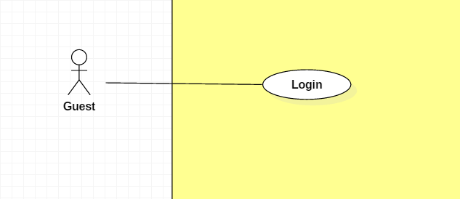

|  |  |  |  |
| --- | --- | --- | --- |
| **USE CASE – UC _G.02** | | | |
| **Usecase No.** | G.02 | **Usecase Version** | 1.0 |
| **Usecase Name** | Login | | |
| **Author** | TungHNM | | |
| **Date** | 03/10/2018 | **Priority** | Normal |
| **Actor:**   * Guest.   **Summary:**   * This use case allows guest to login into system.   **Goal:**   * New session is created.   **Triggers:**   * Guest sends login command to the system.   **Preconditions:** N/A  **Post Conditions:**   * **Success**: Guest logins into system successfully. * **Fail**: Show error message.   **Main Success Scenario:**   |  |  |  | | --- | --- | --- | | **Step** | **Actor Action** | **System Response** | | 1 | Guest clicks on “Login” button | Login page is shown with following labels and fields:   * Username: text, required, max length: 50 * Password: text, required, max length: 50 | | 2 | Guest fills out the form |  | | 3 | Guest clicks on “Login” button | Validate data.  [Exception 1, 2, 3, 4, 5, 6]  New account is added to system.  System displays message: Register successfully ! |   **Alternative Scenario:** N/A  **Exceptions:**   |  |  |  | | --- | --- | --- | | **No** | **Cause** | **System Response** | | 1 | Missing of required fields | System shows error message to notify guest to input missing fields | | 2 | Wrong username or password | System shows error message: Wrong username or password ! |   **Relationships:** N/A  **Business** **Rules**:   * After login to system, guest will be redirected to specific page based on their role on the system:   + If role is “Admin”: the system will display Admin Dashboard view.   + If role is “Member”: the system will display Customer view with homepage | | | |

**2.3.3.3. < Guest > Search model Usecase**

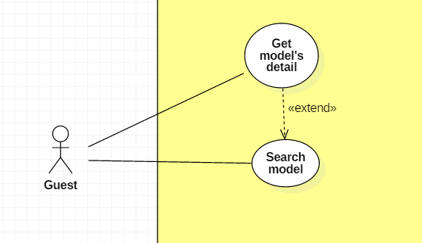

|  |  |  |  |
| --- | --- | --- | --- |
| **USE CASE – UC _G.03** | | | |
| **Usecase No.** | G.03 | **Usecase Version** | 1.0 |
| **Usecase Name** | Search model | | |
| **Author** | TungHNM | | |
| **Date** | 03/10/2018 | **Priority** | Normal |
| **Actor:**   * Guest.   **Summary:**   * This use case allows guest to search model.   **Goal:**   * Make it more convenient for guest to seek for gunpla information.   **Triggers:**   * Guest sends search model command to the system.   **Preconditions:**   * The search model page is displayed.   **Post Conditions:**   * **Success**: A list of matching records are shown. * **Fail**: Show error message.   **Main Success Scenario:**   |  |  |  | | --- | --- | --- | | **Step** | **Actor Action** | **System Response** | | 1 | Guest goes to search model view | System displays search model view with the following elements:   * Search navbar: free text input * SEARCH BY: dropdown list, includes values:   + All: default   + Product Series   + Series Title | | 1 | Guest clicks on search navbar | An text input is displayed with border blue and placeholder: Please input keyword | | 2 | Guest fills out the input text  [Alternative 1]  [Alternative 2] |  | | 3 | Guest clicks on “SEARCH” button or press Enter  [Alternative 4]  [Alternative 5] | A list of matching models by name and Product Series or Series Title based on SEARCH BY filters will be displayed on the view with pagination and sorting filters.  [Alternative 3] |   **Alternative Scenario:**  **Alternative Scenario 1: Choose option “Product Series” in SEARCH BY dropdown list**   |  |  |  | | --- | --- | --- | | **Step** | **Actor Action** | **System Response** | | 1 | Guest clicks on option “Product Series” in SEARCH BY dropdown list | System displays a dropdown list next by with values as all ProductSeries in database. |   **Alternative Scenario 2: Choose option “GUNDAM SERIES” in SEARCH BY dropdown list**   |  |  |  | | --- | --- | --- | | **Step** | **Actor Action** | **System Response** | | 1 | Guest clicks on option “Series Title” in SEARCH BY dropdown list | System displays a dropdown list next by with values as all SeriesTitle in database. |   **Alternative Scenario 3: No matching records**   |  |  |  | | --- | --- | --- | | **Step** | **Actor Action** | **System Response** | | 1 | Guest clicks on “SEARCH” button or press Enter | There is no matching records and system displays message No matching records ! |   **Alternative Scenario 4: Click on a record**   |  |  |  | | --- | --- | --- | | **Step** | **Actor Action** | **System Response** | | 1 | Guest clicks on a record in the list | System view model detail page of the selected model. |   **Alternative Scenario 5: Choose filter “Order by” options**   |  |  |  | | --- | --- | --- | | **Step** | **Actor Action** | **System Response** | | 1 | Guest chooses an option in filter “Order by” dropdown list and option “Ascending” next by | System sorts the list records by ascending order follow with the option in “Order by” dropdown list. | | 2 | Guest chooses option “Descending” | System sorts the list records by descending order follow with the option in “Order by” dropdown list. |   **Exceptions:** N/A  **Relationships:** N/A  **Business** **Rules**:   * A dropdown list with all product series values will displayed when guest clicks on option “Product Series” in SEARCH BY dropdown list * A dropdown list with all series title values will displayed when guest clicks on option “Series Title” in SEARCH BY dropdown list * Category dropdown list or gundam series dropdown list will disappear when guest clicks on option “All” in SEARCH BY dropdown list * System search models by name matching with the keyword input from guest * A list of records will go with pagination and sorting filters | | | |

**2.3.3.4. < Guest > Get model’s detail Usecase**

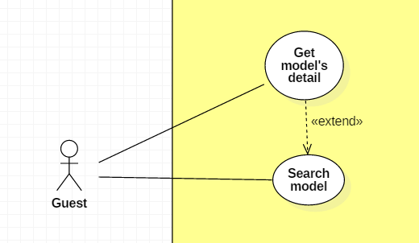

|  |  |  |  |
| --- | --- | --- | --- |
| **USE CASE – UC _G.04** | | | |
| **Usecase No.** | G.04 | **Usecase Version** | 1.0 |
| **Usecase Name** | Get model’s detail | | |
| **Author** | TungHNM | | |
| **Date** | 03/10/2018 | **Priority** | Normal |
| **Actor:**   * Guest.   **Summary:**   * This use case allows guest user to get model’s information detail.   **Goal:**   * Guest can get information from models.   **Triggers:**   * Guest sends get model’s detail command to the system.   **Preconditions:** N/A  **Post Conditions:**   * **Success**: Model’s detail page is shown with information. * **Fail**: Show error message.   **Main Success Scenario:**   |  |  |  | | --- | --- | --- | | **Step** | **Actor Action** | **System Response** | | 1 | Guest clicks on a model and goes to model detail view | System displays the selected model’s detail page with the following labels and text:   * Big image: img * Manufacturer: text * Scale: text * Series: text * Released Date: text * Price: text * Description: text   System displays a slideshow of images divided into following categories:   * Package * Item picture * Other picture * Contents * About item * Color * Assembly guide |   **Alternative Scenario:** N/A  **Exceptions:** N/A  **Relationships:** N/A  **Business** **Rules**:N/A | | | |

**2.3.3.5. < Guest > Search articles Usecase**

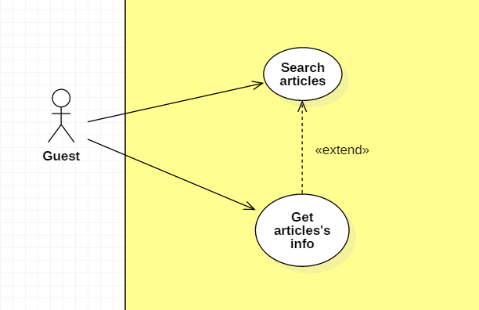

|  |  |  |  |
| --- | --- | --- | --- |
| **USE CASE – UC _G.05** | | | |
| **Usecase No.** | G.05 | **Usecase Version** | 1.0 |
| **Usecase Name** | Search articles | | |
| **Author** | Khanhnb | | |
| **Date** | 03/10/2018 | **Priority** | Normal |
| **Actor:**   * Guest.   **Summary:**   * This use case allows guest to search articles.   **Goal:**   * Make it more convenient for guest to seek for article.   **Triggers:**   * Guest sends search news command to the system.   **Preconditions:**   * The search model news page is displayed.   **Post Conditions:**   * **Success**: A list of matching records are shown. * **Fail**: Show error message.   **Main Success Scenario:**   |  |  |  | | --- | --- | --- | | **Step** | **Actor Action** | **System Response** | | 1 | Guest goes to search news view | System displays search news view with the following elements:   * Search bar: free text input * SEARCH BY: article’s title | | 2 | Guest fills out the input text |  | | 3 | Guest clicks on “SEARCH” button or press Enter | A list of articles with matching titles is shown |   **Alternative Scenario:**  N/A  **Exceptions:** N/A  **Relationships:** N/A  **Business** **Rules**:   * System search article by title matching with the keyword input from guest * A list of records will go with pagination and sorting filters | | | |

**2.3.3.6. < Guest > Get articles’s info Usecase**



|  |  |  |  |
| --- | --- | --- | --- |
| **USE CASE – UC _G.06** | | | |
| **Usecase No.** | G.06 | **Usecase Version** | 1.0 |
| **Usecase Name** | Get articles’s info | | |
| **Author** | Khanhnb | | |
| **Date** | 03/10/2018 | **Priority** | Normal |
| **Actor:**   * Guest.   **Summary:**   * This use case allows guest to get an article’s info.   **Goal:**   * Display an article’s content   **Triggers:**   * Guest sends get news’s detail command to the system.   **Preconditions:**   * Guest select a article from the list of articles.   **Post Conditions:**   * **Success**: The matching record is shown. * **Fail**: Show error message.   **Main Success Scenario:**   |  |  |  | | --- | --- | --- | | **Step** | **Actor Action** | **System Response** | | 1 | Guest clicks on a model and goes to model detail view | System displays news’s detail view with the following elements:   * The title of the article: text * The article’s content |   **Alternative Scenario:**  N/A  **Exceptions:** N/A  **Relationships:** N/A  **Business** **Rules**:  N/A | | | |

**2.3.4. < Member > Overview Usecase**

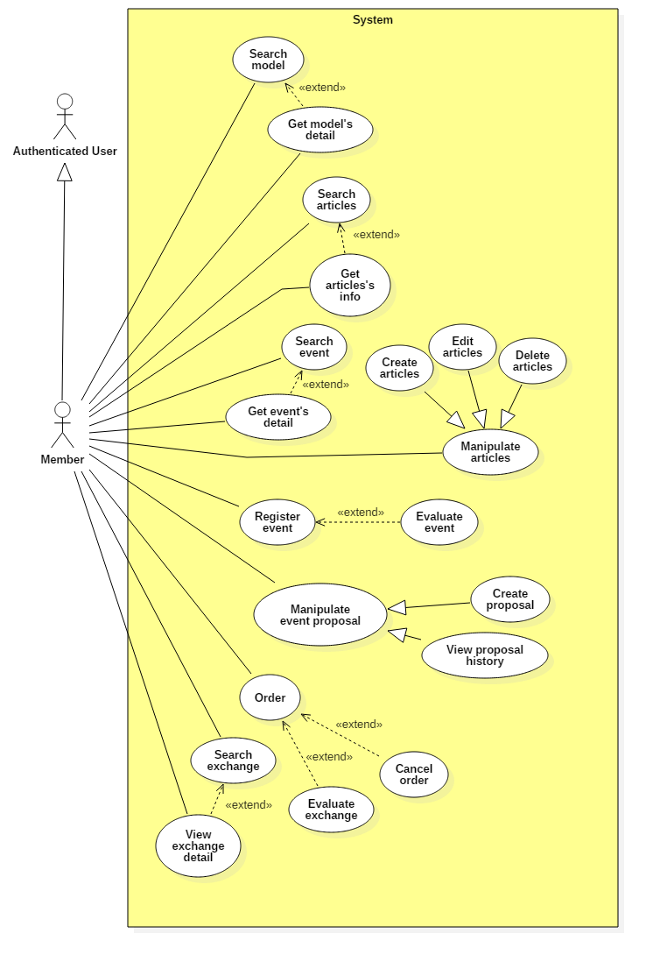

**2.3.4.1. < Member > Search model Usecase**

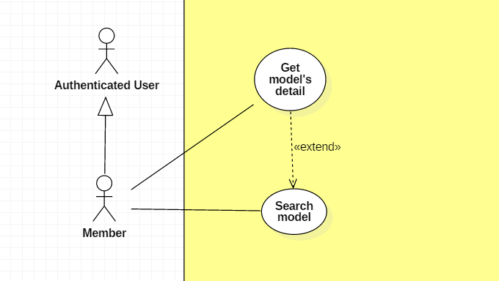

|  |  |  |  |
| --- | --- | --- | --- |
| **USE CASE – UC _M.01** | | | |
| **Usecase No.** | M.01 | **Usecase Version** | 1.0 |
| **Usecase Name** | Search model | | |
| **Author** | TungHNM | | |
| **Date** | 03/10/2018 | **Priority** | Normal |
| **Actor:**   * Member.   **Summary:**   * This use case allows member to search model.   **Goal:**   * Make it more convenient for member to seek for gunpla information.   **Triggers:**   * Member sends search model command to the system.   **Preconditions:**   * The search model page is displayed.   **Post Conditions:**   * **Success**: A list of matching records are shown. * **Fail**: Show error message.   **Main Success Scenario:**   |  |  |  | | --- | --- | --- | | **Step** | **Actor Action** | **System Response** | | 1 | Member goes to search model view | System displays search model view with the following elements:   * Search navbar: free text input * SEARCH BY: dropdown list, includes values:   + All: default   + Product Series   + Series Title | | 1 | Member clicks on search navbar | An text input is displayed with border blue and placeholder: Enter a search term | | 2 | Member fills out the input text  [Alternative 1]  [Alternative 2] |  | | 3 | Member clicks on “SEARCH” button or press Enter  [Alternative 4]  [Alternative 5] | A list of matching models by name and Product Series or Series Title based on SEARCH BY filters will be displayed on the view with pagination and sorting filters.  [Alternative 3] |   **Alternative Scenario:**  **Alternative Scenario 1: Choose option “Product Series” in SEARCH BY dropdown list**   |  |  |  | | --- | --- | --- | | **Step** | **Actor Action** | **System Response** | | 1 | Member clicks on option “Product Series” in SEARCH BY dropdown list | System displays a dropdown list next by with values as all ProductSeries in database. |   **Alternative Scenario 2: Choose option “GUNDAM SERIES” in SEARCH BY dropdown list**   |  |  |  | | --- | --- | --- | | **Step** | **Actor Action** | **System Response** | | 1 | Member clicks on option “Series Title” in SEARCH BY dropdown list | System displays a dropdown list next by with values as all SeriesTitle in database. |   **Alternative Scenario 3: No matching records**   |  |  |  | | --- | --- | --- | | **Step** | **Actor Action** | **System Response** | | 1 | Member clicks on “SEARCH” button or press Enter | There is no matching records and system displays message No matching records ! |   **Alternative Scenario 4: Click on a record**   |  |  |  | | --- | --- | --- | | **Step** | **Actor Action** | **System Response** | | 1 | Member clicks on a record in the list | System view model detail page of the selected model. |   **Alternative Scenario 5: Choose filter “Order by” options**   |  |  |  | | --- | --- | --- | | **Step** | **Actor Action** | **System Response** | | 1 | Guest chooses an option in filter “Order by” dropdown list and option “Ascending” next by | System sorts the list records by ascending order follow with the option in “Order by” dropdown list. | | 2 | Guest chooses option “Descending” | System sorts the list records by descending order follow with the option in “Order by” dropdown list. |   **Exceptions:** N/A  **Relationships:** N/A  **Business** **Rules**:   * A dropdown list with all product series values will displayed when guest clicks on option “Product Series” in SEARCH BY dropdown list * A dropdown list with all series title values will displayed when guest clicks on option “Series Title” in SEARCH BY dropdown list * Category dropdown list or gundam series dropdown list will disappear when guest clicks on option “All” in SEARCH BY dropdown list * System search models by name matching with the keyword input from guest * A list of records will go with pagination and sorting filters | | | |

**2.3.4.2. < Member > Get model’s detail Usecase**



|  |  |  |  |
| --- | --- | --- | --- |
| **USE CASE – UC _M.02** | | | |
| **Usecase No.** | M.02 | **Usecase Version** | 1.0 |
| **Usecase Name** | Get model’s detail | | |
| **Author** | TungHNM | | |
| **Date** | 03/10/2018 | **Priority** | Normal |
| **Actor:**   * Member.   **Summary:**   * This use case allows member to get model’s information detail.   **Goal:**   * Member can get information from models.   **Triggers:**   * Member sends get model’s detail command to the system.   **Preconditions:** N/A  **Post Conditions:**   * **Success**: Model’s detail page is shown with information. * **Fail**: Show error message.   **Main Success Scenario:**   |  |  |  | | --- | --- | --- | | **Step** | **Actor Action** | **System Response** | | 1 | Member clicks on a model and goes to model detail view | System displays the selected model’s detail page with the following labels and text:   * Big image: img * Manufacturer: text * Scale: text * Series: text * Released Date: text * Price: text * Description: text   System displays a slideshow of images divided into following categories:   * Package * Item picture * Other picture * Contents * About item * Color * Assembly guide |   **Alternative Scenario:** N/A  **Exceptions:** N/A  **Relationships:** N/A  **Business** **Rules**:N/A | | | |

**2.3.4.3. < Member > Search articles Usecase**

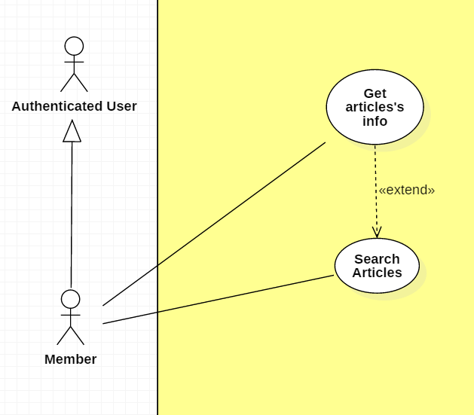

|  |  |  |  |
| --- | --- | --- | --- |
| **USE CASE – UC _M.03** | | | |
| **Usecase No.** | M.03 | **Usecase Version** | 1.0 |
| **Usecase Name** | Search articles | | |
| **Author** | Khanhnb | | |
| **Date** | 03/10/2018 | **Priority** | Normal |
| **Actor:**   * Guest.   **Summary:**   * This use case allows member to search articles.   **Goal:**   * Make it more convenient for member to seek for article.   **Triggers:**   * Member sends search news command to the system.   **Preconditions:**   * The search news page is displayed.   **Post Conditions:**   * **Success**: A list of matching records are shown. * **Fail**: Show error message.   **Main Success Scenario:**   |  |  |  | | --- | --- | --- | | **Step** | **Actor Action** | **System Response** | | 1 | Member goes to search news view | System displays search news view with the following elements:   * Search bar: free text input * SEARCH BY: article’s title | | 2 | Member fills out the input text |  | | 3 | Member clicks on “SEARCH” button or press Enter | A list of articles with matching titles is shown |   **Alternative Scenario:**  N/A  **Exceptions:** N/A  **Relationships:** N/A  **Business** **Rules**:   * System search article by title matching with the keyword input from guest * A list of records will go with pagination and sorting filters | | | |

**2.3.4.4. < Member > Get articles’s info Usecase**



|  |  |  |  |
| --- | --- | --- | --- |
| **USE CASE – UC _M.04** | | | |
| **Usecase No.** | M.04 | **Usecase Version** | 1.0 |
| **Usecase Name** | Get articles’s info | | |
| **Author** | Khanhnb | | |
| **Date** | 03/10/2018 | **Priority** | Normal |
| **Actor:**   * Member .   **Summary:**   * This use case allows Member to get an article’s info.   **Goal:**   * Display an article’s content   **Triggers:**   * Member sends get news’s detail command to the system.   **Preconditions:**   * Member select a article from the list of articles.   **Post Conditions:**   * **Success**: The matching record is shown. * **Fail**: Show error message.   **Main Success Scenario:**   |  |  |  | | --- | --- | --- | | **Step** | **Actor Action** | **System Response** | | 1 | Member click on a article and goes to article detail view | System displays news’s detail view with the following elements:   * The title of the article: text * The article’s content |   **Alternative Scenario:**  N/A  **Exceptions:** N/A  **Relationships:** N/A  **Business** **Rules**:  N/A | | | |

**2.3.4.5. < Administrator > Create article Usecase**

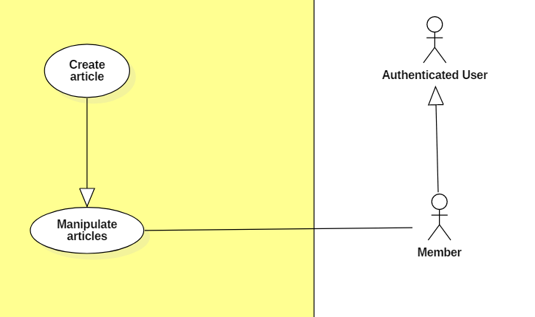

|  |  |  |  |
| --- | --- | --- | --- |
| **USE CASE – UC _A.09** | | | |
| **Usecase No.** | A.09 | **Usecase Version** | 1.0 |
| **Usecase Name** | Create articles | | |
| **Author** | KhanhNB | | |
| **Date** | 25/09/2018 | **Priority** | Normal |
| **Actor:**   * Administrator   **Summary:**   * This use case allows user to create a new article.   **Goal:**   * A new article added to the database system.   **Triggers:**   * Admin write an articles and submit it.   **Preconditions:**   * User must login into system with role Member.   **Post Conditions:**   * **Success**: New article is added to the database system. * **Fail**: Show error message.   **Main Success Scenario:**   |  |  |  | | --- | --- | --- | | **Step** | **Actor Action** | **System Response** | | 1 | Member go to “Create a new article” page | “Create new article” view is shown with following labels and fields:   * Input field for article’s Title * A textarea using CKEditor library * Submit button | | 2 | Member fills out the form. |  | | 3 | Member submit article. | Add new article the database.  System shows message saying “Article submitted! Please wait for admin’s approval!” with a link to the article. |   **Alternative Scenario:**  N/A  **Exceptions:**   |  |  |  | | --- | --- | --- | | **No** | **Cause** | **System Response** | | 1 | Member submit article with empty content | System shows error message to ask the admin to enters missing required fields. | | 2 | Member upload file too large. | System shows error message to ask the admin to upload correct required file size. |   **Relationships:** N/A  **Business** **Rules**:   * In case of success scenarios, a new article would be posted to the database. * Article id is automatically initialized by the system. File upload must be file type of images: *.jpeg, *.jpg, *.png, *.gif. | | | |

**2.3.4.5. < Member > Edit articles Usecase**

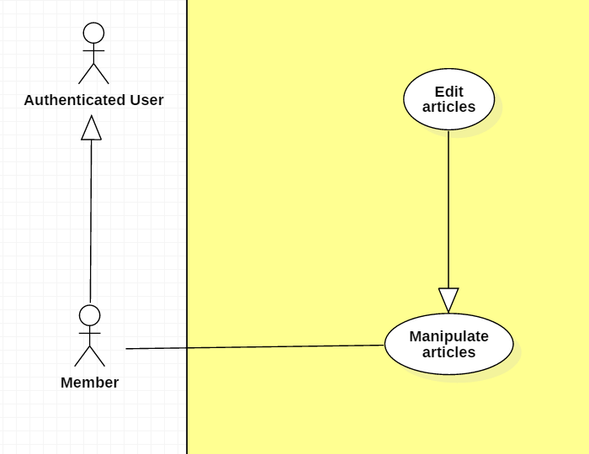

|  |  |  |  |
| --- | --- | --- | --- |
| **USE CASE – UC _M.05** | | | |
| **Usecase No.** | M.05 | **Usecase Version** | 1.0 |
| **Usecase Name** | Edit articles | | |
| **Author** | KhanhNB | | |
| **Date** | 25/09/2018 | **Priority** | Normal |
| **Actor:**   * Member   **Summary:**   * This use case allows member to edit an articles.   **Goal:**   * The articles is updated in database   **Triggers:**   * Member edit an article and submit it.   **Preconditions:**   * User must login into system with role Member. * Member viewing an article that they posted * Member selects “Edit article”   **Post Conditions:**   * **Success**: New article is updated in the database system. * **Fail**: Show error message.   **Main Success Scenario:**   |  |  |  | | --- | --- | --- | | **Step** | **Actor Action** | **System Response** | | 1 | Member go to “Edit article” page | “Edit” view is shown with following labels and fields:   * Input field for article’s Title * A textarea using CKEditor library with the existing data * Submit button * Delete article button | | 2 | Member fills out the form. |  | | 3 | Member submit article. | System update the article in the database |   **Alternative Scenario:**  N/A  **Exceptions:**   |  |  |  | | --- | --- | --- | | **No** | **Cause** | **System Response** | | 1 | Admin submit article with empty content | System shows error message to ask the admin to enters missing required fields. | | 2 | Admin upload file too large. | System shows error message to ask the admin to upload correct required file size. |   **Relationships:** N/A  **Business** **Rules**:   * In case of success scenarios, the article would be updated in the database. * Article id is automatically initialized by the system. File upload must be file type of images: *.jpeg, *.jpg, *.png, *.gif. * Member can only edit articles they posted | | | |

**2.3.4.6. < Member > Delete articles Usecase**

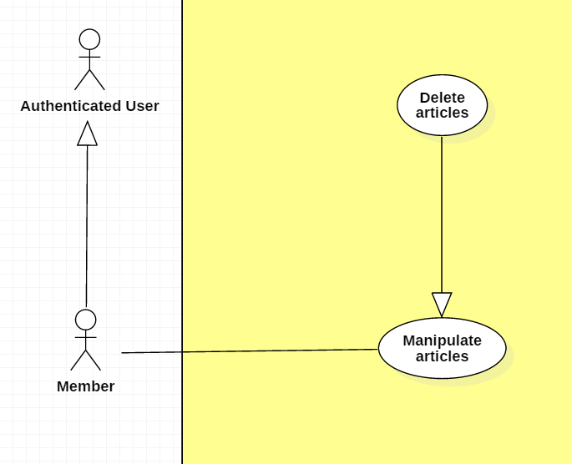

|  |  |  |  |
| --- | --- | --- | --- |
| **USE CASE – UC _M.06** | | | |
| **Usecase No.** | M.06 | **Usecase Version** | 1.0 |
| **Usecase Name** | Delete articles | | |
| **Author** | KhanhNB | | |
| **Date** | 25/09/2018 | **Priority** | Normal |
| **Actor:**   * Member   **Summary:**   * This use case allows member to delete an articles.   **Goal:**   * The article is deleted from the database   **Triggers:**   * Member select “Delete article”   **Preconditions:**   * User must login into system with role Member. * Member viewing an article that they posted * Member selects “Delete article”   **Post Conditions:**   * **Success**: New article is updated in the database system. * **Fail**: Show error message.   **Main Success Scenario:**   |  |  |  | | --- | --- | --- | | **Step** | **Actor Action** | **System Response** | | 1 | Member select “Delete Article” | System displays a dialog for member to confirm, the dialog is displayed with message: Are you sure ?, with 2 buttons:   * Yes * No | | 2 | Member selects “Yes” | System deletes the article from database.  Message saying “This article was deleted successfully” |   **Alternative Scenario:**   |  |  |  | | --- | --- | --- | | 1 | Member selects “No” | The dialog disappears, member sees the detail page again. |   **Exceptions:**   |  |  |  | | --- | --- | --- | | **No** | **Cause** | **System Response** | | 1 | Article was already deleted | System shows error message “This article has been already deleted” |   **Relationships:** N/A  **Business** **Rules**:   * In case of success scenarios, the article would be deleted from the database. * Member can only delete articles they posted | | | |

**2.3.4.7. < Member > Search event Usecase**

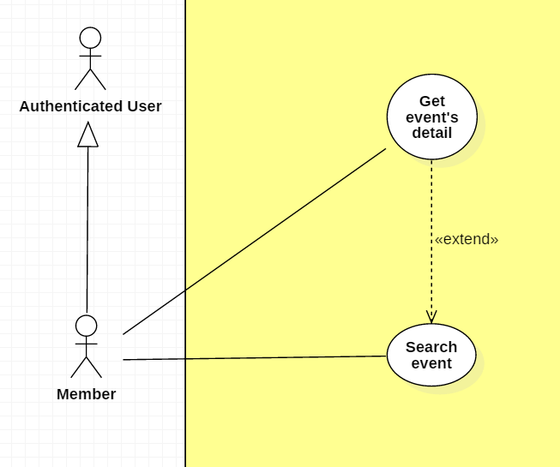

|  |  |  |  |
| --- | --- | --- | --- |
| **USE CASE – UC _M.07** | | | |
| **Usecase No.** | M.07 | **Usecase Version** | 1.0 |
| **Usecase Name** | Search event | | |
| **Author** | KhanhNB | | |
| **Date** | 25/09/2018 | **Priority** | Normal |
| **Actor:**   * Member   **Summary:**   * This use case allows member to search for events.   **Goal:**   * Allow member to see a list of events posted on the website   **Triggers:**   * Member search for even   **Preconditions:**   * User must login into system with role Member. * Member selects “Edit article” * Member must be the author of this article   **Post Conditions:**   * **Success**: New article is updated in the database system. * **Fail**: Show error message.   **Main Success Scenario:**   |  |  |  | | --- | --- | --- | | **Step** | **Actor Action** | **System Response** | | 1 | Member go to “Edit article” page | “Edi article” view is shown with following labels and fields:   * Input field for article’s Title * A textarea using CKEditor library with the existing data * Submit button | | 2 | Member fills out the form. |  | | 3 | Member submit article. | Validate data.  System update the article in the database |   **Alternative Scenario:**  N/A  **Exceptions:**   |  |  |  | | --- | --- | --- | | **No** | **Cause** | **System Response** | | 1 | Member submit article with empty content | System shows error message to ask the admin to enters missing required fields. | | 2 | Member upload file too large. | System shows error message to ask the admin to upload correct required file size. |   **Relationships:** N/A  **Business** **Rules**:   * In case of success scenarios, the article would be updated in the database. * Article id is automatically initialized by the system. File upload must be file type of images: *.jpeg, *.jpg, *.png, *.gif. | | | |

**2.3.4.8. < Member > Register event Usecase**

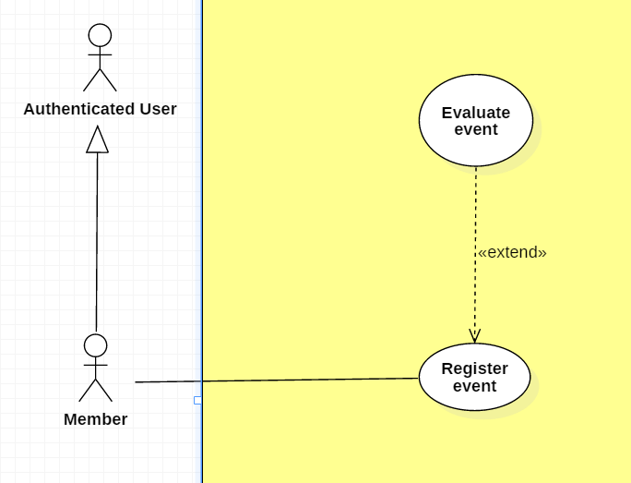

|  |  |  |  |
| --- | --- | --- | --- |
| **USE CASE – UC _M.08** | | | |
| **Usecase No.** | M.08 | **Usecase Version** | 1.0 |
| **Usecase Name** | Register event | | |
| **Author** | Khanhnb | | |
| **Date** | 03/10/2018 | **Priority** | Normal |
| **Actor:**   * Member .   **Summary:**   * This use case allows Member to register to an event   **Goal:**   * The member is added to the event’s attendee list   **Triggers:**   * Member select “Register” while viewing an event’s detail   **Preconditions:**   * Member is viewing an event’s detail   **Post Conditions:**   * **Success**: Member successfully register to an event, member’s id is added to the list of attendees * **Fail**: Show error message.   **Main Success Scenario:**   |  |  |  | | --- | --- | --- | | **Step** | **Actor Action** | **System Response** | | 1 | Member is in Event detail View of an event that requires payment  [Alternative 1] | “Event detail” view is shown with following labels and fields:   * The event’s info is displayed * Card number text input * Number of tickets text input * Register button | | 2 | Member fill all required form |  | | 3 | Member click “Register” | System add member to the list of attendees  A message saying “You’ve been added to the list of attendees” shows. |   **Alternative Scenario:**  Alternative Scenario 1:   |  |  |  | | --- | --- | --- | | **Step** | **Actor Action** | **System Response** | | 1 | Member is in Event detail View of an event that doesn’t requires payment | “Event detail” view is shown with following labels and fields:   * The event’s info is displayed * Number of tickets text input * Register button | | 2 | Member fill all required form |  | | 3 | Member click “Register” | System add member to the list of attendees  A message saying “You’ve been added to the list of attendees” shows. |   **Exceptions:**   |  |  |  | | --- | --- | --- | | **No** | **Cause** | **System Response** | | 1 | Card number or card owner’s name is invalid | System shows Popup saying “Card is invalid! | | 2 | Number of tickets the user entered exceeds the amount of remaining tickets for that event | A message saying “The number of tickets you’ve entered exceeds the remaining tickets amount!” shows. |   **Relationships:** N/A  **Business** **Rules**:   * The system will check for the card’s validity to see if it’s real | | | |

**2.3.4.9. < Member > Evaluate event Usecase**



|  |  |  |  |
| --- | --- | --- | --- |
| **USE CASE – UC _M.09** | | | |
| **Usecase No.** | M.09 | **Usecase Version** | 1.0 |
| **Usecase Name** | Evaluate event | | |
| **Author** | Khanhnb | | |
| **Date** | 03/10/2018 | **Priority** | Normal |
| **Actor:**   * Member .   **Summary:**   * This use case allows Member to evaluate to an event   **Goal:**   * The member can evaluate to show their satisfactory   **Triggers:**   * Member evaluate the event   **Preconditions:**   * User is logged in with the role “Member” * User is in the event’s list of attendees   **Post Conditions:**   * **Success**: Member successfully register to an event, member’s id is added to the list of attendees * **Fail**: Show error message.   **Main Success Scenario:**   |  |  |  | | --- | --- | --- | | **Step** | **Actor Action** | **System Response** | | 1 | Member select the star ratings | System save the member’s rating and use it to calculate the average rating for that event. |   **Alternative Scenario:** N/A  **Exceptions:** N/A  **Relationships:** N/A  **Business** **Rules**:   * The ratings range from 1 to 5 stars * The member’s rating is saved and the system will add that to the total number of rating that event has and calculate the average accordingly. | | | |

**2.3.4.10. < Member > Search exchange Usecase**

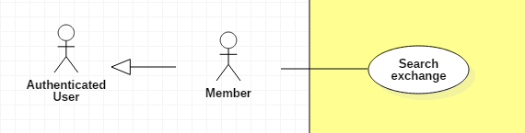

|  |  |  |  |
| --- | --- | --- | --- |
| **USE CASE – UC _M.10** | | | |
| **Usecase No.** | M.10 | **Usecase Version** | 1.0 |
| **Usecase Name** | Search a Trade | | |
| **Author** | SangLNN | | |
| **Date** | 26/09/2018 | **Priority** | Normal |
| **Actor:**   * Member.   **Summary:**   * This use case allows member or guest search a trade by keyword and distance.   **Goal:**   * System create view to show search result.   **Triggers:**   * User sends search a trade command with keyword and distance to the system.   **Preconditions:**   * User must on website page.   **Post Conditions:**   * **Success**: System create view to show all result matching keyword and distance. * **Fail**: Show error message.   **Main Success Scenario:**   |  |  |  | | --- | --- | --- | | **Step** | **Actor Action** | **System Response** | | 1 | User click on “Trade market” link from header navbar or “Trade listing” on trade market page to send list all trade command. | System create a view show search form with following fields:   * Search input: text input , required. * “More” button   [Alternative Scenario 1] | | 2 | User type keyword and press enter to send search command. | [Exception 1]  - System create a view show all result.  - Fillter  [Alternative Scenario 2]  - Group by  [Alternative Scenario 3] |   **Alternative Scenario:**  Alternative Scenario 1: Search with location and range   |  |  |  | | --- | --- | --- | | **Step** | **Actor Action** | **System Response** | | 1 | User click on “more” button. | System will show additional search form with following labels and fields:   * Search with location and form: radio button. * Location: text input, readonly. * Change your location: button. * Range: range input, required, min value: 500, max value: 20000. | | 2 | User fills out the form. |  | | 3 | User type keyword and press enter to send search command. | [Exception 1]  - System create a view show all result.  - Fillter  [Alternative Scenario 2]  - Group by  [Alternative Scenario 3] |   Alternative Scenario 2 : Fillter Scenario.   |  |  |  | | --- | --- | --- | | **Step** | **Actor Action** | **System Response** | | 1 | User select on fillter option send fillter command. | System will list trade post sorting by user selected option. |   Alternative Scenario 3 : Group by Scenario.   |  |  |  | | --- | --- | --- | | **Step** | **Actor Action** | **System Response** | | 1 | User select on tab group option send group by command. | System will list trade post group by user selected option. |   **Exceptions:**   |  |  |  | | --- | --- | --- | | **No** | **Cause** | **System Response** | | 1 | No result found. | System shows message no result found. |   **Relationships:** N/A  **Business** **Rules**:   * Short information per post contains: Cover image, title, condition, trade type, price, brand, model. * Result list will show in datatables with pagination and 5 trade post per page. * Have 3 grouping tab: All, Selling , Buying. * Have 4 fillter: Date descending, Date ascending, Price descending, price ascending. | | | |

**2.3.4.11. < Member > View exchange detail Usecase**

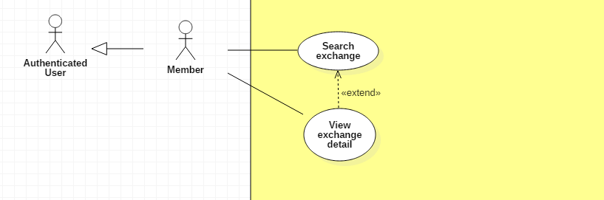

|  |  |  |  |
| --- | --- | --- | --- |
| **USE CASE – UC _M.11** | | | |
| **Usecase No.** | M.11 | **Usecase Version** | 1.0 |
| **Usecase Name** | View trade details | | |
| **Author** | SangLNN | | |
| **Date** | 26/09/2018 | **Priority** | Normal |
| **Actor:**   * Member.   **Summary:**   * This use case allows member or guest view trade post details.   **Goal:**   * System create view to show all information for trade post.   **Triggers:**   * User sends view trade command with trade post id to the system.   **Preconditions:**   * User must on website page.   **Post Conditions:**   * **Success**: System create view to show all information for trade post. * **Fail**: Show error message.   **Main Success Scenario:**   |  |  |  | | --- | --- | --- | | **Step** | **Actor Action** | **System Response** | | 1 | User or Guest click on trade post link from trade post list to send view trade details command. | System get all information from database and create a view show informatiom in 3 section:  Product information section:   * Photo slide show * Price * Title * Trade id * Date posted * Location * Type of trade * Brand * Model * Quantity * Rating * “Send order” button. * Share this post.   Trader information section:   * Delivery * More trade by owner * Print this trade * Send to friend * Save as Favorite * Report this trade   Description section:   * Description |   **Alternative Scenario:** N/A  **Exceptions:** N/A  **Relationships:** N/A  **Business** **Rules**: N/A | | | |

**2.3.4.12. < Member > Order Usecase**

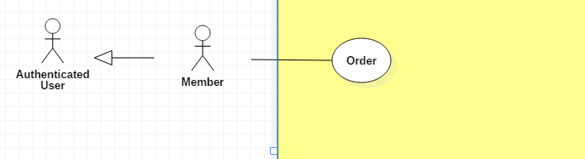

|  |  |  |  |
| --- | --- | --- | --- |
| **USE CASE – UC _M.12** | | | |
| **Usecase No.** | M.12 | **Usecase Version** | 1.0 |
| **Usecase Name** | Order a trade | | |
| **Author** | SangLNN | | |
| **Date** | 26/09/2018 | **Priority** | Normal |
| **Actor:**   * Member.   **Summary:**   * This use case allows member to order a trade.   **Goal:**   * User can get request order one trade post to trade post owner and wating them to accept request.   **Triggers:**   * User sends order trade command with trade post id to the system.   **Preconditions:**   * User must login into system with role Member. * Member need complete all feedback request to send order.   **Post Conditions:**   * **Success**: System notify to trade post owner the request order. * **Fail**: Show error message.   **Main Success Scenario:**   |  |  |  | | --- | --- | --- | | **Step** | **Actor Action** | **System Response** | | 1 | User click “Send order” button on trade post detail view. | System create view show a order form with following labels and fields:   * Quantity: Number, required, positive integer and bellow than 1000. * Billing information: button * Cancel order: button   [Alternative scenario 1] | | 2 | User fills out the form and click “Billing information” button | Validate quantity data.  [Exception 1]  System create view show billing information form with following labels and fields:   * Full name: text, required, length 3 - 50 * Phone number: text, required, length 7 - 12 * Email: text, readonly * Billing address: text, required, length 7 - 250 * Auto get your location: button   [Alternative Scenario 2]   * Change your location: button [Alternative Scenario 3] * Confirm order: button * Cancel order: button   [Alternative scenario 1] | | 3 | User click “Confirm order” button. | System show a confirm modal with message “Are you sure to order?” and two option Y/N. | | 4 | User confirm order by click “Yes” to send order command.  User cancel confirm order by click “No” . | The order details will save to database and system will nofity to owner of this trade post this request order.  System close modal confirm and show message your order has been sent.  System close modal back to billing information view. |   **Alternative Scenario:**  Alternative Scenario 1: Cancel order   |  |  |  | | --- | --- | --- | | **Step** | **Actor Action** | **System Response** | | 1 | User click “Cancle order” on Main scenario step 1,2,3 . | System remove the form order and back to view trade post details. |   Alternative Scenario 2: Auto get your location Scenario.   |  |  |  | | --- | --- | --- | | **Step** | **Actor Action** | **System Response** | | 1 | User click “Auto get your location” button to send get your location command. | [Exception 2]  System auto get your location and generated to text address then autoform to address field. |   Alternative Scenario 3: Change your location Scenario.   |  |  |  | | --- | --- | --- | | **Step** | **Actor Action** | **System Response** | | 1 | User click “Change your location” button. | System create and show modal with following labels and fields:   * Province/City: select option, required. * District: select option, required. * Ward: select option, required. * Street name: text input, required, length 3 - 50. * Apartment number: text input, required, length 3 – 50. * Your full address: text input, readonly.   And “submit” modal button. | | 2 | User fills out the form. |  | | 3 | User click “submit” button. | System close modal and get text data from “Your full address” field and fill to “Billing address” field on trader information form. |   **Exceptions:**   |  |  |  | | --- | --- | --- | | **No** | **Cause** | **System Response** | | 1 | User input quantity is not valid. | System shows error message to ask member enters valid quantity. | | 2 | User do not allows location permission. | System shows error message to ask member provide required permission. |   **Relationships:** N/A  **Business** **Rules**:   * System auto fill billing information from profile database. * Order quantity must be lower or equal stock quantity. * Order id is automatic initialized by the system. | | | |

**2.3.4.13. < Member > Cancel order Usecase**

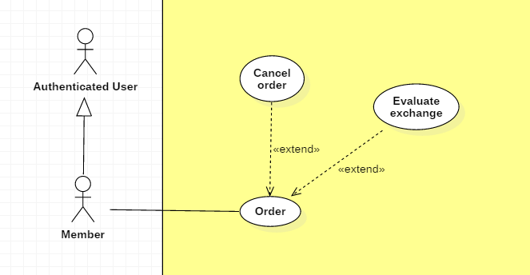

|  |  |  |  |
| --- | --- | --- | --- |
| **USE CASE – UC _M.05** | | | |
| **Usecase No.** | M.13 | **Usecase Version** | 1.0 |
| **Usecase Name** | Cancel an order | | |
| **Author** | SangLNN | | |
| **Date** | 26/09/2018 | **Priority** | Normal |
| **Actor:**   * Member.   **Summary:**   * This use case allows member to cancel an order.   **Goal:**   * Member can cancel an order .   **Triggers:**   * Member sends cancel order command with order id to the system.   **Preconditions:**   * User must login into system with role Member. * Order on pending state. * Order has been accepted bellow 24hrs ago.   **Post Conditions:**   * **Success**: System show message to cancel order successfully and notify to buyer/seller this order has been cancelled. * **Fail**: Show error message.   **Main Success Scenario: Cancel pending order.**   |  |  |  | | --- | --- | --- | | **Step** | **Actor Action** | **System Response** | | 1 | User click “Cancel order” button on pending order list on my order page.  [Alternative scenario 1] | System show a confirm dialog with message “Are you sure to cancel order?” and two option Y/N. | | 2 | User confirm cancle order by click “Yes” to send cancel order command.  User cancel confirm cancel order by click “No” . | System remove this order request from database.  System close dialog back to pending order list view. |   **Alternative Scenario:**  Alternative Scenario 1: Cancel Accepted order Scenario.   |  |  |  | | --- | --- | --- | | **Step** | **Actor Action** | **System Response** | | 1 | User click “Cancel order” button on accepted order list on my order page. | System create and show modal with following labels and fields:   * Reason: text input, length 10 - 250.   And “submit” modal button. | | 2 | User fills out the form. |  | | 3 | User click “submit” button. | System close modal and set order state to cancelled then notify to trade post owner the reason. |   **Exceptions: N/A**  **Relationships:** N/A  **Business** **Rules**:   * User can only cancel an accepted order within 24 hours after you ordered. | | | |

**2.3.4.14. < Member > Evaluate exchange Usecase**



|  |  |  |  |
| --- | --- | --- | --- |
| **USE CASE – UC _M.06** | | | |
| **Usecase No.** | M.14 | **Usecase Version** | 1.0 |
| **Usecase Name** | Evaluate a trade | | |
| **Author** | SangLNN | | |
| **Date** | 26/09/2018 | **Priority** | Normal |
| **Actor:**   * Member.   **Summary:**   * This use case allows member to feedback a trade.   **Goal:**   * After a trade has been confirm success, system will send a feedback form to member and request them to feedback the trade.   **Triggers:**   * Member sends feedback trade command with order id to the system.   **Preconditions:**   * User must login into system with role Member. * User have a trade has been confirm trade success.   **Post Conditions:**   * **Success**: System show message feedback successfully and store feedback data to database system. * **Fail**: Show error message.   **Main Success Scenario:**   |  |  |  | | --- | --- | --- | | **Step** | **Actor Action** | **System Response** | | 1 | Member click “feedback” button on histoty order list. | System create view show a feedback form with following labels and fields:   * Feedback star: radio button, required * Comment: text input, required, length 7-1000. | | 2 | Member fills out the form. |  | | 3 | Member click “submit” on feedback form to send submit feedback command. | Validate form data.  [Exception 1]  System store feeback data to database system and show message feedback successfully. |   **Alternative Scenario:** N/A  **Exceptions:**   |  |  |  | | --- | --- | --- | | **No** | **Cause** | **System Response** | | 1 | Member send submit feedback command without fills out the form. | System shows error message to ask member enters missing required fields. |   **Relationships:** N/A  **Business** **Rules**:   * Member must be do the feedback to continous send an other order. | | | |

**2.3.5. < Buyer/Seller > Overview Usecase**

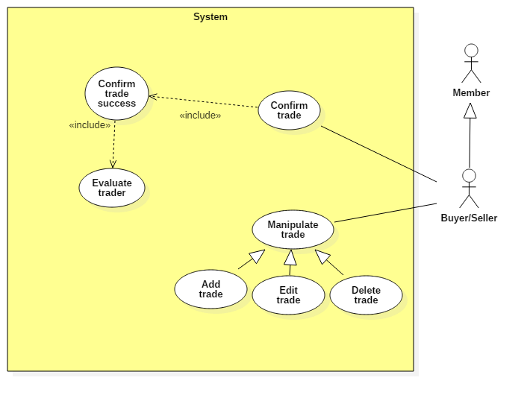

**2.3.5.1. < Buyer/Seller > Add tradeUsecase**

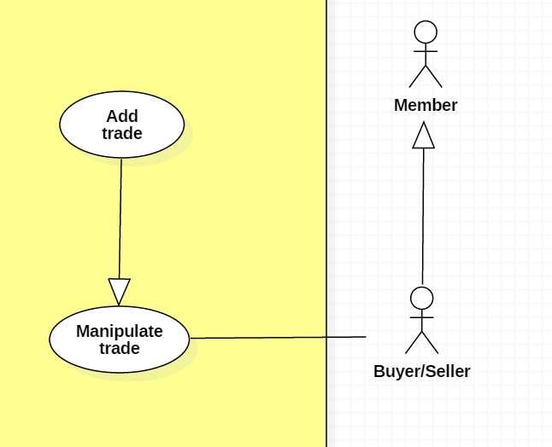

|  |  |  |  |
| --- | --- | --- | --- |
| **USE CASE – UC _BS.01** | | | |
| **Usecase No.** | BS.01 | **Usecase Version** | 1.0 |
| **Usecase Name** | Post a new trade | | |
| **Author** | SangLNN | | |
| **Date** | 25/09/2018 | **Priority** | Normal |
| **Actor:**   * Buyer/Seller   **Summary:**   * This use case allows member to create a new trade post for trade.   **Goal:**   * A new trade post information is added to the database system.   **Triggers:**   * User sends post new trade command with post information to the system.   **Preconditions:**   * User must login into system with role Member.   **Post Conditions:**   * **Success**: New trade post is added to the database system. * **Fail**: Show error message.   **Main Success Scenario:**   |  |  |  | | --- | --- | --- | | **Step** | **Actor Action** | **System Response** | | 1 | User click “Post new trade” button on trade market page. | Create post new trade view is shown with following labels and fields:   * Type of Trade: radio button , required, 2 options: “I want to sell” and “I want to buy”. * Title: text input, required, length 7 – 250. * Photos: file input, required, number of file 1 – 5, maximum size per file is 2.5mb. * Condition : radio button , required, 2 options: “New” and “Used”. * Price: text, required, length 1 – 7. * Quantity: number, required, positive integer and bellow than 1000. * Brand: text input, required, length 3 – 50. * Model: text input, required, length 3 – 50. * Description : text input, required, length 20 – 5000.   Create trade post owner’s information view is shown with following labels and fields:   * Full name: text input, required, length 3 – 50. * Email: text input, readonly. * Phone Number: text input, required, length 7 – 12. * Address: text input, readonly. * Auto get your location: Button   [Alternative Scenario 1]   * Change your location: Button   [Alternative Scenario 2]  And “Post your trade” submit form button. | | 2 | User fills out the form. |  | | 3 | User sends post new trade command by click “Post your trade” button. | Validate data.  [Exception 1]  [Exception 2]  Add new trade post in the database.  Update trader information (optional).  System shows message trade post has been created successfully and waiting to administrators approve. |   **Alternative Scenario:**  **Alternative Scenario 1: Auto get your location Scenario.**   |  |  |  | | --- | --- | --- | | **Step** | **Actor Action** | **System Response** | | 1 | User click “Auto get your location” button to send get your location command. | [Exception 3]  System auto gets your location and generates to text address then autoforms to address field. |   **Alternative Scenario 2: Change your location Scenario.**   |  |  |  | | --- | --- | --- | | **Step** | **Actor Action** | **System Response** | | 1 | User click “Change your location” button. | System create and show modal with following labels and fields:   * Province/City: select option, required. * District: select option, required. * Ward: select option, required. * Street name: text input, required, length 3 - 50. * Apartment number: text input, required, length 3 – 50. * Your full address: text input, readonly.   And “submit” modal button. | | 2 | User fills out the form. |  | | 3 | User click “submit” button. | System close modal and get text data from “Your full address” field and fill to “Address” field on trade post owner’s information form. |   **Exceptions:**   |  |  |  | | --- | --- | --- | | **No** | **Cause** | **System Response** | | 1 | User sends post new trade command by click “Post your trade” without filling out full form. | System shows error message to ask member enters missing required fields. | | 2 | User upload file too large. | System shows error message to ask member upload correct requied file size. | | 3 | User do not allows location permission. | System shows error message to ask member provide required permission. |   **Relationships:** N/A  **Business** **Rules**:   * In case of success scenarios, a trade post would be added to the system but still waiting for administrators to approve. * System auto fills out trade post owner’s information from profile database. * Member can get their location by using auto get location service or manual input. * Phone number and price must be string of numbers. * Post trade id is automatic initialized by the system. * Member need provide a location permisstion to use auto get your location. * File upload must be file type of images: *.jpeg, *.jpg, *.png, *.gif. | | | |

**2.3.5.2. < Buyer/Seller > Edit trade Usecase**

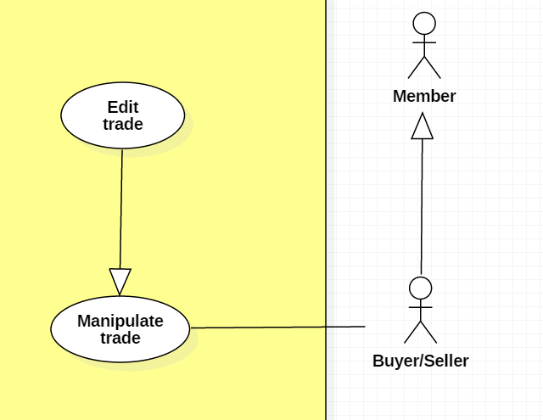

|  |  |  |  |
| --- | --- | --- | --- |
| **USE CASE – UC _BS.02** | | | |
| **Usecase No.** | BS.02 | **Usecase Version** | 1.0 |
| **Usecase Name** | Edit a trade | | |
| **Author** | SangLNN | | |
| **Date** | 26/09/2018 | **Priority** | Normal |
| **Actor:**   * Buyer/Seller   **Summary:**   * This use case allows member to edit their trade post information.   **Goal:**   * A new trade post information is updated to the database system.   **Triggers:**   * User sends edit trade post command with updated post information to the system.   **Preconditions:**   * User must login into system with role Member. * Trade post is on pending or trade posting empty trading activity.   **Post Conditions:**   * **Success**: A new post trade information is updated to the database system. * **Fail**: Show error message.   **Main Success Scenario:**   |  |  |  | | --- | --- | --- | | **Step** | **Actor Action** | **System Response** | | 1 | User click on “Edit post” button from any trade post. | Create edit trade post view is show with following labels and fields:   * Type of Trade: radio button , required, 2 option: “I want to sell” and “I want to buy”. * Title: text input, required, length 7 – 250. * Photos: file input, required, number of file 1 – 5, maximum size per file is 2.5mb. * Condition : radio button , required, 2 option: “New” and “Used”. * Price: text, required, length 1 – 7. * Quantity: number, required, positive integer and bellow than 1000. * Brand: text input, required, length 3 – 50. * Model: text input, required, length 3 – 50. * Description : text input, required, length 20 – 5000.   Create trader information view is show with following labels and fields:   * Full name: text input, required, length 3 – 50. * Email: text input, readonly. * Phone Number: text input, required, length 7 – 12. * Address: text input, readonly. * Auto get your location: Button   [Alternative Scenario 1]   * Change your location: Button   [Alternative Scenario 2]  And “Save your change” submit form button. | | 2 | User fills out the form. |  | | 3 | User sends edit trade post command by click “Save your change” button. | Validate data.  [Exception 1]  [Exception 2]  New trade post information is updated in the database.  System shows message trade post has been updated successfully and waiting to administrators approve. |   **Alternative Scenario:** **N/A**  **Alternative Scenario:**  **Alternative Scenario 1: Auto get your location Scenario.**   |  |  |  | | --- | --- | --- | | **Step** | **Actor Action** | **System Response** | | 1 | User click “Auto get your location” button to send get your location command. | [Exception 3]  System auto get your location and generated to text address then autoform to address field. |   **Alternative Scenario 2: Change your location Scenario.**   |  |  |  | | --- | --- | --- | | **Step** | **Actor Action** | **System Response** | | 1 | User click “Change your location” button. | System create and show modal with following labels and fields:   * Province/City: select option, required. * District: select option, required. * Ward: select option, required. * Street name: text input, required, length 3 - 50. * Apartment number: text input, required, length 3 – 50. * Your full address: text input, readonly.   And “submit” modal button. | | 2 | User fills out the form. |  | | 3 | User click “submit” button. | System close modal and get text data from “Your full address” field and fill to “Address” field on trader information form. |   **Exceptions:**   |  |  |  | | --- | --- | --- | | **No** | **Cause** | **System Response** | | 1 | User sends post new trade command by click “Save your change” without fills out full form. | System shows error message to ask member enters missing required fields. | | 2 | User upload file too large. | System shows error message to ask member upload correct requied file size. | | 3 | User do not allows location permission. | System shows error message to ask member provide required permission. |   **Relationships:** N/A  **Business** **Rules**:   * “Edit trade post” button is only show on trade post is on pending or trade posting empty trading activity. * In case of success scenarios, a trade post information would be updated to the system but still waiting administrators approve. * Member can get their location by using auto get location service or manual input. * Phone number and price must be string of numbers. * Member need provide a location permisstion to use auto get your location. * File upload must be file type of images: *.jpeg, *.jpg, *.png, *.gif. | | | |

**2.3.5.3. < Buyer/Seller > Delete trade Usecase**

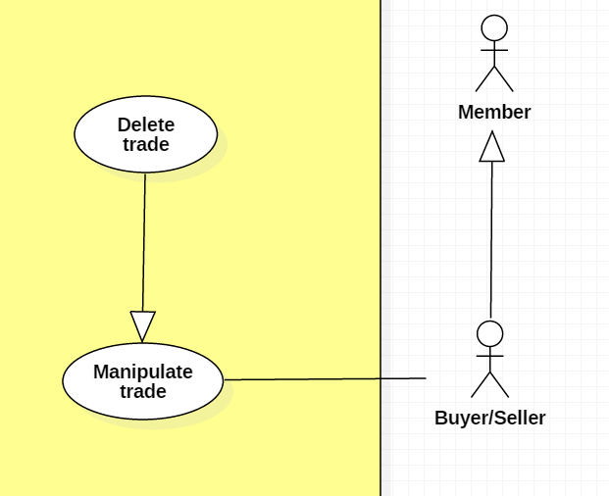

|  |  |  |  |
| --- | --- | --- | --- |
| **USE CASE – UC _BS.03** | | | |
| **Usecase No.** | BS.03 | **Usecase Version** | 1.0 |
| **Usecase Name** | Delete a trade post | | |
| **Author** | SangLNN | | |
| **Date** | 26/09/2018 | **Priority** | Normal |
| **Actor:**   * Buyer/Seller   **Summary:**   * This use case allows member to delete a pending trade post or a trade post have no request order.   **Goal:**   * The trade post has selected is deleted from the database system.   **Triggers:**   * User sends delete trade post command with trade post id to the system.   **Preconditions:**   * User must login into system with role Member. * Trade post is on pending or trade posting empty trading activity.   **Post Conditions:**   * **Success**: The trade post has selected is deleted from the database system. * **Fail**: Show error message.   **Main Success Scenario:**   |  |  |  | | --- | --- | --- | | **Step** | **Actor Action** | **System Response** | | 1 | User click on “Delete post” button. | System show a confirm modal with message “Are you sure to delete this post?” and two option Y/N. | | 2 | User confirm delete by click “Yes” to send delete command.  User cancel delete by click “No”. | [Exception 1]  The trade post has selected is deleted from database.  System close modal and show message trade post has been deleted successfully.  System close modal and nothing has changed. |   **Alternative Scenario:** N/A  **Exceptions:**   |  |  |  | | --- | --- | --- | | **No** | **Cause** | **System Response** | | 1 | The trade post already deleted before. | System shows error message the trade post is no longer existed. |   **Relationships:** N/A  **Business** **Rules**:   * “Edit trade post” button is only show on trade post is on pending or trade posting empty trading activity. * In case of success scenarios, a trade would deleted from database system. | | | |

**2.3.5.4. < Buyer/Seller > Confirm trade Usecase**

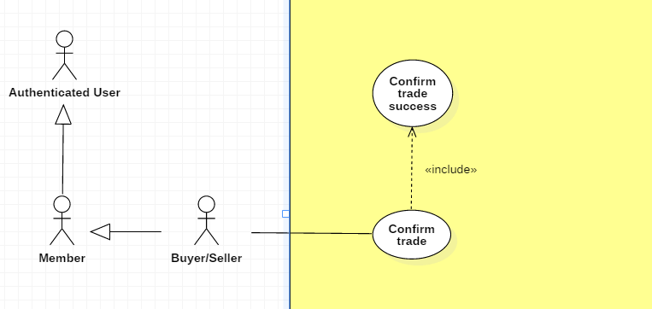

|  |  |  |  |
| --- | --- | --- | --- |
| **USE CASE – UC _BS.04** | | | |
| **Usecase No.** | BS.04 | **Usecase Version** | 1.0 |
| **Usecase Name** | Confirm trade | | |
| **Author** | SangLNN | | |
| **Date** | 26/09/2018 | **Priority** | Normal |
| **Actor:**   * Buyer/Seller.   **Summary:**   * This use case allows buyer/seller to confirm a order request.   **Goal:**   * After member order a trade the request send to buyer/seller. Buyer/seller can view list of order request and choose any order to accept the order request.   **Triggers:**   * Buyer/seller sends accept request command with order id to the system.   **Preconditions:**   * User must login into system with role Member. * User have at least one request order.   **Post Conditions:**   * **Success**: System show message accepted and sends notify to who ordered. * **Fail**: Show error message.   **Main Success Scenario:**   |  |  |  | | --- | --- | --- | | **Step** | **Actor Action** | **System Response** | | 1 | User click “Accept” button on request order list to send accept request command.  [Alternative 1] | System notify to who ordered the request has been accepted and ser order state to accepted. The trade post owner information wil send to trader. |   **Alternative Scenario:**  **Alternative Scenario 1: Decline request order.**   |  |  |  | | --- | --- | --- | | **Step** | **Actor Action** | **System Response** | | 1 | If buyer/seller decline request by click “reject” button. | System create and show modal with following labels and fields:   * Reason: text input, length 10 - 250.   And “submit” modal button. | | 2 | User fills out the form. |  | | 3 | User click “submit” button. | System close modal and set order state to rejected then notify to trader the reason. |   **Exceptions: N/A**  **Relationships:** N/A  **Business** **Rules**: N/A | | | |

**2.3.5.5. < Buyer/Seller > Confirm trade success Usecase**



|  |  |  |  |
| --- | --- | --- | --- |
| **USE CASE – UC _BS.05** | | | |
| **Usecase No.** | BS.05 | **Usecase Version** | 1.0 |
| **Usecase Name** | Confirm trade success | | |
| **Author** | SangLNN | | |
| **Date** | 26/09/2018 | **Priority** | Normal |
| **Actor:**   * Buyer/Seller.   **Summary:**   * This use case allows buyer/seller to confirm a trade has been traded successfully.   **Goal:**   * After trade, buyer/seller need to confirm trade successfully.   **Triggers:**   * Buyer/seller sends confirm trade success command with order id to the system.   **Preconditions:**   * User must login into system with role Member. * User have at least one request order accepted.   **Post Conditions:**   * **Success**: System show message traded successfully and sends feedback form to who ordered. * **Fail**: Show error message.   **Main Success Scenario:**   |  |  |  | | --- | --- | --- | | **Step** | **Actor Action** | **System Response** | | 1 | User click “Confirm trade success” button on payment list to send confirm trade success command.  [Alternative Scenario 1] | System shows a confirm dialog with message “Are you sure to confirm trade success?” and two option Y/N. | | 2 | User confirm by click “Yes”  [Alternative Scenario 2] | System close dialog and set order state to success then notify to trader traded successfully. |   **Alternative Scenario:**  **Alternative Scenario 1: Reject a transaction**   |  |  |  | | --- | --- | --- | | **Step** | **Actor Action** | **System Response** | | 1 | If buyer/seller click “Cancel payment” button on payment list. | System create and show modal with following labels and fields:   * Reason: text input, length 10 - 250.   And “submit” modal button.. | | 2 | User fills out the form. |  | | 3 | User click “submit” button to send cancel payment command. | System close dialog and set order state to cancelled then notify to trader traded has been cancelled with reason. |   **Alternative Scenario 2: Confirm by click “no”**   |  |  |  | | --- | --- | --- | | **Step** | **Actor Action** | **System Response** | | 1 | User confirm by click “No” | System close dialog and nothing has change. |   **Exceptions: N/A**  **Relationships:** N/A  **Business** **Rules**: N/A | | | |

**2.3.5.5. < Buyer/Seller > Evaluate trader Usecase**

|  |  |  |  |
| --- | --- | --- | --- |
| **USE CASE – UC _BS.06** | | | |
| **Usecase No.** | BS.06 | **Usecase Version** | 1.0 |
| **Usecase Name** | Evaluate a trader | | |
| **Author** | SangLNN | | |
| **Date** | 26/09/2018 | **Priority** | Normal |
| **Actor:**   * Buyer/Seller.   **Summary:**   * This use case allows buyer/seller to feedback a trade.   **Goal:**   * After a trade has been confirm success, system will send a feedback form to owner and request them to feedback the trade.   **Triggers:**   * User sends feedback trader command with userid to the system.   **Preconditions:**   * User must login into system with role Member. * User have a trade has been confirm trade success.   **Post Conditions:**   * **Success**: System show message feedback successfully and store feedback data to database system. * **Fail**: Show error message.   **Main Success Scenario:**   |  |  |  | | --- | --- | --- | | **Step** | **Actor Action** | **System Response** | | 1 | User click “feedback” button on histoty order list. | System create view show a feedback form with following labels and fields:   * Feedback star: radio button, required * Comment: text input, required, length 7-1000. | | 2 | User fills out the form. |  | | 3 | User click “submit” on feedback form to send submit feedback command. | Validate form data.  [Exception 1]  System store feeback data to database system and show message feedback successfully. |   **Alternative Scenario:** N/A  **Exceptions:**   |  |  |  | | --- | --- | --- | | **No** | **Cause** | **System Response** | | 1 | User send submit feedback command without fills out the form. | System shows error message to ask member enters missing required fields. |   **Relationships:** N/A  **Business** **Rules**:   * Buyer/Sell must be do the feedback to continous using system. | | | |

**2.3.6. < Scheduler > Overview Usecase**

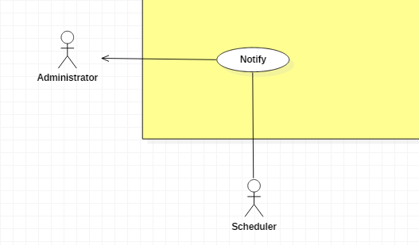

**2.3.6.1. < Scheduler > Notify Usecase**



|  |  |  |  |
| --- | --- | --- | --- |
| **USE CASE – UC _S.01** | | | |
| **Usecase No.** | S.01 | **Usecase Version** | 1.0 |
| **Usecase Name** | Notify | | |
| **Author** | TungHNM | | |
| **Date** | 30/09/2018 | **Priority** | Normal |
| **Actor:**   * Scheduler.   **Summary:**   * Scheduler will notify notifications to users.   **Goal:**   * Make it easier for user to update information.   **Triggers:**   * Administrator approves user’s proposals. * Administrator approves user’s exchange. * Administrator update user’s profile, articles, exchange * User sends order to an exchange, notification will be sent to the exchange’s owner.   **Preconditions:** N/A  **Post Conditions:**   * **Success**: Notification is sent to user. * **Fail**: Log error to console and file..   **Main Success Scenario:**   |  |  |  | | --- | --- | --- | | **Step** | **Actor Action** | **System Response** | | 1 | Scheduler sends send notification command | System sends notification to user |   **Alternative Scenario:** N/A  **Exceptions:** N/A  **Relationships:**   * < Administrator > Approve user’s proposal * < Administrator > Approve user’s article * < Administrator > Approve user’s exchange post * < Member > orders an trade post   **Business** **Rules**:N/A | | | |

**3. Software System Attribute**

**3.1. Usability**

* UI website is fit for each browser in each device

o Font style: Helvetica, Arial, Helvetica Neue, Roboto, Arial, Droid Sans, sans-serif

o Font size: 12px -26px

o Color: green, black, red, white, blue, Light Slate Grey, Fuego, Honeysuckle…

o Background: Whitesmoke, white

**3.2. Reliability**

* Crawl data from other websites with 100% accuracy.
* Get accurate user’s location using Google Maps

**3.3. Availability**

* System replies in maximum 2 seconds

**3.4. Security**

* System always checks for authorization and authentication before doing anything.
* Input data is validated before saving to database

**3.5. Maintainability**

* The system is divided into separated modules for easy maintaining

**3.6. Portability**

* Web application can run on Chrome version 42 or later, or on firefox 56 or later.

**3.7. Performance**

* Website can locate the user’s location in 2 seconds max

**4. Conceptual Diagram**

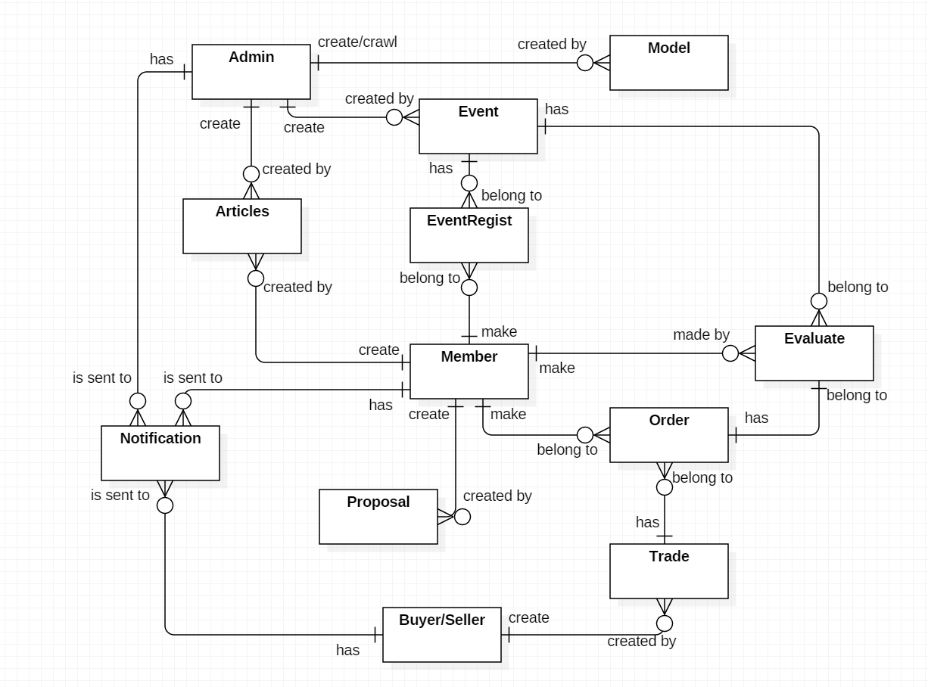

**Data Dictionary**

|  |  |
| --- | --- |
| **Entity Data Dictionary:** describe all contents of all entities | |
| **Entity Name** | **Description** |
| Articles | Contain information articles, sharing experience, guide which are create by administrator or members |
| Event | Contain event’s information, created by administrator |
| Model | Contain model’s information, crawled or created by administrator |
| Proposal | Contain proposal’s information that is created by member |
| EventRegist | Contain event registrations, created by member |
| Trade | Contain exchange’s information, created by Buyer/Seller |
| Order | Contain order’s information, created by member and belongs to a trade |
| Evaluate | Contain rating and feedback about events and exchange, made by member |
| Notification | Is sent to administrator when duplicate event’s calendar  Is sent to Buyer/Seller after administrator approve the exchange  Is sent to member after his/her order is approved by the trade’s owner |
| User (Administrator, Member, Buyer/Seller) | Abstract entities that describe a role in the system |

**D. Report No. 4 Software Design Description**

**1. Design Overview**

This document describes the technical and user interface design of **GWA System**. It includes the architectural design, the detailed design of common functions and business functions and the design of database model.

The architectural design describes the overall architecture of the system and the architecture of each main component and subsystem.

The detailed design describes static and dynamic structure for each components and functions. It includes class diagram, class explanations and sequence diagrams for each use cases.

The database design describes the relationship between entities and detail of each entity.

Document overview:

* Section 2: gives an overall description of the system architecture design.
* Section 3: gives component diagrams that describe the connection and integration of the system.
* Section 4: gives the detail design description which includes class diagram, class explanation, and sequence diagram to details the application functions.
* Section 5: describe screens design.
* Section 6: describe a fully attributed ERD.
* Section 7: describe algorithms**.**

**2. System Architectural Design**

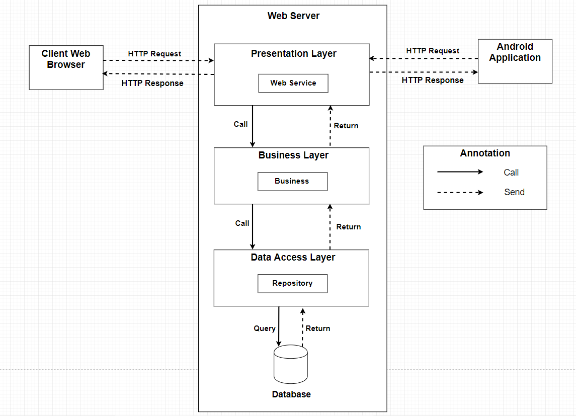

**2.1. Web application architecture description**

In Web Application, the system is developed under 3-layers architecture style, with Spring Boot technology. We choose this architecture for Web application because of the following advantages:

* We can separate our business code into logical layers, each layer performing a specific role within the application. Presentation layer is responsible for handling all user interface and browser communication logic, whereas business layer is responsible for executing business logics and data access layer is responsible for executing anythings that relate to database.
* The presentation layer provides Rest API for web and mobile app to communicate by **json** data through network environment, so we can use the business code in web service without repeating the code.
* It is easy to maintain, to apply object oriented concept and to update data provider queries.

This project follows 3-layers architecture with the following components:

* **WebController:** is the part of presentation layer that acts like event handler to handle user interaction. It receives request from user by request mapping and select the appropriate view to return to user.
* **RestController:** is the part of presentation layer that provides api for client to communicate and reads data from response, call the business layer to execute business logic, then return **json** data to client. Web and Mobile app will render that **json** data to UI.
* **Service:** is the part of business layer that is responsible for executing complex business logics. This component will get user’s data from controller, call repository and perform business operations.
* **Model:** is the part of data access layer that contains the mapping of actual tables in database to classes.
* **Repository:** is the part of data access layer that uses models to execute CRUD database operations. This component only execute operations that are related to and is meant for directly accessing the database.

**3. Component Diagram**

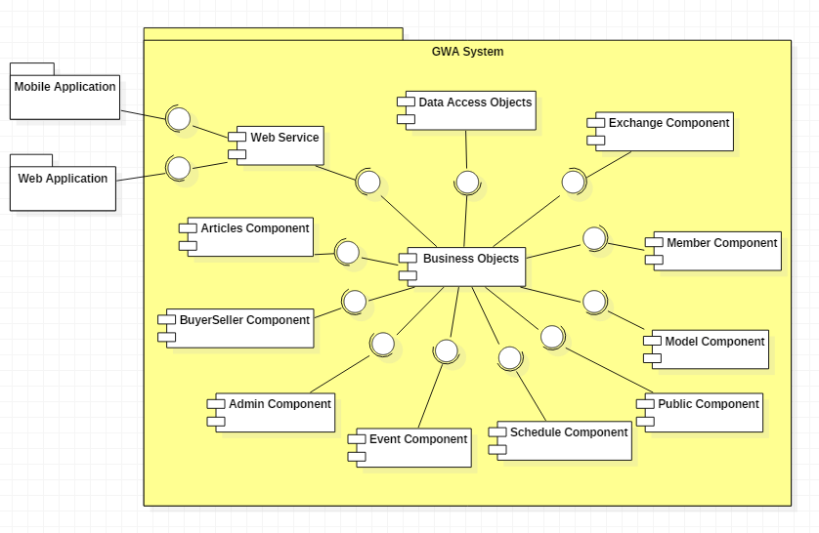

|  |  |
| --- | --- |
| Component Dictionary: Describes components | |
| Web Application | Web application package |
| Mobile Application | Mobile application package |
| Web Service | Provide API for client to interact with the system |
| Admin Component | Component to handle admin activities in the system |
| BuyerSeller Component | Component to handle buy/seller activities in the system |
| Member Component | Component to handle member activities in the system |
| Public Component | Component to handle guest activities in the system |
| Schedule Component | Component to handle scheduler in the system |
| Event Component | Component about manipulating events |
| Articles Component | Component about manipulating articles |
| Exchange Component | Component about manipulating exchange |
| Model Component | Component about manipulating models |
| Business Objects | Common objects to handle domain business operations for each components |
| Data Access Objects | Component to handle interaction between the system and database |

**4. Detailed Description**

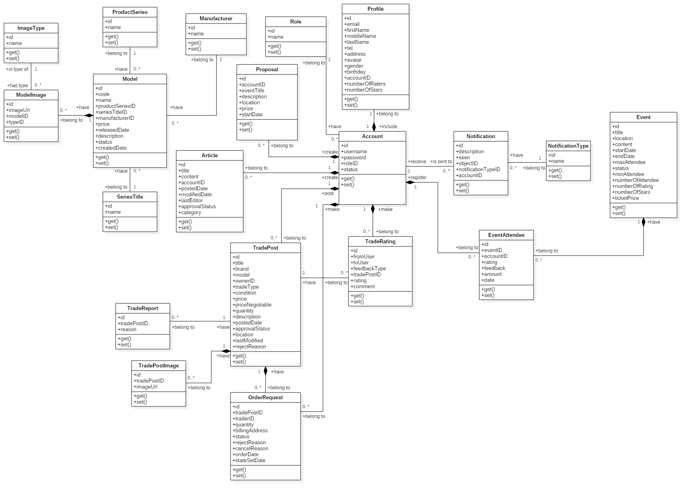 **4.1. Class Diagram**

|  |  |  |
| --- | --- | --- |
| **Class Name** | **Mapping column with Conceptual diagram** | **Description** |
| Model | Model | Contain model’s information |
| ModelImage | N/A | Not exist in conceptual diagram. It’s used to contain models’s images |
| ImageType | N/A | Not exist in conceptual diagram. It’s used to contain types of images |
| ProductSeries | N/A | Not exist in conceptual diagram. It’s used to contain product series information |
| SeriesTitle | N/A | Not exist in conceptual diagram. It’s used to contain series title information |
| Manufacturer | N/A | Not exist in conceptual diagram. It’s used to contain manufacturers information |
| Article | Articles | Contain article’s information |
| Proposal | Proposal | Contain member’s proposal information |
| Account | User | Contain user’s information for authentication and authorization |
| Profile | N/A | Not exist in conceptual diagram. It’s used to contain user’s profile information |
| Role | N/A | Not exist in conceptual diagram. It’s used to contain user’s role information |
| TradePost | Trade | Contain buyer/seller’s trade post information |
| TradePostImage | N/A | Not exist in conceptual diagram. It’s used to contain trade post’s images |
| OrderRequest | Order | Contain information of user’s order request to trade |
| TradeRating | Evaluate | Contain trade rating information |
| TradeReport | N/A | Not exist in conceptual diagram. It’s used to contain user’s report on trade post |
| Event | Event | Contain event information |
| EventAttendee | EventRegist | Contain user’s registration on events |
| Notification | Notification | Contain notification information |
| NotificationType | N/A | Not exist in conceptual diagram. It’s used to contain notification type information |

**4.2. Class Diagram Explanation**

**4.2.1. Model**

**Attribute**

|  |  |  |  |
| --- | --- | --- | --- |
| **Attribute** | **Type** | **Visibility** | **Description** |
| id | int | Private | Unique identifier of model |
| name | String | Private | Model name |
| productSeries | ProductSeries | Private | Model’s product series |
| seriesTitle | SeriesTitle | Private | Model’s series title |
| manufacturer | Manufacturer | Private | Model’s manufacturer |
| price | float | Private | Model’s price |
| realeasedDate | String | Private | Model’s released date |
| description | String | Private | Model’s description |
| status | String | Private | Model’s status |
| createdDate | String | Private | Model’s created date |

**Method**

|  |  |  |  |
| --- | --- | --- | --- |
| **Method** | **Return Type** | **Visibility** | **Description** |
| getter | Attribute type | Public | Get attribute value |
| setter | Void | Public | Set value of attribute |

**4.2.2. SeriesTitle**

**Attribute**

|  |  |  |  |
| --- | --- | --- | --- |
| **Attribute** | **Type** | **Visibility** | **Description** |
| id | int | Private | Unique identifier of series title |
| name | String | Private | Series title’s name |

**Method**

|  |  |  |  |
| --- | --- | --- | --- |
| **Method** | **Return Type** | **Visibility** | **Description** |
| getter | Attribute type | Public | Get attribute value |
| setter | Void | Public | Set value of attribute |

**4.2.3. ProductSeries**

**Attribute**

|  |  |  |  |
| --- | --- | --- | --- |
| **Attribute** | **Type** | **Visibility** | **Description** |
| id | int | Private | Unique identifier of product series |
| name | String | Private | Product series’s name |

**Method**

|  |  |  |  |
| --- | --- | --- | --- |
| **Method** | **Return Type** | **Visibility** | **Description** |
| getter | Attribute type | Public | Get attribute value |
| setter | Void | Public | Set value of attribute |

**4.2.4. Manufacturer**

**Attribute**

|  |  |  |  |
| --- | --- | --- | --- |
| **Attribute** | **Type** | **Visibility** | **Description** |
| id | int | Private | Unique identifier of manufacturer |
| name | String | Private | Manufacturer’s name |

**Method**

|  |  |  |  |
| --- | --- | --- | --- |
| **Method** | **Return Type** | **Visibility** | **Description** |
| getter | Attribute type | Public | Get attribute value |
| setter | Void | Public | Set value of attribute |

**4.2.5. ModelImage**

**Attribute**

|  |  |  |  |
| --- | --- | --- | --- |
| **Attribute** | **Type** | **Visibility** | **Description** |
| id | int | Private | Unique identifier of model image |
| imageUrl | String | Private | Image’s url |
| model | Model | Private | The model which image belongs to |
| type | ImageType | Private | Image’s type |

**Method**

|  |  |  |  |
| --- | --- | --- | --- |
| **Method** | **Return Type** | **Visibility** | **Description** |
| getter | Attribute type | Public | Get attribute value |
| setter | Void | Public | Set value of attribute |

**4.2.6. ImageType**

**Attribute**

|  |  |  |  |
| --- | --- | --- | --- |
| **Attribute** | **Type** | **Visibility** | **Description** |
| id | int | Private | Unique identifier of image type |
| name | String | Private | Image type’s name |

**Method**

|  |  |  |  |
| --- | --- | --- | --- |
| **Method** | **Return Type** | **Visibility** | **Description** |
| getter | Attribute type | Public | Get attribute value |
| setter | Void | Public | Set value of attribute |

**4.2.7. Article**

**Attribute**

|  |  |  |  |
| --- | --- | --- | --- |
| **Attribute** | **Type** | **Visibility** | **Description** |
| id | int | Private | Unique identifier of article |
| title | String | Private | Article title |
| content | String | Private | Article content detail information |
| account | Account | Private | User who posts article |
| postedDate | String | Private | Article posted date |
| modifiedDate | String | Private | Article last modified date |
| lastEditor | String | Private | Username of the last editor |
| approvalStatus | String | Private | Article’s approval status |
| category | String | Private | Article’s category |

**Method**

|  |  |  |  |
| --- | --- | --- | --- |
| **Method** | **Return Type** | **Visibility** | **Description** |
| getter | Attribute type | Public | Get attribute value |
| setter | Void | Public | Set value of attribute |

**4.2.8. Proposal**

**Attribute**

|  |  |  |  |
| --- | --- | --- | --- |
| **Attribute** | **Type** | **Visibility** | **Description** |
| id | int | Private | Unique identifier of proposal |
| account | Account | Private | User who posts proposal |
| eventTitle | String | Private | Proposal event title |
| description | String | Private | Proposal description |
| location | String | Private | Proposal event location |
| prize | String | Private | Proposal event winng rewards |
| startDate | String | Private | Proposal event start date |

**Method**

|  |  |  |  |
| --- | --- | --- | --- |
| **Method** | **Return Type** | **Visibility** | **Description** |
| getter | Attribute type | Public | Get attribute value |
| setter | Void | Public | Set value of attribute |

**4.2.9. Account**

**Attribute**

|  |  |  |  |
| --- | --- | --- | --- |
| **Attribute** | **Type** | **Visibility** | **Description** |
| id | int | Private | Unique identifier of account |
| username | String | Private | Account username |
| password | String | Private | Account password |
| role | Role | Private | Account role |
| status | String | Private | Account status |

**Method**

|  |  |  |  |
| --- | --- | --- | --- |
| **Method** | **Return Type** | **Visibility** | **Description** |
| getter | Attribute type | Public | Get attribute value |
| setter | Void | Public | Set value of attribute |

**4.2.10. Role**

**Attribute**

|  |  |  |  |
| --- | --- | --- | --- |
| **Attribute** | **Type** | **Visibility** | **Description** |
| id | int | Private | Unique identifier of role |
| name | String | Private | Role name |

**Method**

|  |  |  |  |
| --- | --- | --- | --- |
| **Method** | **Return Type** | **Visibility** | **Description** |
| getter | Attribute type | Public | Get attribute value |
| setter | Void | Public | Set value of attribute |

**4.2.11. Profile**

**Attribute**

|  |  |  |  |
| --- | --- | --- | --- |
| **Attribute** | **Type** | **Visibility** | **Description** |
| id | int | Private | Unique identifier of user profile |
| email | String | Private | User’s email |
| firstName | String | Private | User’s first name |
| middleName | String | Private | User’s middle name |
| lastName | String | Private | User’s last name |
| tel | String | Private | User’s mobile number |
| address | String | Private | User’s address |
| avatar | String | Private | User’s avatar as image |
| gender | String | Private | User’s gender |
| birthday | String | Private | User’s birthday |
| account | Account | Private | Profile owner |

**Method**

|  |  |  |  |
| --- | --- | --- | --- |
| **Method** | **Return Type** | **Visibility** | **Description** |
| getter | Attribute type | Public | Get attribute value |
| setter | Void | Public | Set value of attribute |

**4.2.12. Event**

**Attribute**

|  |  |  |  |
| --- | --- | --- | --- |
| **Attribute** | **Type** | **Visibility** | **Description** |
| id | int | Private | Unique identifier of event |
| title | String | Private | Event title |
| location | String | Private | Event location occur |
| content | String | Private | Event content |
| startDate | String | Private | Event start date |
| endDate | String | Private | Event end date |
| maxAttendee | int | Private | Event’s maximum attendee |
| status | String | Private | Event status |
| minAttendee | int | Private | Event’s minimum attendee |
| numberOfAttendee | int | Private | Event’s current number of attendee, this attribute is for improving performance |
| numberOfRating | int | Private | Number of users who evaluate the events, this attribute is for improving performance in calculating event rating |
| numberOfStars | int | Private | Number of star rating, this attribute is for improving performance in calculating event rating |
| ticketPrice | float | Private | Price of event’s ticket |

**Method**

|  |  |  |  |
| --- | --- | --- | --- |
| **Method** | **Return Type** | **Visibility** | **Description** |
| getter | Attribute type | Public | Get attribute value |
| setter | Void | Public | Set value of attribute |

**4.2.13. EventAttendee**

**Attribute**

|  |  |  |  |
| --- | --- | --- | --- |
| **Attribute** | **Type** | **Visibility** | **Description** |
| id | int | Private | Unique identifier of eventattendee |
| event | Event | Private | Object event |
| account | Account | Private | Object account which represents the event attendee |
| rating | int | Private | User’s rating on events |
| feedback | String | Private | User’s feedback on events |
| amount | int | Private | Number of tickets which a user regist for |
| date | String | Private | Event registration date |

**Method**

|  |  |  |  |
| --- | --- | --- | --- |
| **Method** | **Return Type** | **Visibility** | **Description** |
| getter | Attribute type | Public | Get attribute value |
| setter | Void | Public | Set value of attribute |

**4.2.14. Notification**

**Attribute**

|  |  |  |  |
| --- | --- | --- | --- |
| **Attribute** | **Type** | **Visibility** | **Description** |
| id | int | Private | Unique identifier of notification |
| description | String | Private | Notification description |
| seen | int | Private | Notification seen status |
| object | object | Private | Notification object message |
| notificationType | NoticationType | Private | Notification type object |
| account | Account | Private | User whom notification is sent to |

**Method**

|  |  |  |  |
| --- | --- | --- | --- |
| **Method** | **Return Type** | **Visibility** | **Description** |
| getter | Attribute type | Public | Get attribute value |
| setter | Void | Public | Set value of attribute |

**4.2.15. NotificationType**

**Attribute**

|  |  |  |  |
| --- | --- | --- | --- |
| **Attribute** | **Type** | **Visibility** | **Description** |
| id | int | Private | Unique identifier of notificationtype |
| name | String | Private | NotificationType name |

**Method**

|  |  |  |  |
| --- | --- | --- | --- |
| **Method** | **Return Type** | **Visibility** | **Description** |
| getter | Attribute type | Public | Get attribute value |
| setter | Void | Public | Set value of attribute |

**4.2.16. TradePost**

**Attribute**

|  |  |  |  |
| --- | --- | --- | --- |
| **Attribute** | **Type** | **Visibility** | **Description** |
| id | int | Private | Unique identifier of trade post |
| title | String | Private | Trade post title |
| brand | String | Private | Product’s brand |
| model | String | Private | Product name |
| owner | Account | Private | Trade post owner |
| tradeType | String | Private | Trade type |
| condition | String | Private | Trade condition |
| price | float | Private | Products’s price |
| priceNegotiable | float | Private | Price may be negotiable when exchange |
| quantity | int | Private | Product quantity |
| description | String | Private | Trade post description |
| postedDate | String | Private | Trade posted date |
| approvalStatus | String | Private | Trade’s approval status |
| location | String | Private | Location for exchange |
| lastModified | String | Private | Trade post’s last modified |
| rejectReason | String | Private | Reject reason from administrator |

**Method**

|  |  |  |  |
| --- | --- | --- | --- |
| **Method** | **Return Type** | **Visibility** | **Description** |
| getter | Attribute type | Public | Get attribute value |
| setter | Void | Public | Set value of attribute |

**4.2.17. OrderRequest**

**Attribute**

|  |  |  |  |
| --- | --- | --- | --- |
| **Attribute** | **Type** | **Visibility** | **Description** |
| id | int | Private | Unique identifier of order request |
| tradePost | TradePost | Private | Trade post that user request to order |
| trader | Account | Private | Member who sends order request to buyer/seller for exchange |
| quantity | int | Private | Number of order products |
| billingAddress | String | Private | Negotiable exchange location |
| statusID | int | Private | Order request status |
| rejectReason | String | Private | Reason that buyer/seller reject the exchange after accepted order request |
| cancelReason | String | Private | Reason that buyer/seller cancel order request |
| orderDate | String | Private | Order request date |
| stateSetDate | String | Private | The datetime which the order request is reject or canceled |

**Method**

|  |  |  |  |
| --- | --- | --- | --- |
| **Method** | **Return Type** | **Visibility** | **Description** |
| getter | Attribute type | Public | Get attribute value |
| setter | Void | Public | Set value of attribute |

**4.2.18. TradePostImage**

**Attribute**

|  |  |  |  |
| --- | --- | --- | --- |
| **Attribute** | **Type** | **Visibility** | **Description** |
| id | int | Private | Unique identifier of trade post image |
| tradePost | TradePost | Private | The trade post which image belongs to |
| imageUrl | String | Private | Image url |

**Method**

|  |  |  |  |
| --- | --- | --- | --- |
| **Method** | **Return Type** | **Visibility** | **Description** |
| getter | Attribute type | Public | Get attribute value |
| setter | Void | Public | Set value of attribute |

**4.2.19. TradeReport**

**Attribute**

|  |  |  |  |
| --- | --- | --- | --- |
| **Attribute** | **Type** | **Visibility** | **Description** |
| id | int | Private | Unique identifier of trade report |
| tradePost | TradePost | Private | The trade post which trade report belongs to |
| reason | String | Private | Reason of report |

**Method**

|  |  |  |  |
| --- | --- | --- | --- |
| **Method** | **Return Type** | **Visibility** | **Description** |
| getter | Attribute type | Public | Get attribute value |
| setter | Void | Public | Set value of attribute |

**4.2.20. TradeRating**

**Attribute**

|  |  |  |  |
| --- | --- | --- | --- |
| **Attribute** | **Type** | **Visibility** | **Description** |
| id | int | Private | Unique identifier of trade rating |
| fromUser | Account | Private | User who does the evaluation |
| toUser | Account | Private | User who receives the rating |
| feedbackType | String | Private | Represents for type of rating, a member evaluate the exchange for trade post owner or trade post owner evaluates the traders, for calculating the reputation |
| tradePost | TradePost | Private | Trade post that is evaluated |
| rating | int | Private | Number of stars rating |
| comment | String | Private | Feedback about exchange |

**Method**

|  |  |  |  |
| --- | --- | --- | --- |
| **Method** | **Return Type** | **Visibility** | **Description** |
| getter | Attribute type | Public | Get attribute value |
| setter | Void | Public | Set value of attribute |

**4.3. Interaction Diagram**

**4.3.1. Sequence Diagram**

**4.3.1.1. Search model**

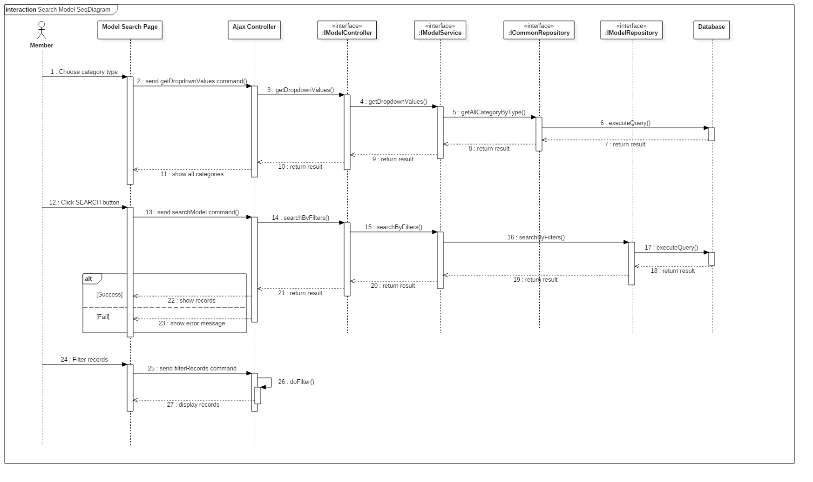

**4.3.1.2. Create model**

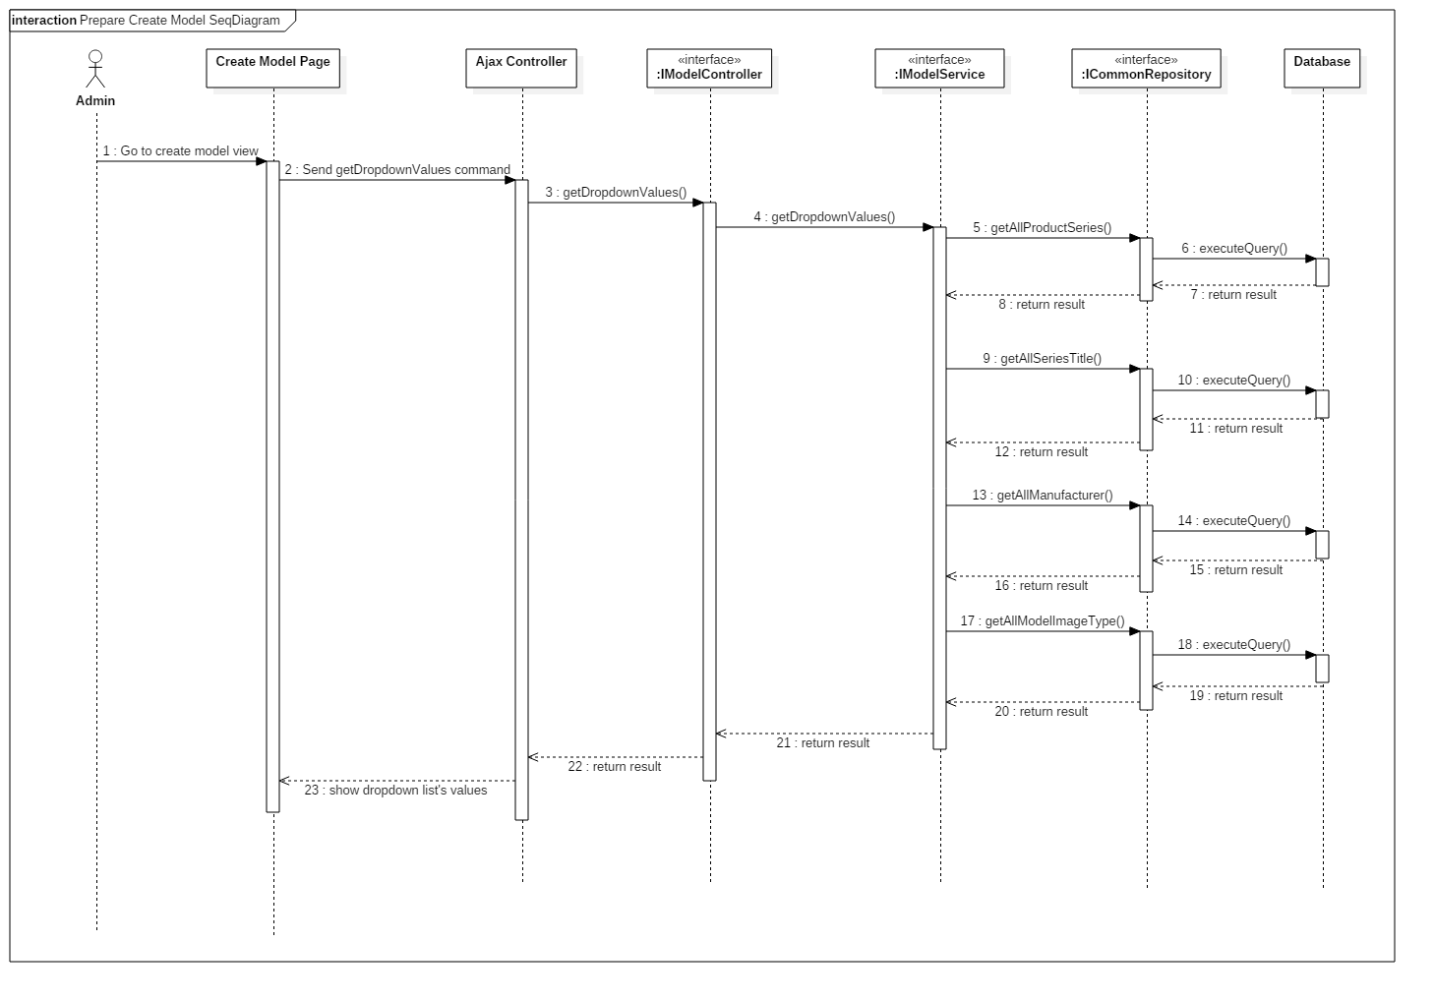 **4.3.1.2.1. Prepare Create Model**

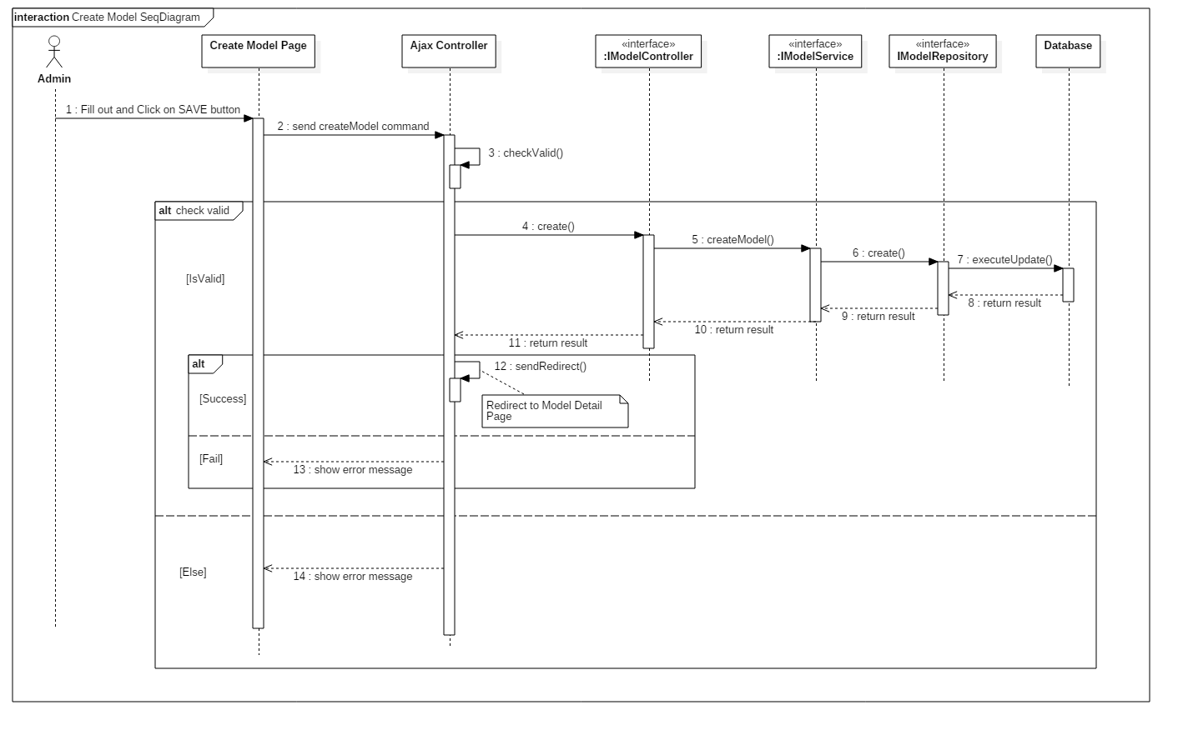 **4.3.1.2.2. Create Model**

**4.3.1.3. Edit model**

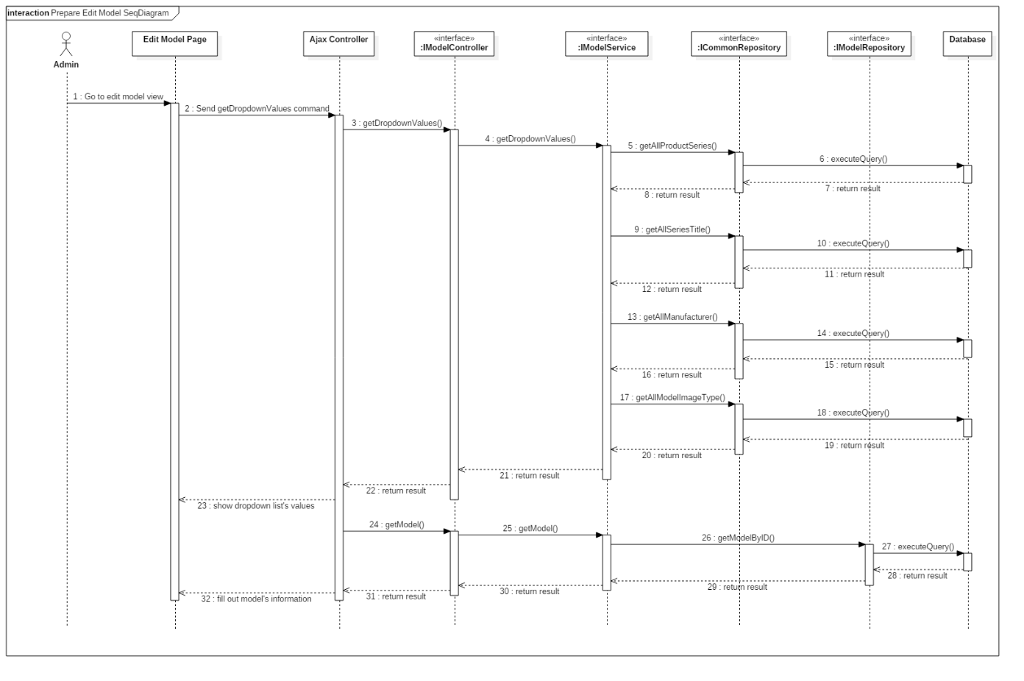 **4.3.1.3.1. Prepare Edit Model**

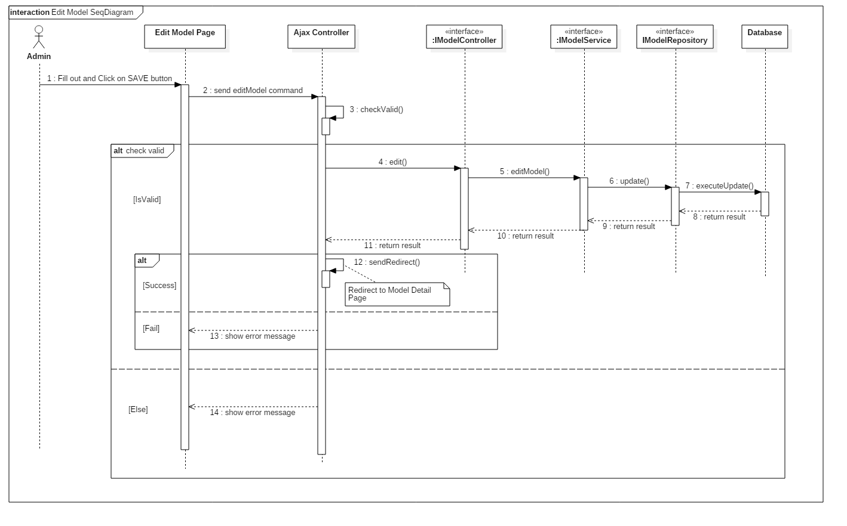 **4.3.1.3.2. Edit Model**

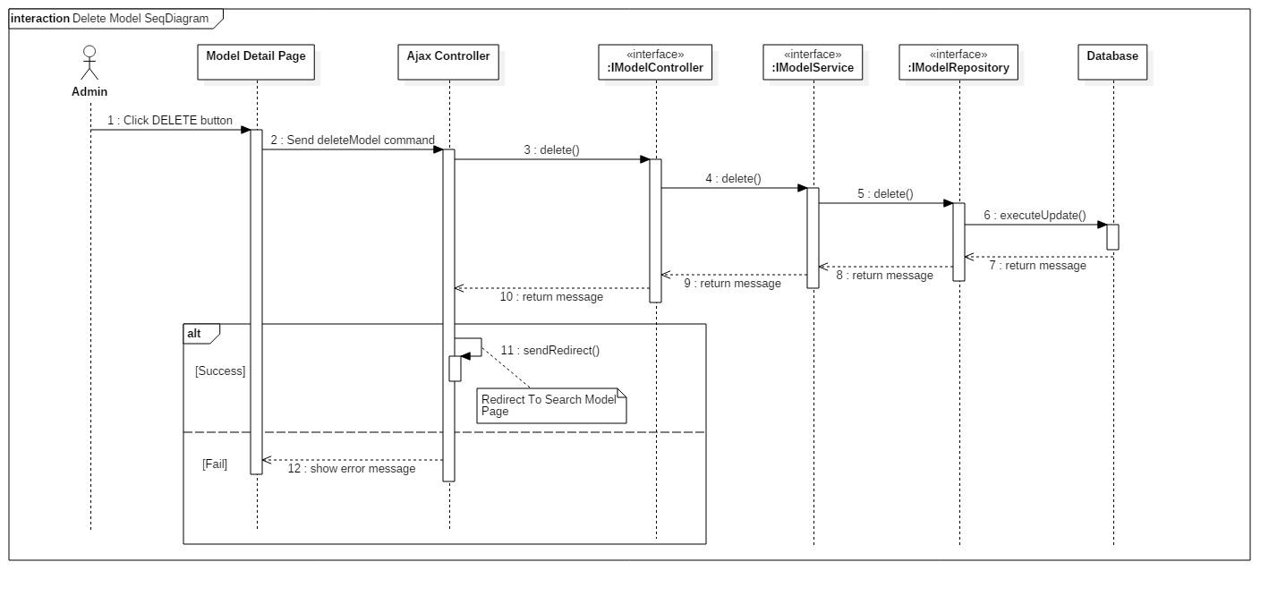 **4.3.1.4. Delete model**

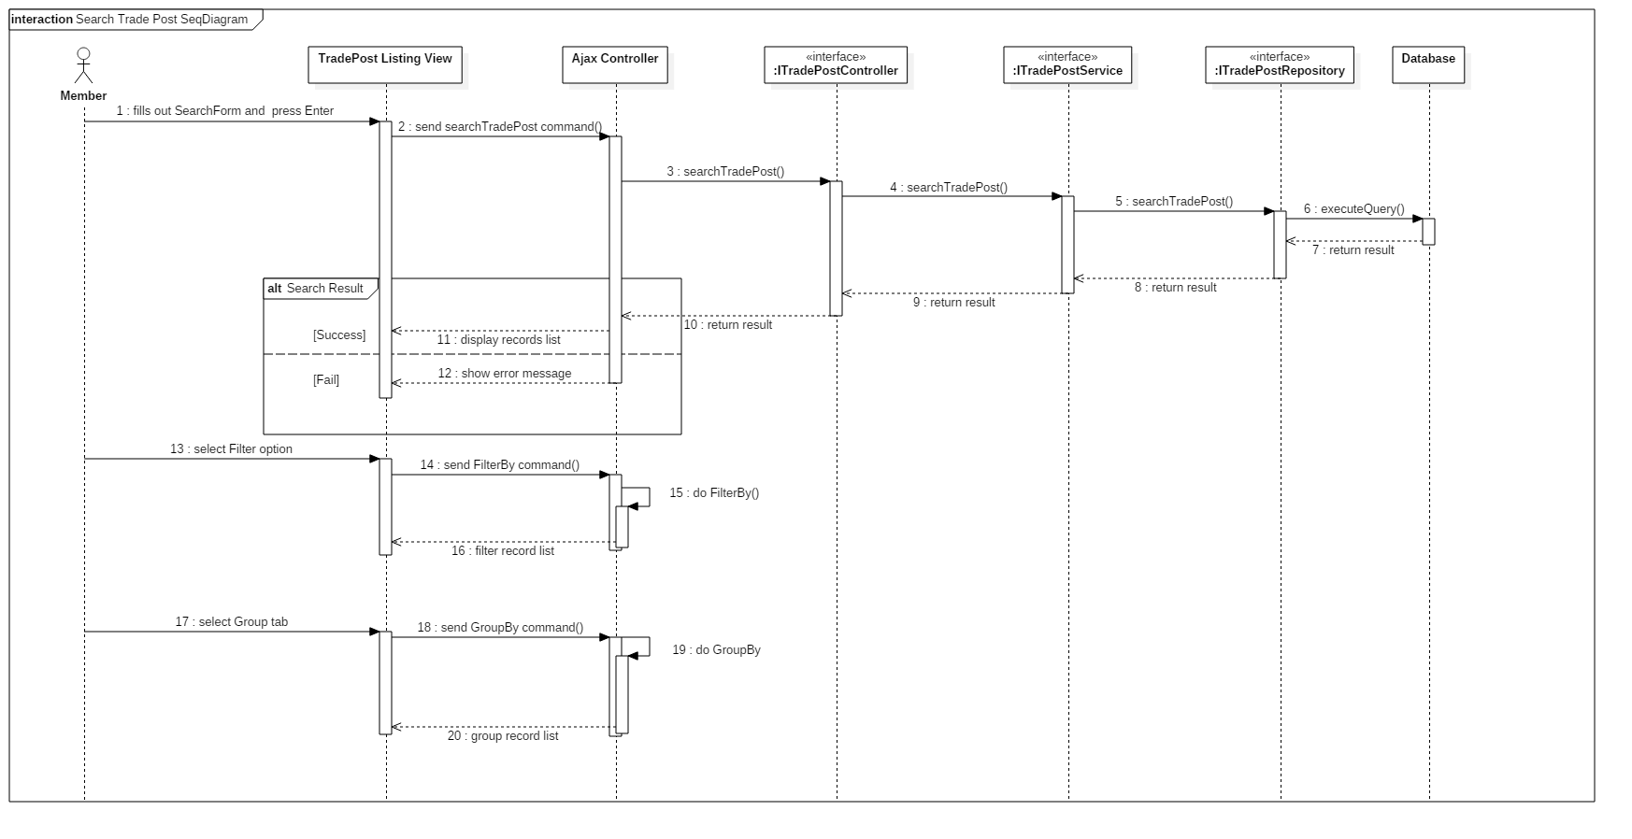 **4.3.1.5. Search Trade Post**

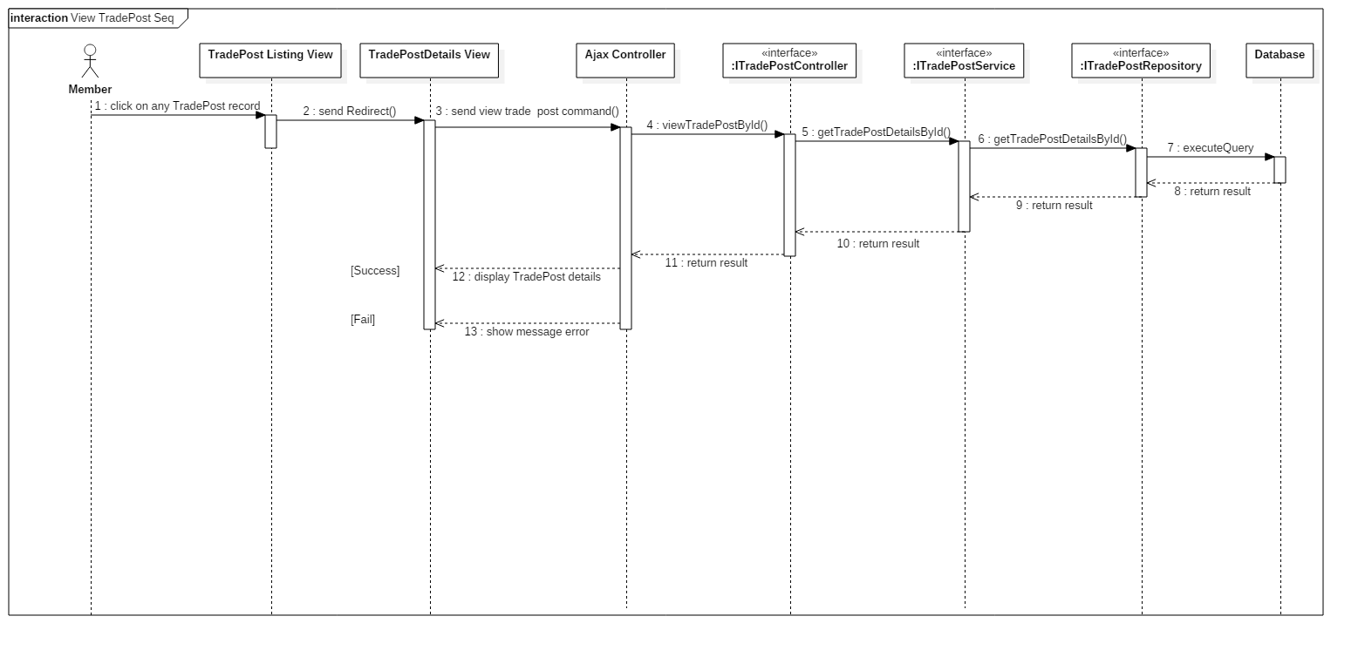 **4.3.1.6. Get Trade Post Detail Information**

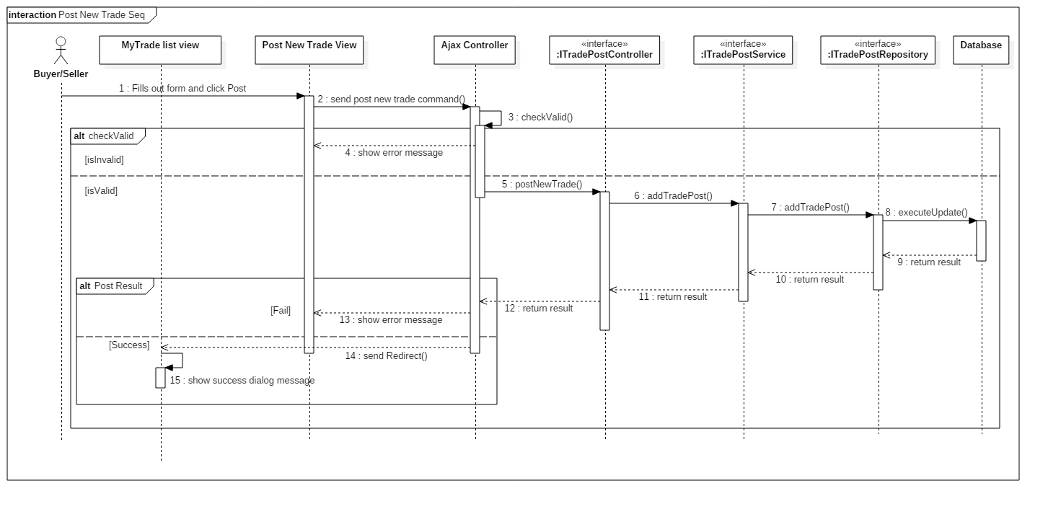 **4.3.1.7. Post new trade**

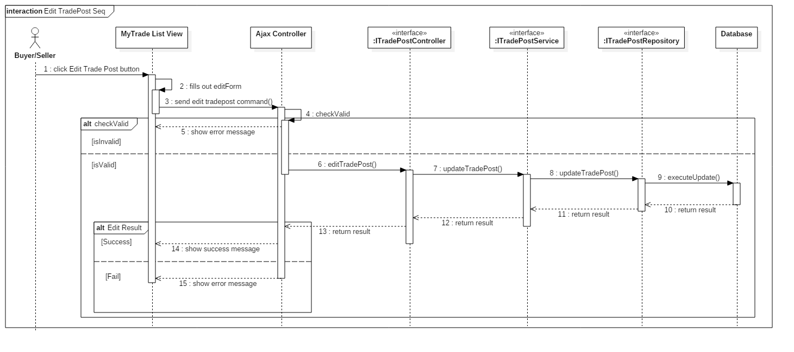 **4.3.1.8. Edit trade post**

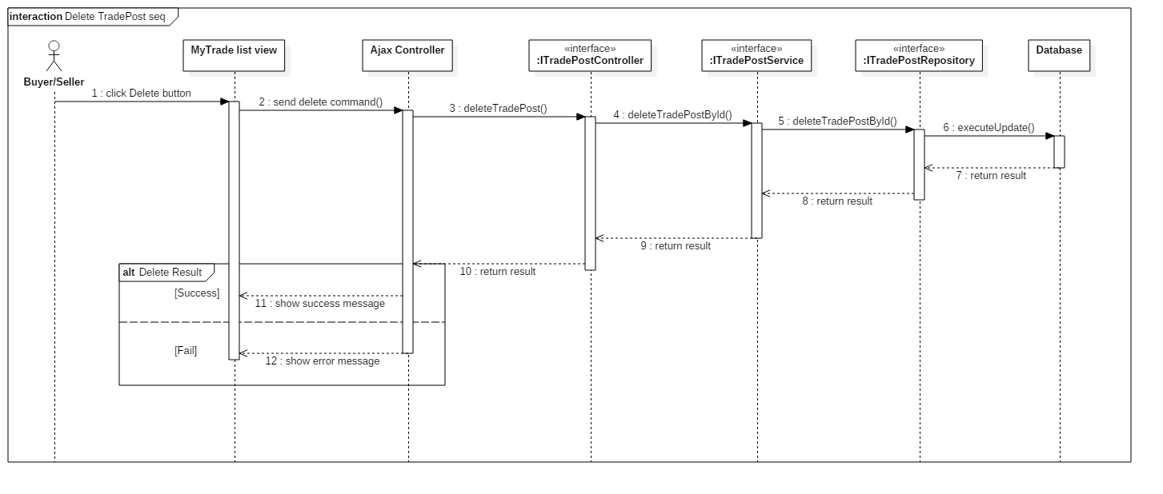 **4.3.1.9. Delete trade post**

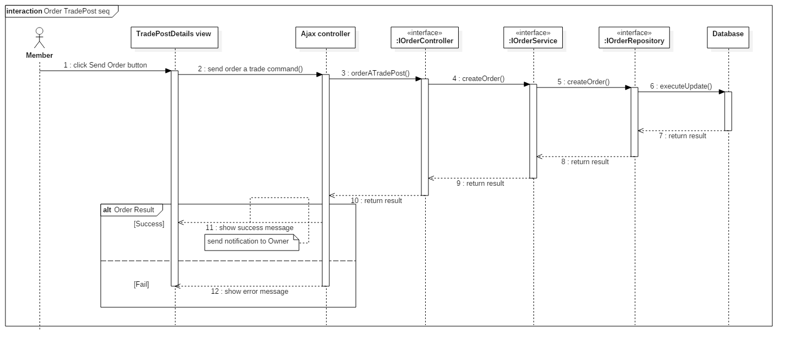 **4.3.1.10. Request order to a trade post**

**4.3.1.11. Cancel an order**

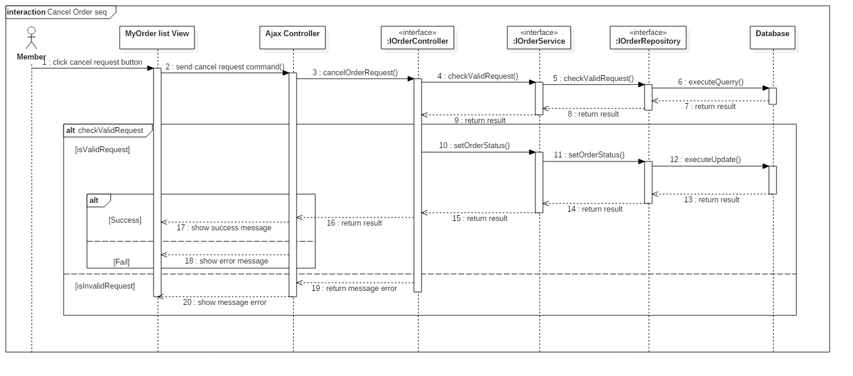

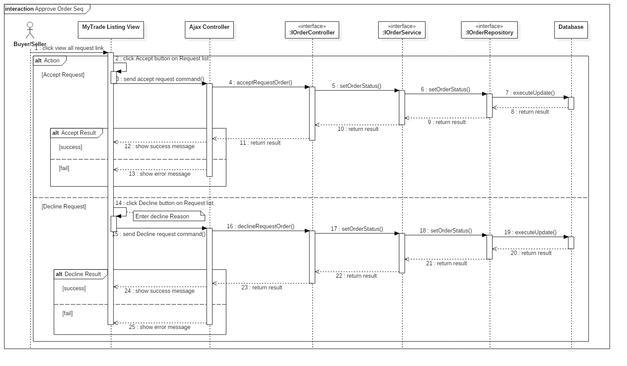 **4.3.1.12. Approve order request**

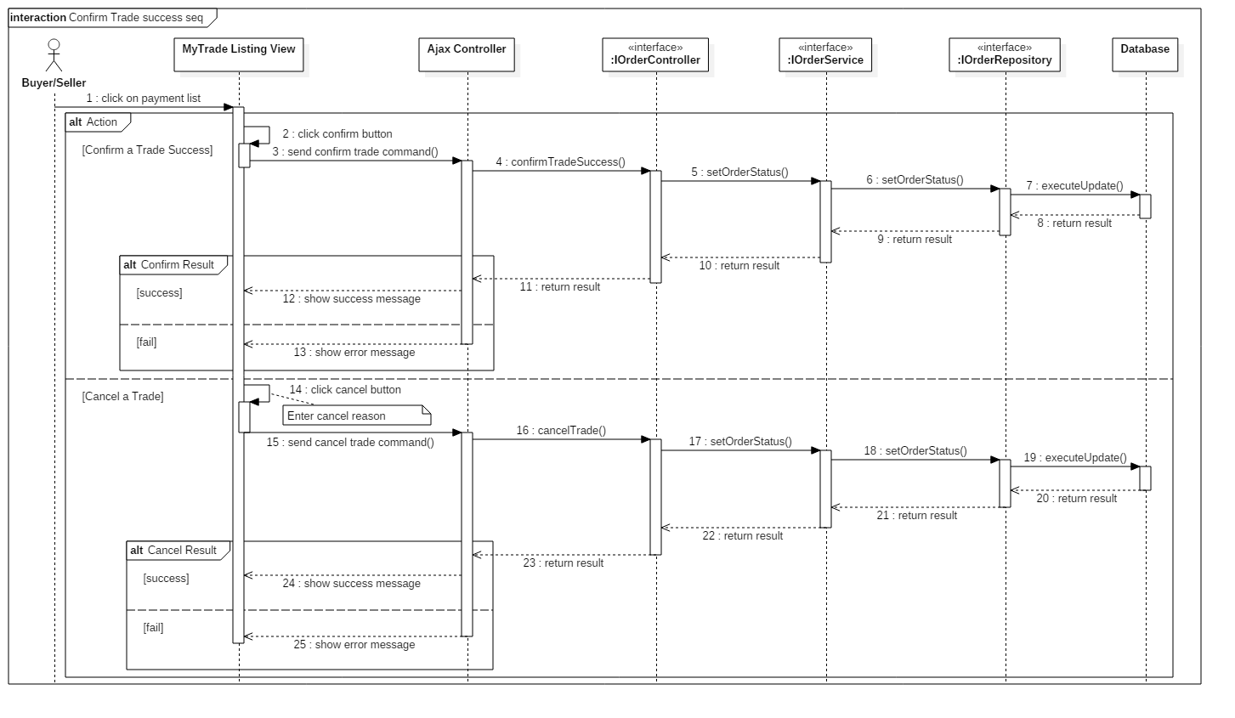 **4.3.1.13. Confirm trade success**

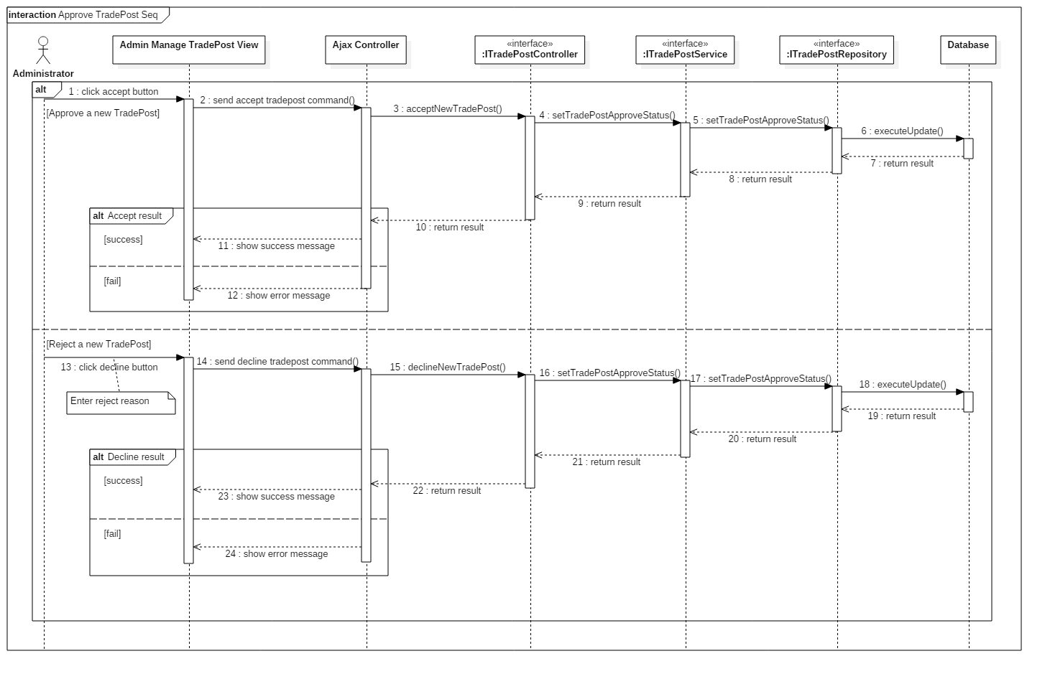 **4.3.1.14. Approve a trade post from buyer/seller**

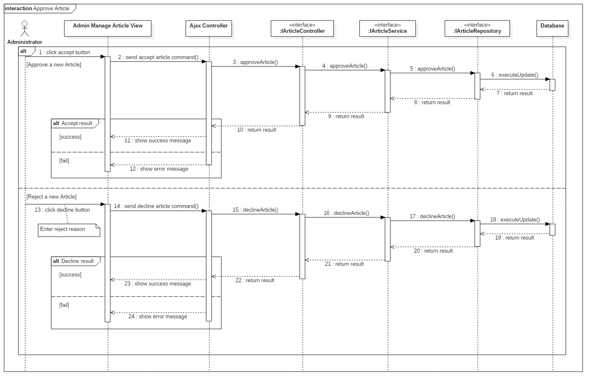 **4.3.1.15. Administrator approve member’s articles**

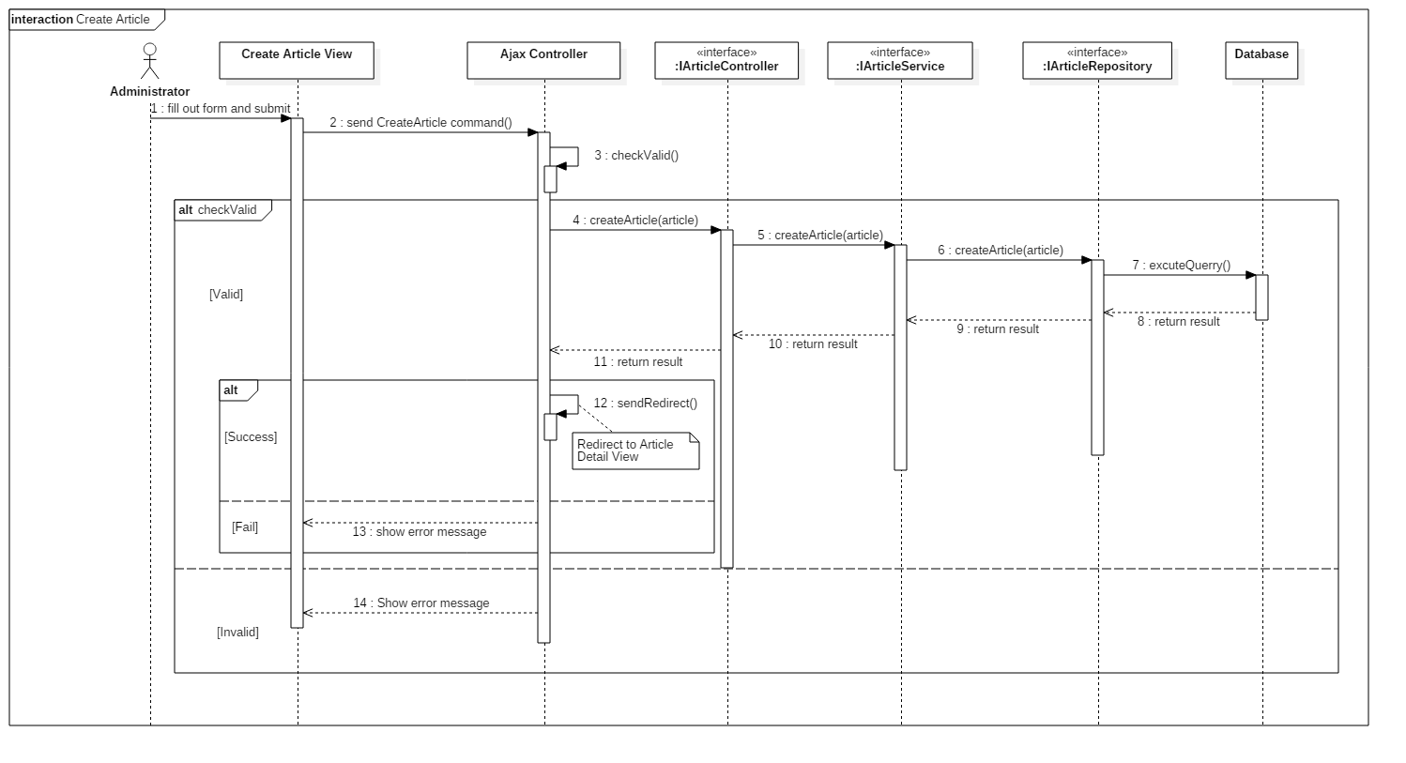 **4.3.1.16. Create new article**

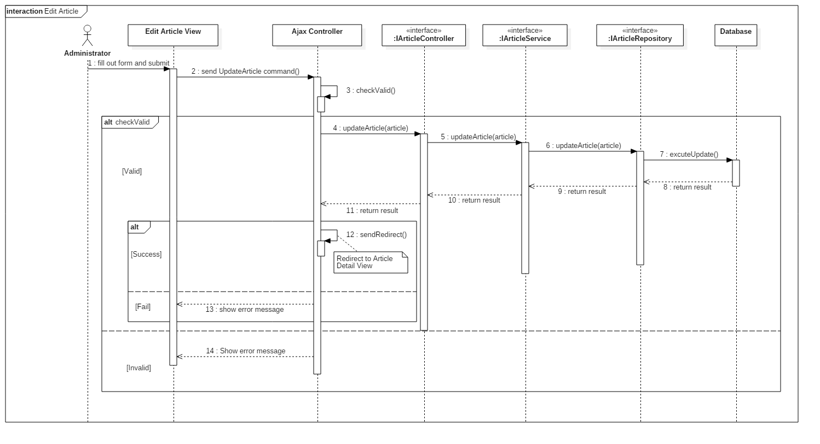 **4.3.1.17. Edit article**

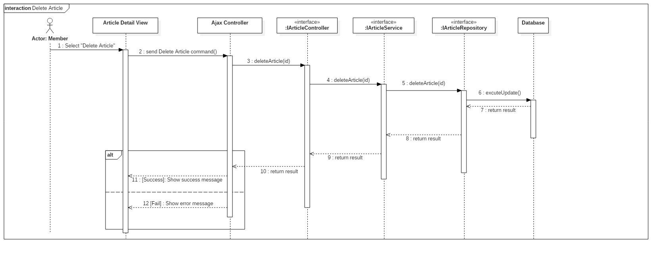 **4.3.1.18. Delete article**

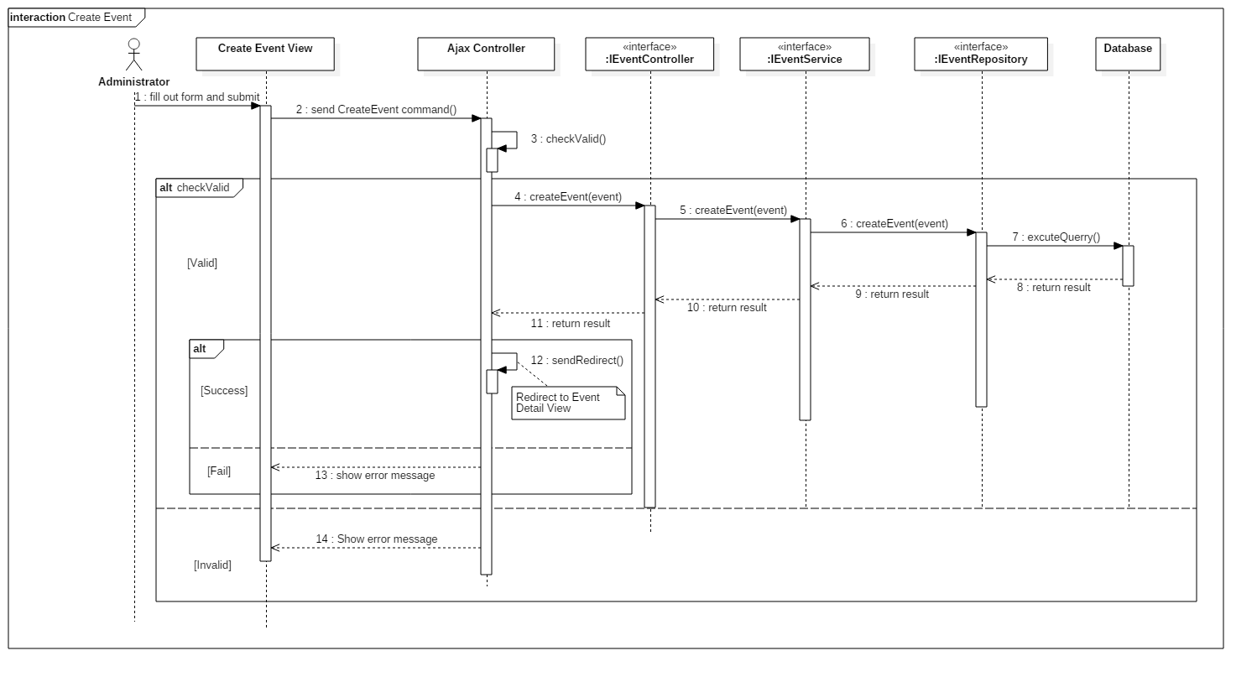 **4.3.1.19. Create event**

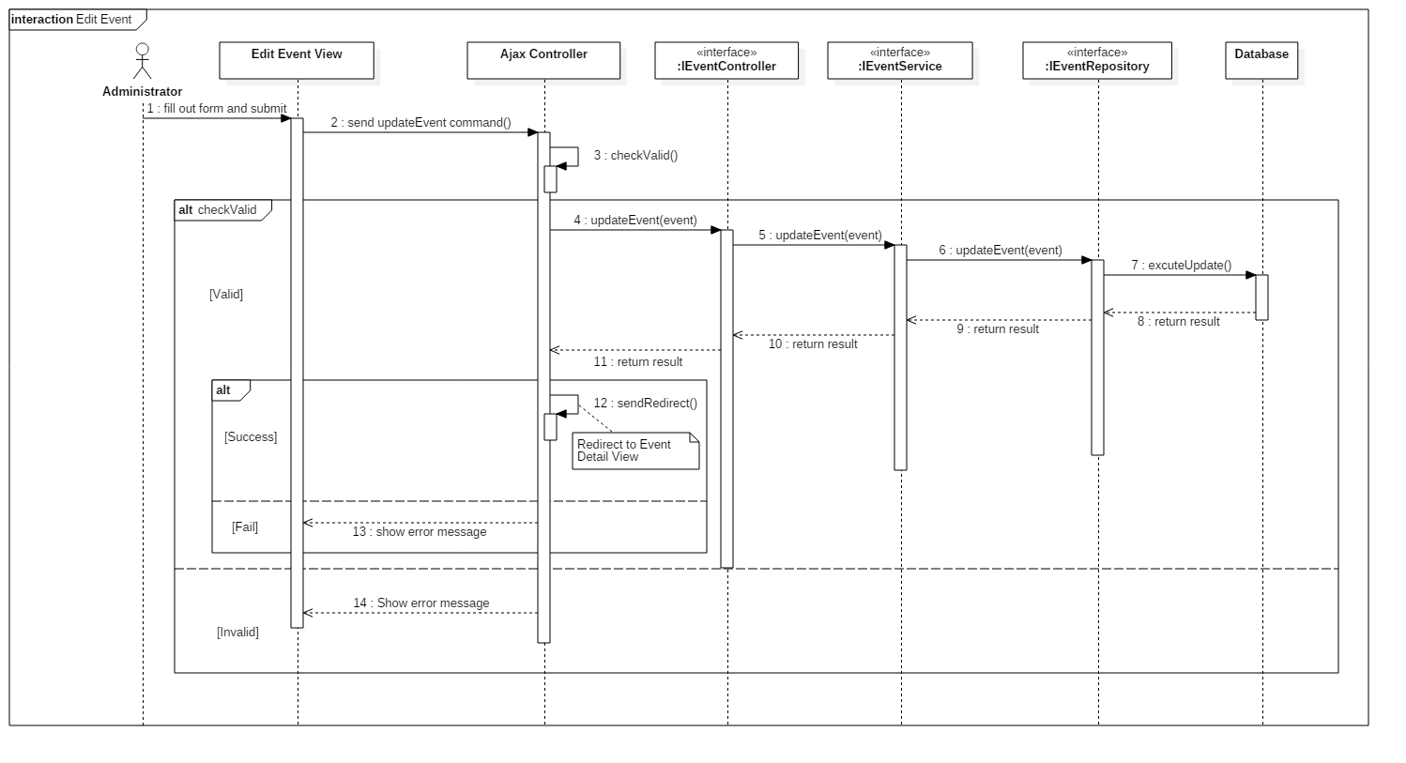 **4.3.1.20. Edit event**

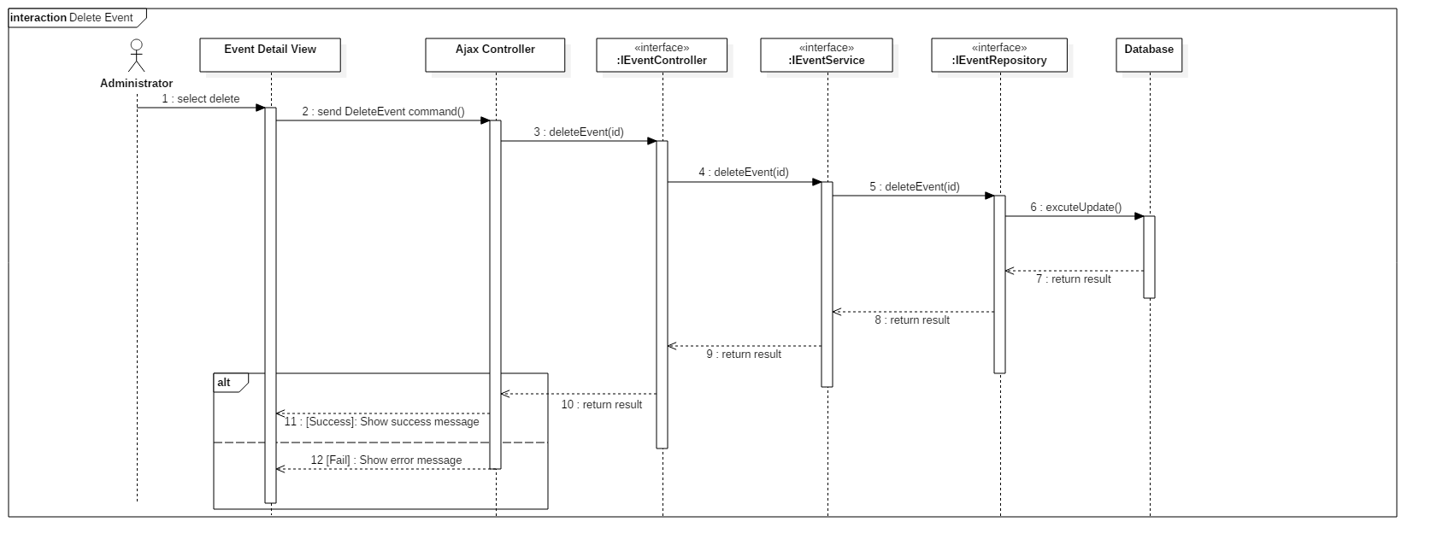 **4.3.1.21. Delete event**

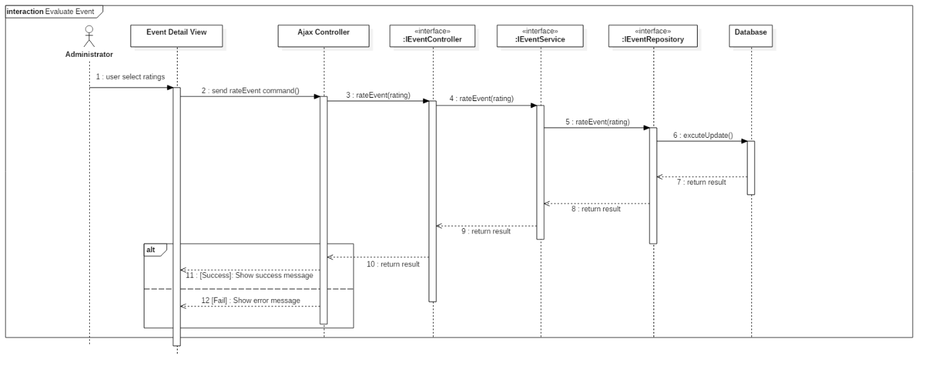 **4.3.1.22. Evaluate Event**

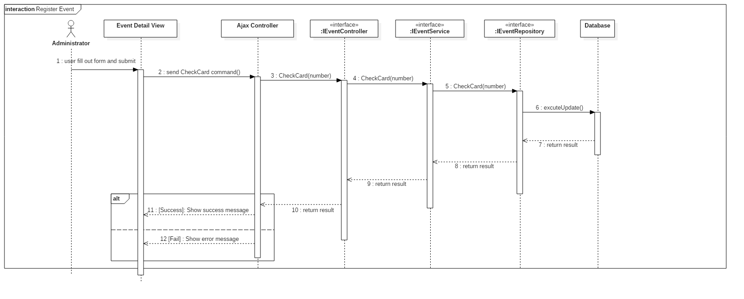 **4.3.1.23. Register event**

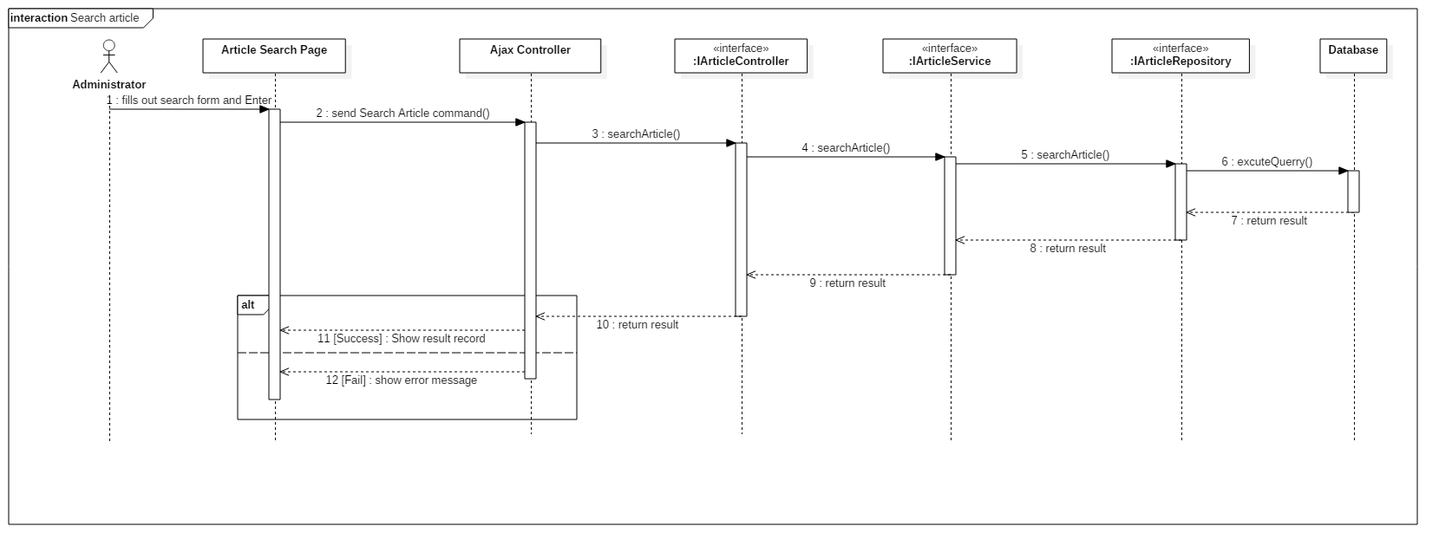 **4.3.1.24. Search article**

**5. Interface**

**5.1. Member**

**5.1.1. Web application**

**5.1.1.1. Display search model view**

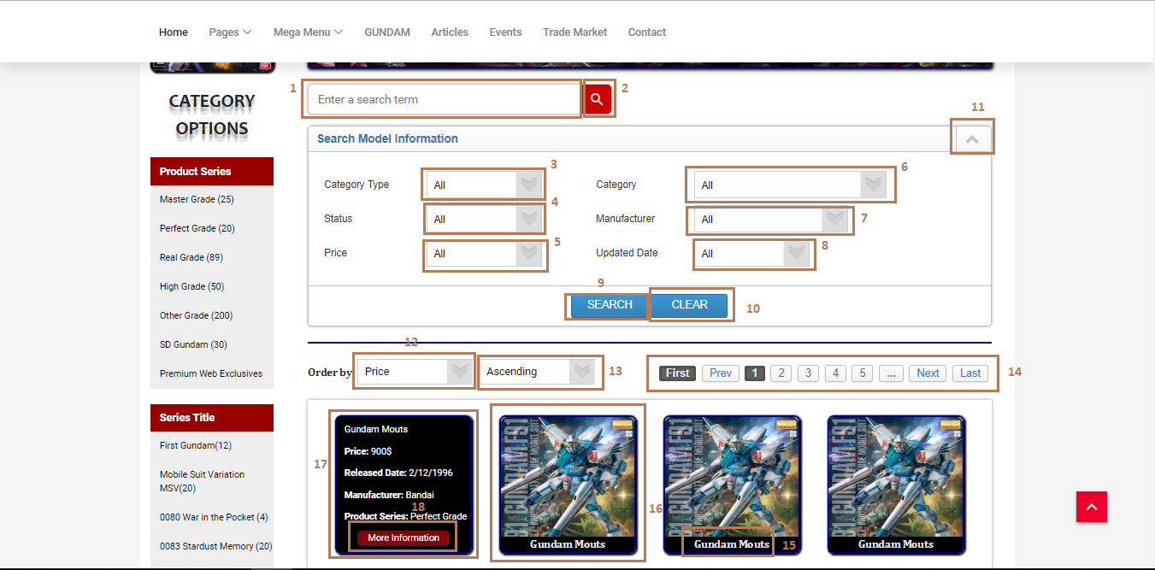

**Fields**

|  |  |  |  |  |  |  |  |
| --- | --- | --- | --- | --- | --- | --- | --- |
| **No** | **Field Name** | **Description** | **Read only** | **Mandatory** | **Control Type** | **Data Type** | **Length** |
| 1 | Search input text | Input search keyword, search by model name | No | No | Text input | String | N/A |
| 3 | CategoryType | Choose category types filter | No | No | Dropdown list | String | N/A |
| 4 | Status | Choose status filter | No | No | Dropdown list | String | N/A |
| 5 | Price | Choose price filter | No | No | Dropdown list | Float | N/A |
| 6 | Category | This field is loaded follow with user’s option in category type dropdown list, to choose the specified category | No | No | Dropdown list | String | N/A |
| 7 | Manufacturer | Choose manufacturer filter | No | No | Dropdown list | String | N/A |
| 8 | Updated Date | Choose updated date time filter | No | No | Dropdown list | String | N/A |
| 12 | Order By options | Choose order by options | No | No | Dropdown list | String | N/A |
| 13 | Ascending or Descending options | This dropdown list follows with order by dropdown list | No | No | Dropdwon list | String | N/A |
| 15 | Model name | Display model name | Yes | Yes | Label | String | N/A |
| 16 | Search record | Search record | Yes | Yes | N/A | N/A | N/A |
| 17 | Model detail info | Display model detail info when hover on a record | Yes | Yes | N/A | String | N/A |

**Buttons/Hyperlinks**

|  |  |  |  |  |
| --- | --- | --- | --- | --- |
| **No** | **Function** | **Description** | **Validation** | **Outcome** |
| 2 | Search | Send search command to server with value in search input text | N/A | List records match with the input keyword |
| 9 | Search with filters in search model information form | Send search command to server with values in search input text and all filters’s values in search model information form | N/A | List records match with the input keyword and the filters |
| 10 | Reset all field in search model information form | All dropdown list values will set to option “All” | N/A | All dropdown list values are set to option “All” |
| 11 | Open/close search information form | Open or close the search filters form | N/A | The search filters form will be pulled up/pushed down when click |
| 14 | Pagination | For paging with first, next, page numbers, next and last | N/A | The list records is updated match with page numbers |
| 18 | Redirect to the selected model’s detail page | Redirect to the selected model’s detail page | N/A | The selected model’s detail page is shown |

**5.1.1.2. Display model detail**

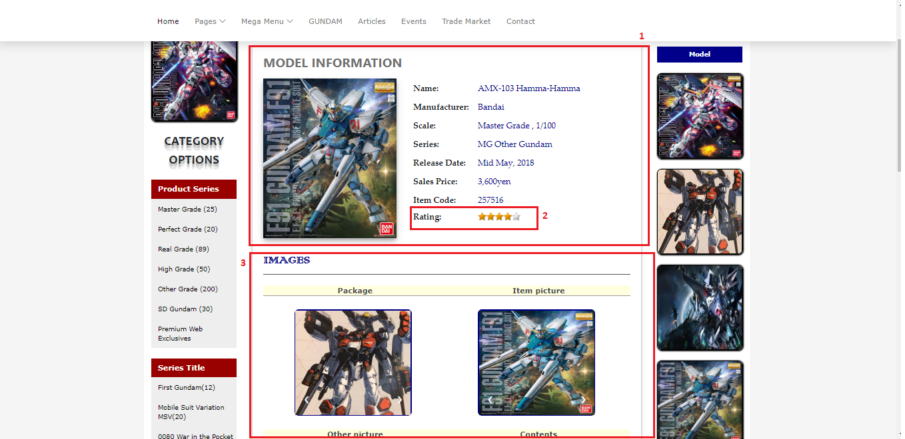

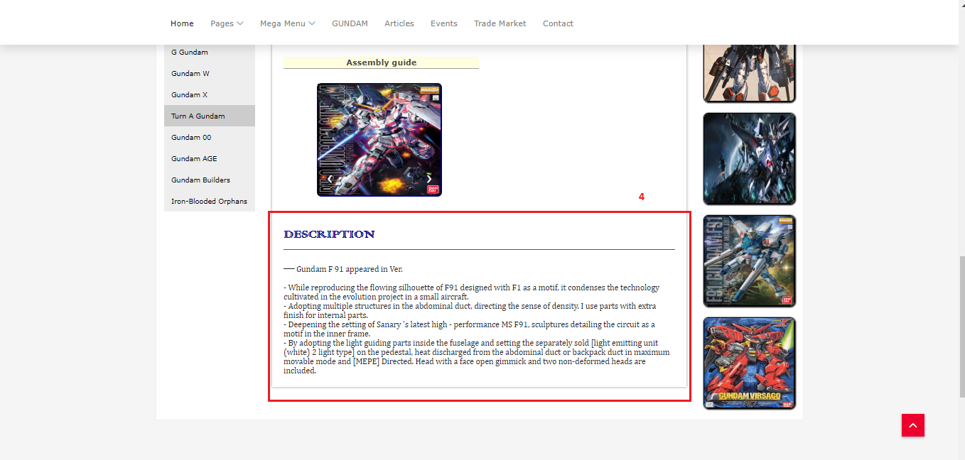

**Fields**

|  |  |  |  |  |  |  |  |
| --- | --- | --- | --- | --- | --- | --- | --- |
| **No** | **Field Name** | **Description** | **Read only** | **Mandatory** | **Control Type** | **Data Type** | **Length** |
| 1 | Model information | Model detail info | Yes | Yes | N/A | String | N/A |
| 3 | Model images | Model images | Yes | Yes | N/A | Img | N/A |
| 4 | Model description | Model’s description | Yes | Yes | N/A | String | N/A |

**Buttons/Hyperlinks**

|  |  |  |  |  |
| --- | --- | --- | --- | --- |
| **No** | **Function** | **Description** | **Validation** | **Outcome** |
| 2 | Rating | User evaluates a model | Each user can only  evaluate a model for one time | Model detail info with user’s rating |

**5.1.1.3. Display TradePost Listing view**

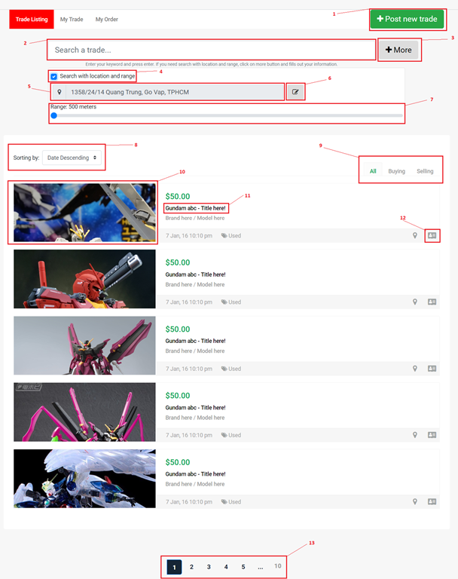

**Fields**

|  |  |  |  |  |  |  |  |
| --- | --- | --- | --- | --- | --- | --- | --- |
| **No** | **Field Name** | **Description** | **Read only** | **Mandatory** | **Control Type** | **Data Type** | **Length** |
| 2 | Search tradepost | Enter your keyword to search your tradepost. | No | Yes | Textbox | String | N/A |
| 4 | Search with location and range | Enable/Disable search with location and range | No | No | Checkbox | Boolean | N/A |
| 5 | Location | Display your location here | Yes | Yes | Textbox | String | N/A |
| 7 | Range | Slide to choose your range you want to search | No | Yes | Range input | Integer | N/A |
| 8 | Sorting | Select your sorting type. | No | Yes | Drop list | Integer | N/A |

**Buttons/Hyperlinks**

|  |  |  |  |  |
| --- | --- | --- | --- | --- |
| **No** | **Function** | **Description** | **Validation** | **Outcome** |
| 1 | Post New Trade | Go to Post New Trade page and display post new trade form. | N/A | Go to post new trade Page |
| 3 | More search | Show/Hide more search panel. | N/A | Show/Hide search form |
| 6 | Edit Location | Show Location editor modal. | N/A | Show edit modal |
| 9 | Change tab | Change tab view group by all/selling/buying. | N/A | Change tab |
| 10,11 | View TradePost details | Go to TradePost details view page to display all information about tradepost. | N/A | Go to post details Page |
| 12 | View owner profile | Go to tradepost owner profile. | N/A | Go to profile Page |
| 13 | Paging | Separate content to page list. | N/A | Change page content |

**5.1.1.4. Display TradePost details view**

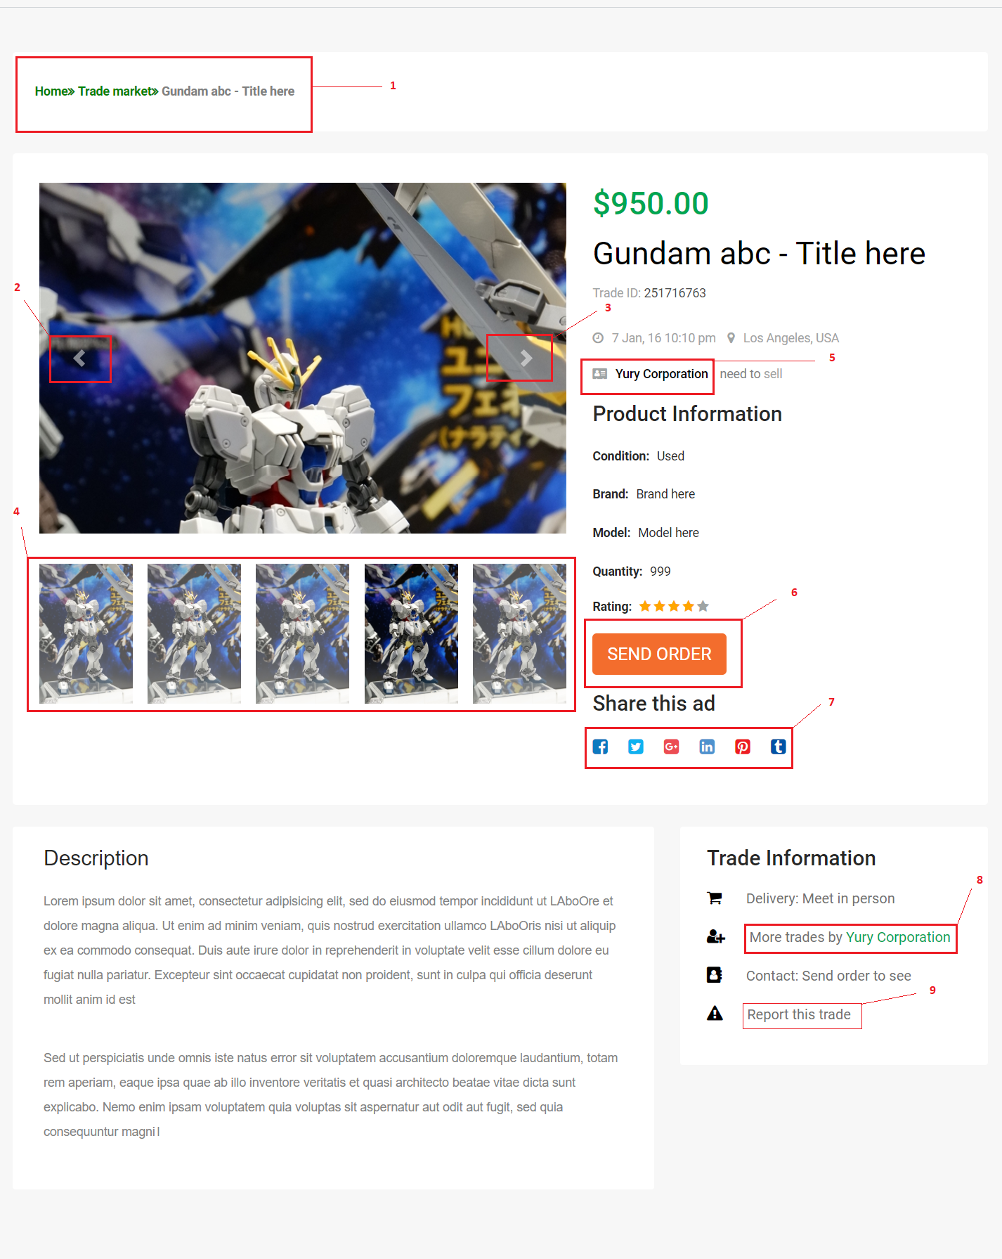

**Fields:** N/A

**Buttons/Hyperlinks**

|  |  |  |  |  |
| --- | --- | --- | --- | --- |
| **No** | **Function** | **Description** | **Validation** | **Outcome** |
| 1 | Page Address | Show address link to explore post. | N/A | Go to Page |
| 2 | Previous Image | Previous control for product Image slideshow. | N/A | Click for previous Image. |
| 3 | Next Image | Next control for product Image slideshow. | N/A | Click for next Image. |
| 4 | Slideshow indicator | List images in slideshow. Click to view this image. | N/A | Change Image. |
| 5 | Owner link | Click to go to owner profile page. | N/A | Go to profile Page |
| 6 | Send order button | Click to show send order modal. | N/A | Show  send order modal |
| 7 | Share this trade button list | Click on any social button to share this trade. | N/A | Share link to social page. |
| 8 | More trade post from owner | Click to show modal with trade post list from this trade post owner. | N/A | Show more post modal |
| 9 | Report button | Click to show report form. | N/A | Show report modal. |

**5.1.1.5. Display MyOrder view**

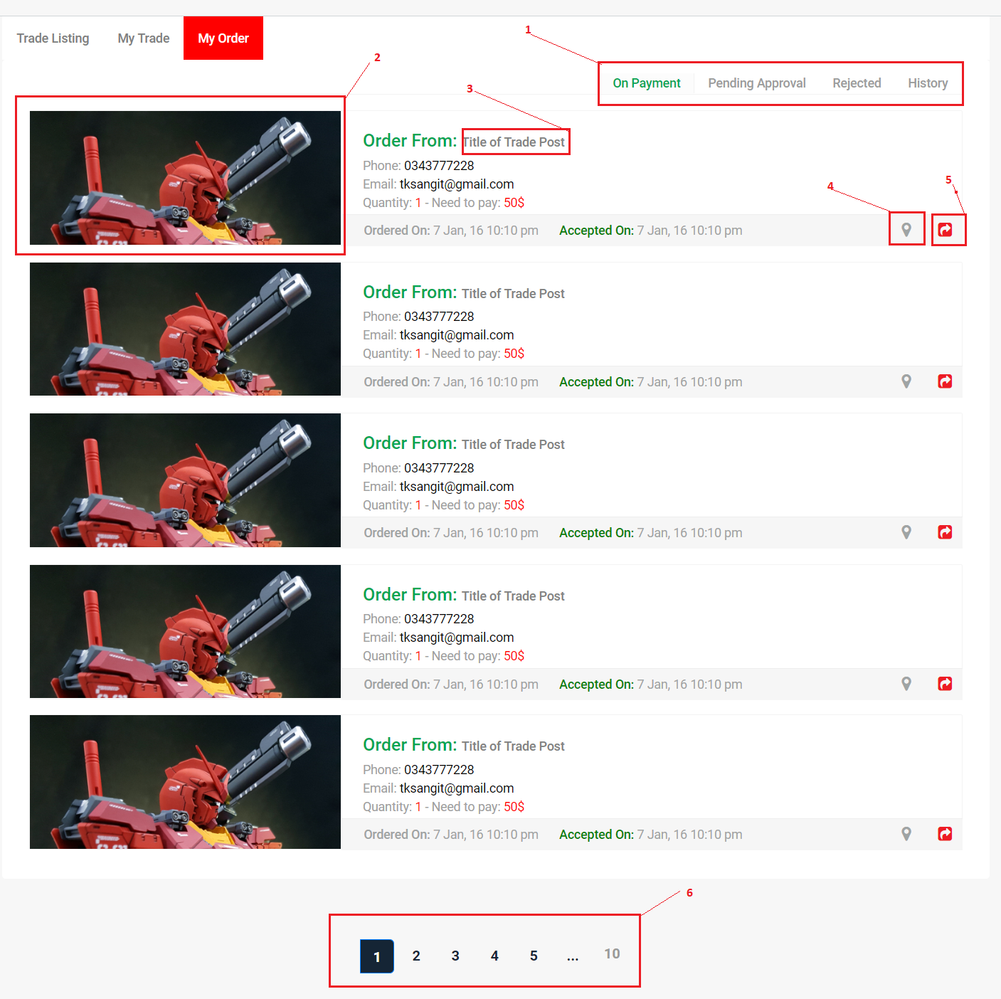

**Fields:** N/A

**Buttons/Hyperlinks:**

|  |  |  |  |  |
| --- | --- | --- | --- | --- |
| No | Function | Description | Validation | Outcome |
| 1 | Change tab | Click to change tab. | N/A | Change tab group |
| 2,3 | View Post details | Click to go to trade post details page. | N/A | Go to details page. |
| 4 | Get direction | Click to get direction to trade post owner. | N/A | Show direction modal. |
| 5 | Cancel order | Click to cancel order. | N/A | Show cancel order modal. |
| 6 | Paging | Separate content to page list. | N/A | Change page content. |

**5.1.1.6. Display article listing view**

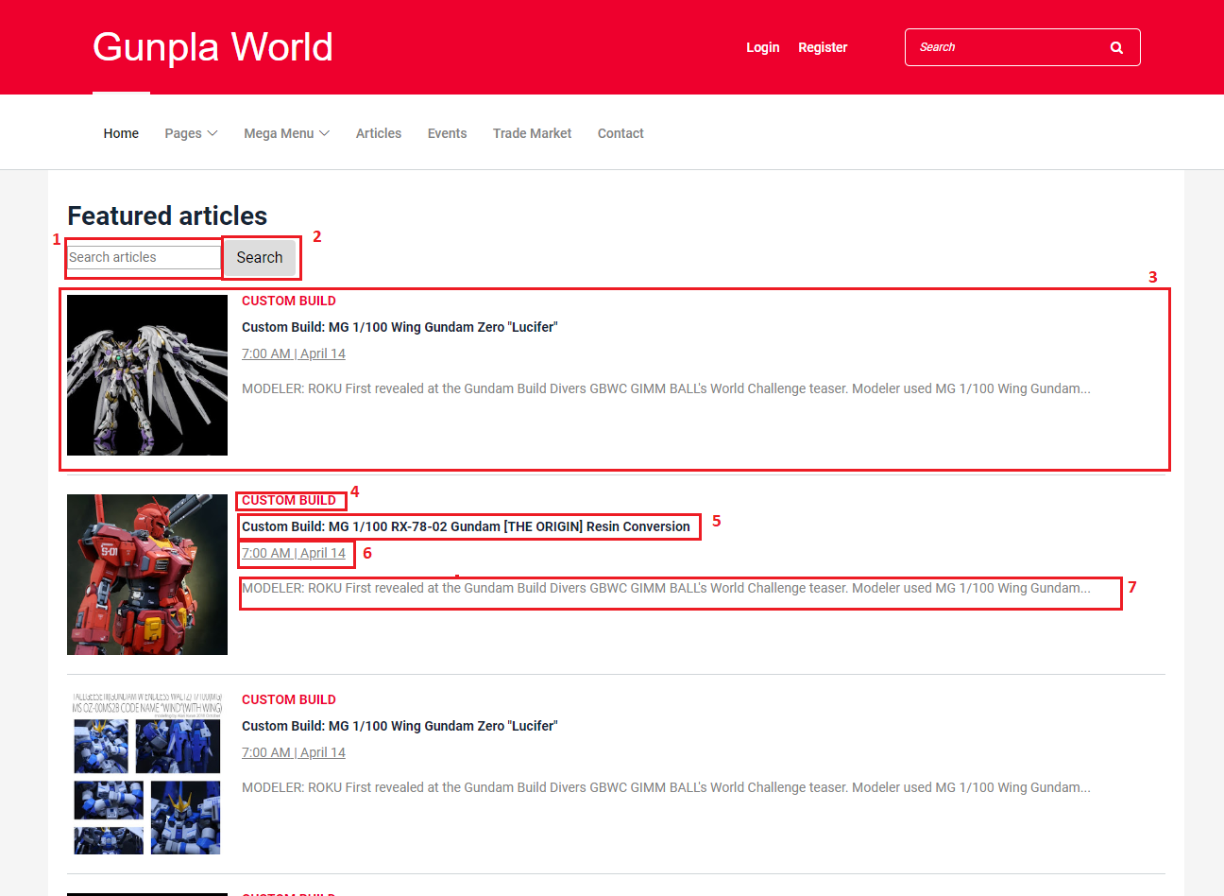

**Fields**

|  |  |  |  |  |  |  |  |
| --- | --- | --- | --- | --- | --- | --- | --- |
| **No** | **Field Name** | **Description** | **Read only** | **Mandatory** | **Control Type** | **Data Type** | **Length** |
| 1 | Search input text | Input search keyword, search by article title | No | No | Text input | String | N/A |
| 3 | Search record | Result record from searching | Yes | No | N/A | N/A | N/A |
| 6 | Article’s date | The day that the article was posted on | Yes | No | N/A | String | N/A |

**Buttons/Hyperlinks**

|  |  |  |  |  |
| --- | --- | --- | --- | --- |
| **No** | **Function** | **Description** | **Validation** | **Outcome** |
| 2 | Search | Send search command to server with value in search input text | N/A | List records match with the input keyword |
| 4 | Article category | The category that this article belongs to | N/A | Search articles with that category |
| 5 | Article’s title | Title of the article | N/A | Redirects to the article’s detail view |
| 7 | Article’s content | A short part of the article’s description | N/A | Redirects to the article’s detail view |

**5.1.1.7. Article detail view**

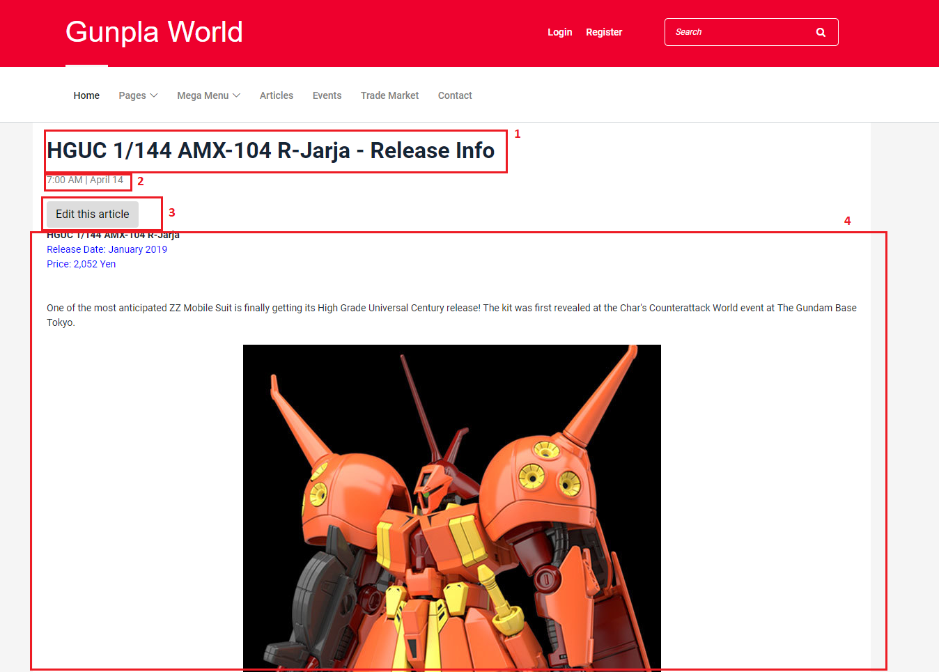

**Fields**

|  |  |  |  |  |  |  |  |
| --- | --- | --- | --- | --- | --- | --- | --- |
| **No** | **Field Name** | **Description** | **Read only** | **Mandatory** | **Control Type** | **Data Type** | **Length** |
| 1 | Article’s title | The title of the article | Yes | No | N/A | String | N/A |
| 2 | Article’s date | The day that the article was posted on | Yes | No | N/A | String | N/A |
| 4 | Article’s content | The content of the article | Yes | No | N/A | String | N/A |

**Buttons/Hyperlinks**

|  |  |  |  |  |
| --- | --- | --- | --- | --- |
| **No** | **Function** | **Description** | **Validation** | **Outcome** |
| 3 | Edit this article | Let the user edit the article | N/A | Redirects the user to the edit article view |

**5.1.1.8. Edit Article view**

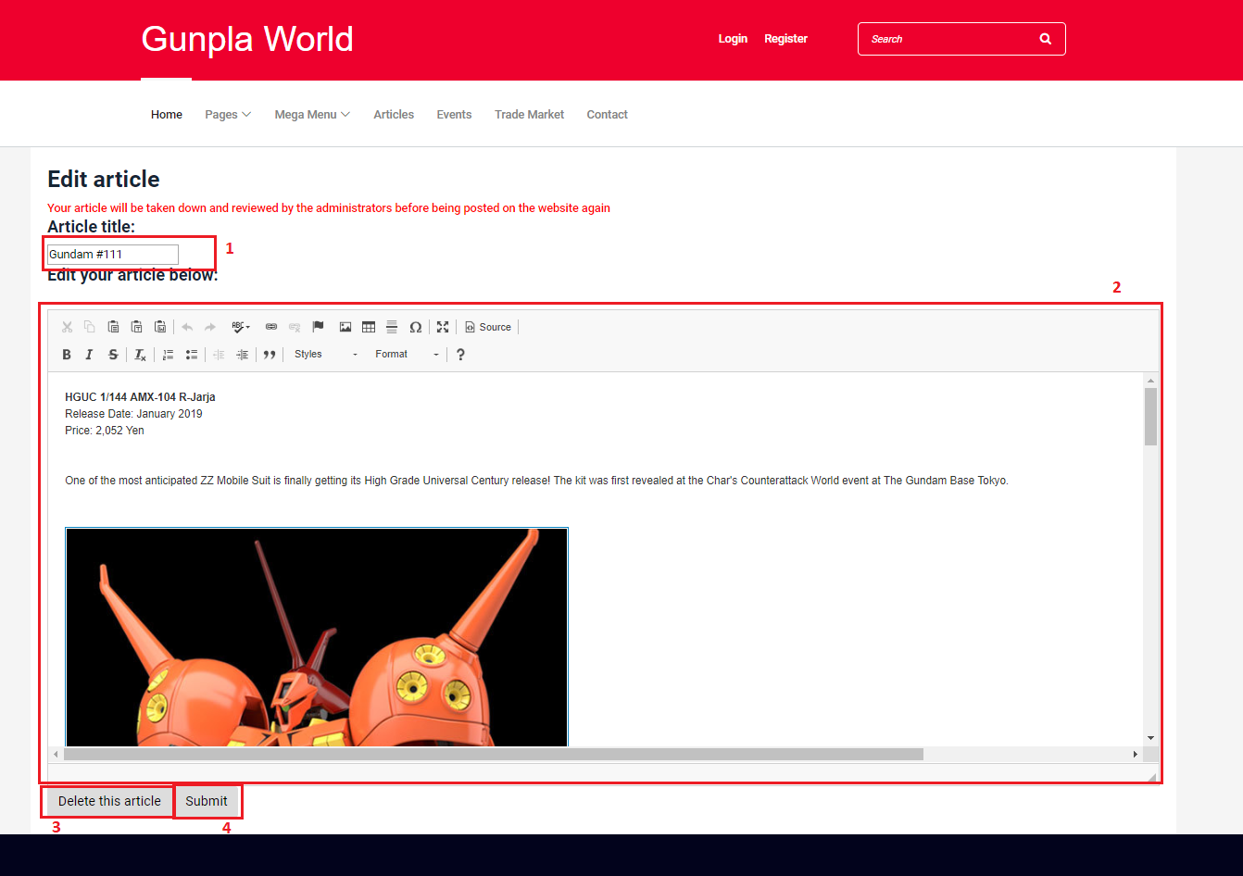

**Fields**

|  |  |  |  |  |  |  |  |
| --- | --- | --- | --- | --- | --- | --- | --- |
| **No** | **Field Name** | **Description** | **Read only** | **Mandatory** | **Control Type** | **Data Type** | **Length** |
| 1 | Article’s title | The title of the article | No | Yes | N/A | String | N/A |
| 2 | Article’s content | The content of the article | No | Yes | N/A | String | N/A |

**Buttons/Hyperlinks**

|  |  |  |  |  |
| --- | --- | --- | --- | --- |
| **No** | **Function** | **Description** | **Validation** | **Outcome** |
| 3 | Delete this article | Let the user delete the article | N/A | Prompts the user for confirmation before deleting the article |
| 4 | Submit | Submit the article | All required fields must not be empty | Success: article’s information is saved to the database and redirects the user to that article’s page.  Failure: show error message |

**5.1.1.9. Event list view**

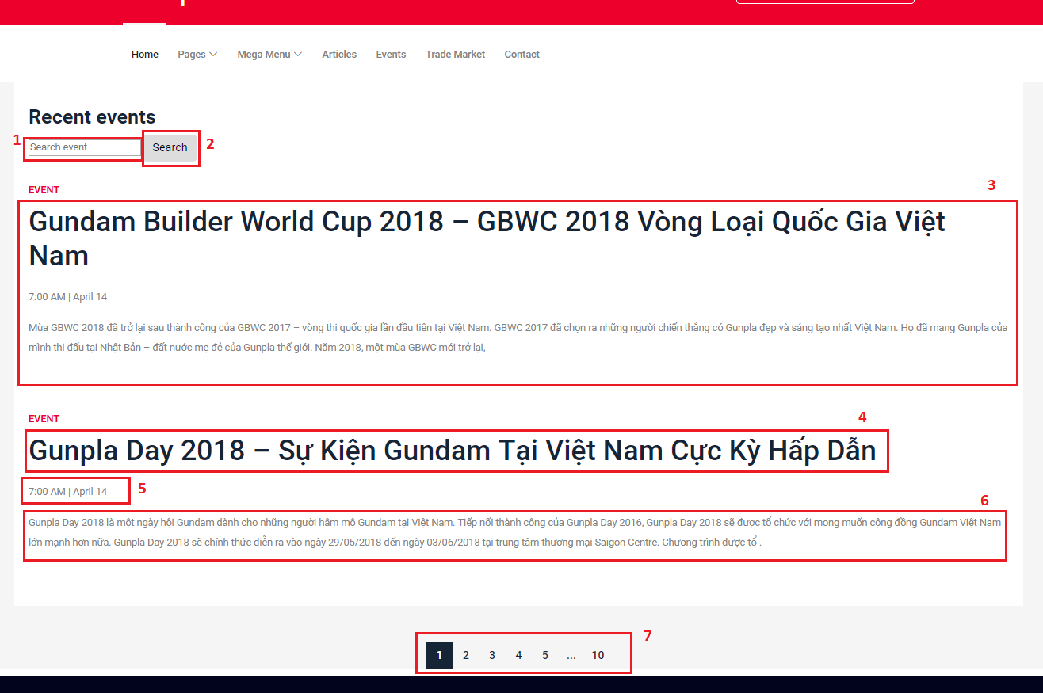

**Fields**

|  |  |  |  |  |  |  |  |
| --- | --- | --- | --- | --- | --- | --- | --- |
| **No** | **Field Name** | **Description** | **Read only** | **Mandatory** | **Control Type** | **Data Type** | **Length** |
| 1 | Search input text | Input search keyword, search by article title | No | No | N/A | String | N/A |
| 3 | Search result | Event records from searching | No | No | N/A | String | N/A |

**Buttons/Hyperlinks**

|  |  |  |  |  |
| --- | --- | --- | --- | --- |
| **No** | **Function** | **Description** | **Validation** | **Outcome** |
| 2 | Search | Search event by title | N/A | List records match with the input keyword |
| 4 | Event’s title | The title of the event | N/A | Redirects the user to the event’s detail view |
| 5 | Event’s date | The date the event was posted on | N/A | Redirects the user to the event’s detail view |
| 6 | Event’s content | A short part of the event’s content | N/A | Redirects the user to the event’s detail view |

**5.1.1.10. Event detail view**

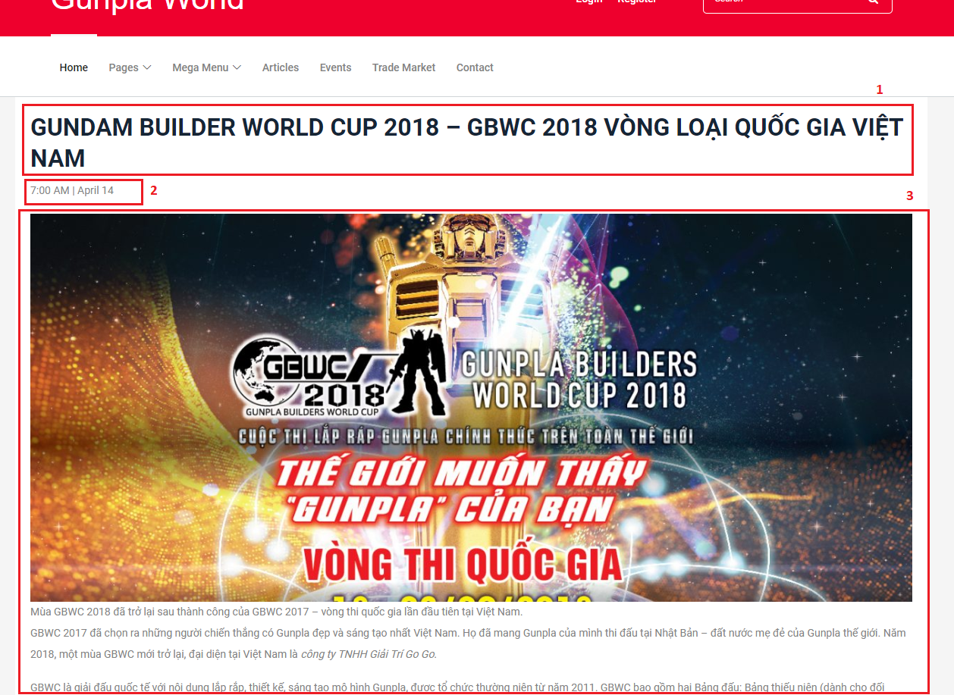

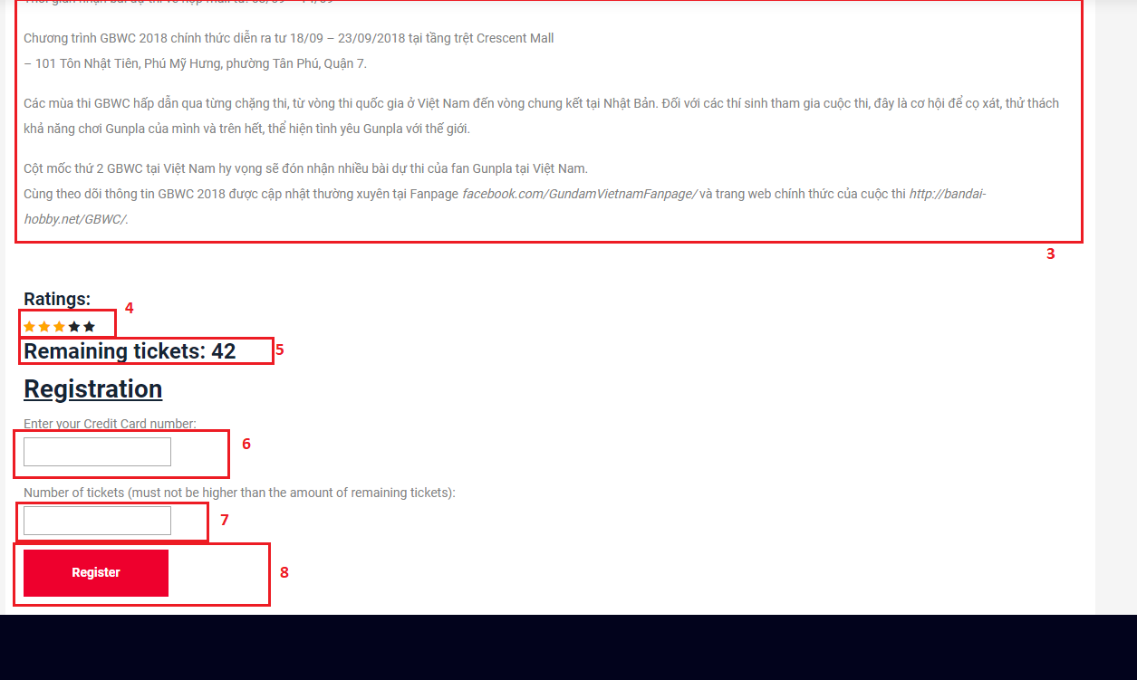

**Fields**

|  |  |  |  |  |  |  |  |
| --- | --- | --- | --- | --- | --- | --- | --- |
| **No** | **Field Name** | **Description** | **Read only** | **Mandatory** | **Control Type** | **Data Type** | **Length** |
| 1 | Event’s title | The event’s title | Yes | Yes | N/A | String | N/A |
| 2 | Event’ date | The date the event was posted on | Yes | Yes | N/A | String | N/A |
| 3 | Event’s content | The content of the event | Yes | Yes | N/A | String | N/A |
| 5 | Remaining tickets | The amount of tickets left available | Yes | Yes | N/A | String | N/A |
| 6 | Credit card number input | The number of member’s credit card | No | No | N/A | String | N/A |
| 7 | Number of tickets | The number of tickets the user wants to buy | No | Yes | N/A | String | N/A |

**Buttons/Hyperlinks**

|  |  |  |  |  |
| --- | --- | --- | --- | --- |
| **No** | **Function** | **Description** | **Validation** | **Outcome** |
| 4 | Ratings | Rate the event from 1-5 stars | N/A | Save the ratings to database |
| 8 | Register | Register the user to the event | N/A | Add the user to the list of event’s attendees |

**5.1.2. Mobile application**

**5.2. Buyer/Seller**

**5.2.1. Web application**

**5.2.1.1. Display Post New TradePost view**

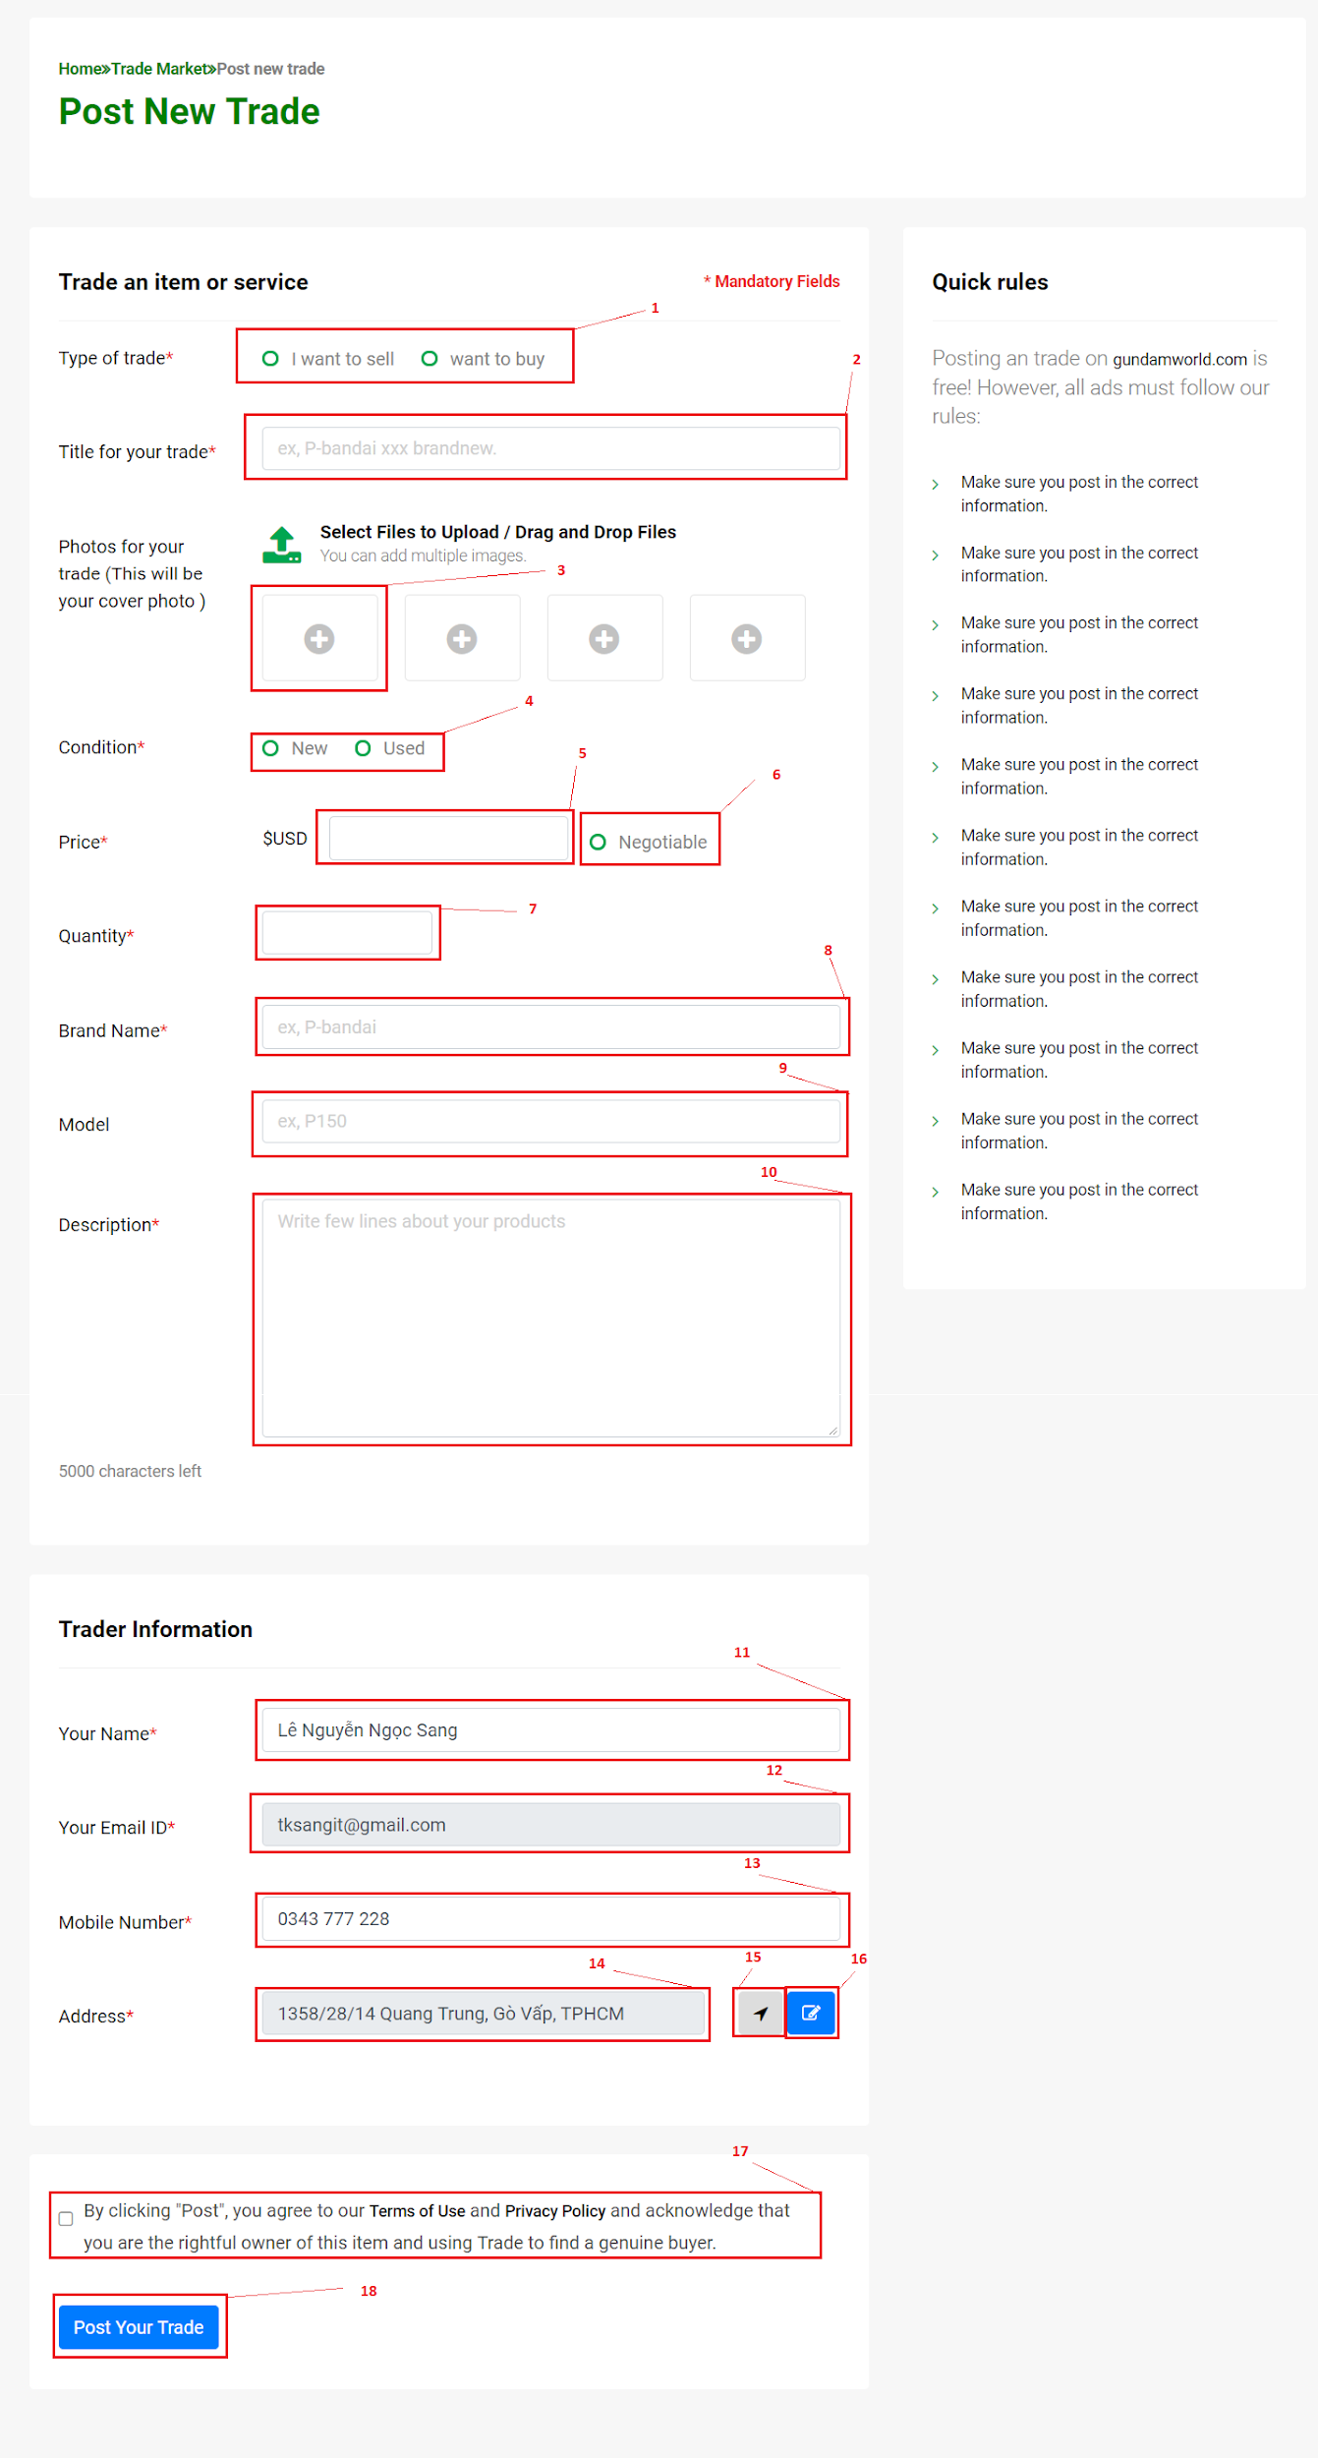

**Fields**

|  |  |  |  |  |  |  |  |
| --- | --- | --- | --- | --- | --- | --- | --- |
| **No** | **Field Name** | **Description** | **Read only** | **Mandatory** | **Control Type** | **Data Type** | **Length** |
| 1 | Type of trade | Select your type of trade: sell or buy | No | Yes | Radio button group | Integer | N/A |
| 2 | Title of your trade | Type your title here. | No | Yes | Textbox | String | N/A |
| 3 | Upload Image | Click to choose your image. | No | Yes | File | Image file type: png ,jpeg, jpg, gif | N/A |
| 4 | Condition | Choose your product condition: Used or New | No | Yes | Radio button group | Integer | N/A |
| 5 | Price | Type your price here | No | Yes | Textbox | String | N/A |
| 6 | Price Negotiable | Set your price can negotiable: Yes or No | No | No | Radio button | Boolean | N/A |
| 7 | Quantity | Type your quantity here | No | Yes | Textbox | Integer | N/A |
| 8 | Brand name | Type your product brand here | No | No | Textbox | String | N/A |
| 9 | Model | Type your product model here | No | No | Textbox | String | N/A |
| 10 | Description | Type your product description here | No | Yes | Textbox | String | N/A |
| 11 | Your name | Input your name here | No | Yes | Textbox | String | N/A |
| 12 | Your Email | Your email will show here | Yes | Yes | Textbox | String | N/A |
| 13 | Mobile Number | Input your mobile number here | No | Yes | Textbox | String | N/A |
| 14 | Address | Your location will show here | Yes | No | Textbox | String | N/A |
| 17 | Agree term | You need agree button to post your trade | No | Yes | Radio button | Boolean | N/A |

**Buttons/Hyperlinks**

|  |  |  |  |  |
| --- | --- | --- | --- | --- |
| **No** | **Function** | **Description** | **Validation** | **Outcome** |
| 15 | Auto get your location | Click to auto get your location and fills result to address field. | N/A | Call auto get location function |
| 16 | Edit your location | Click to show modal to select correct your location | N/A | Show  edit location modal |
| 18 | Post your trade | Click to submit your trade post | N/A | Submit form. |

**5.2.1.2. Display My trade view**

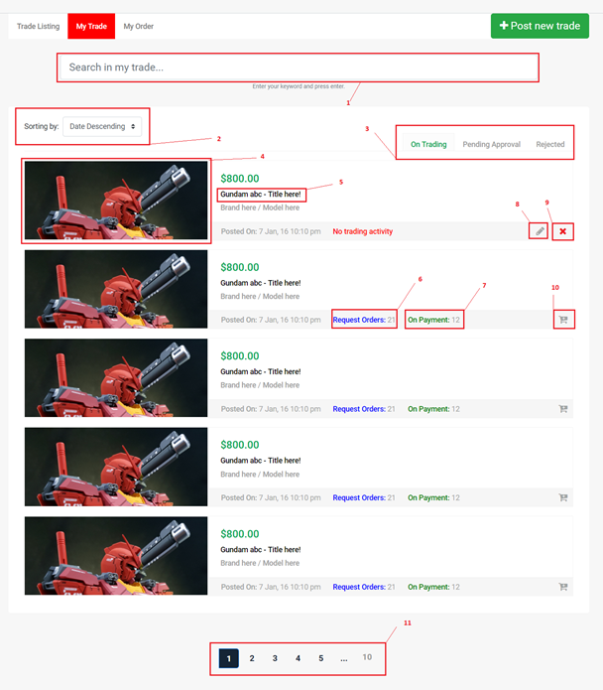

**Fields**

|  |  |  |  |  |  |  |  |
| --- | --- | --- | --- | --- | --- | --- | --- |
| **No** | **Field Name** | **Description** | **Read only** | **Mandatory** | **Control Type** | **Data Type** | **Length** |
| 1 | Search in my trade | Enter your keyword to search your tradepost. | No | Yes | Textbox | String | N/A |
| 2 | Sorting | Select your sorting type. | No | Yes | Drop list | Integer | N/A |

**Buttons/Hyperlinks**

|  |  |  |  |  |
| --- | --- | --- | --- | --- |
| **No** | **Function** | **Description** | **Validation** | **Outcome** |
| 3 | Change tab | Change tab view group by On trading/Pending Approval/Rejected | N/A | Change page content |
| 4,5 | View TradePost details | Go to TradePost details view page to display all information about tradepost. | N/A | Go to post details Page |
| 6 | View all Request Order | View all request order for the trade post. | N/A | Show  all request modal |
| 7 | View all On Payment | View all on payment for the trade post. | N/A | Show  on payment modal |
| 8 | Edit this trade | Edit information of this trade. | N/A | Show  edit modal |
| 9 | Delete this trade | Delete the trade | N/A | Show delete modal |
| 10 | Update Quantity | Update trade quantity | N/A | Show update quantity modal |
| 11 | Paging | Separate content to page list. | N/A | Change page content |

**5.2.2. Mobile Application**

**5.3. Guest**

**5.3.1. Web application**

**5.3.1.1. Register account**

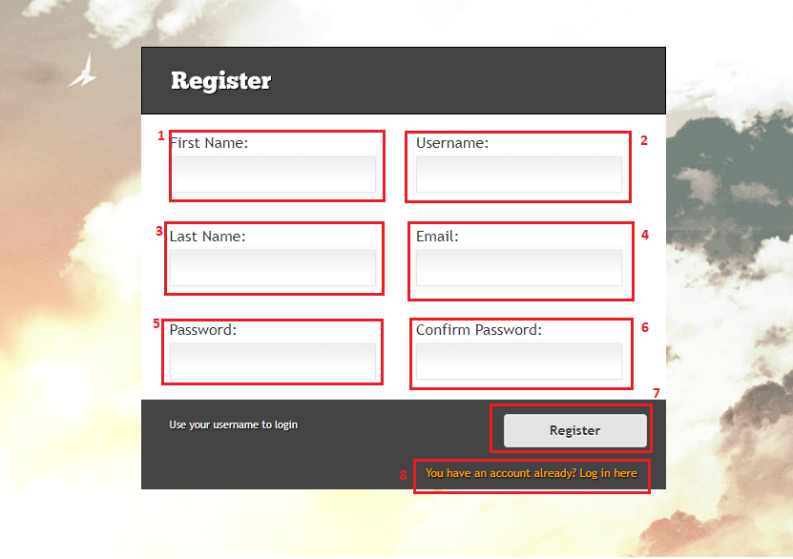

**Fields**

|  |  |  |  |  |  |  |  |
| --- | --- | --- | --- | --- | --- | --- | --- |
| **No** | **Field Name** | **Description** | **Read only** | **Mandatory** | **Control Type** | **Data Type** | **Length** |
| 1 | Firstname | User’s first name | No | Yes | Text input | String | <= 50 |
| 2 | Username | User’s username for login | No | Yes | Text input | String | <= 50 |
| 3 | Lastname | User’s lastname | No | Yes | Text input | String | <= 50 |
| 4 | Email | User’s email | No | Yes | Text input | String | <= 50 |
| 5 | Password | User’s password | No | Yes | Text input | String | <= 50 |
| 6 | ConfirmPassword | To confirm password, this field’s value must be the same as password | No | Yes | Text input | String | N/A |

**Buttons/Hyperlinks**

|  |  |  |  |  |
| --- | --- | --- | --- | --- |
| **No** | **Function** | **Description** | **Validation** | **Outcome** |
| 7 | Register | Send register command with values | Entered email must match the required format  Entered email and username must not be duplicate in database  Length of field’s value must not be out of range  Password and confirm password must match to each other  All required fields must be filled out | Login page with register success message |
| 8 | Redirect to login page | For whom already had account | N/A | Login page |

**5.3.1.2. Login**

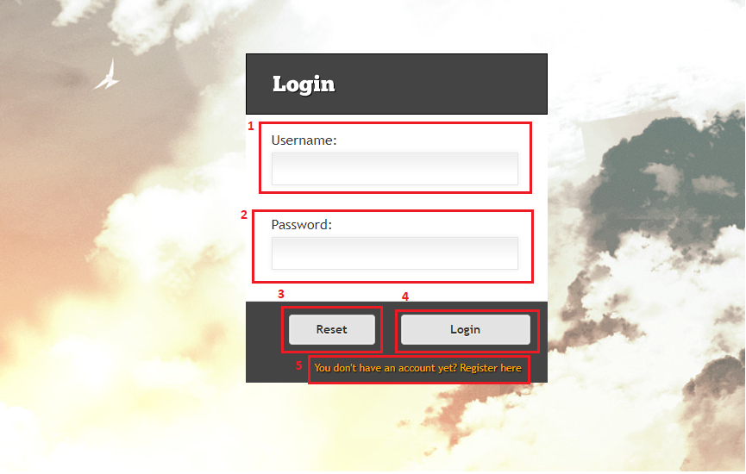

**Fields**

|  |  |  |  |  |  |  |  |
| --- | --- | --- | --- | --- | --- | --- | --- |
| **No** | **Field Name** | **Description** | **Read only** | **Mandatory** | **Control Type** | **Data Type** | **Length** |
| 1 | Username | User’s username | No | Yes | Text input | String | N/A |
| 2 | Password | User’s password | No | Yes | Text input | String | N/A |

**Buttons/Hyperlinks**

|  |  |  |  |  |
| --- | --- | --- | --- | --- |
| **No** | **Function** | **Description** | **Validation** | **Outcome** |
| 3 | Reset | Reset all fields | N/A | All fields are clear |
| 4 | Login | Send login command to the system with username and password | Check exist in database | Success: show homepage  Fail: show error message |
| 5 | Redirect to Register page | For whom doesn’t have an account | N/A | Register page is shown |

**5.3.2. Mobile application**

**5.4. Authenticated User**

**5.4.1. Web application**

**5.4.1.1. Get profile**

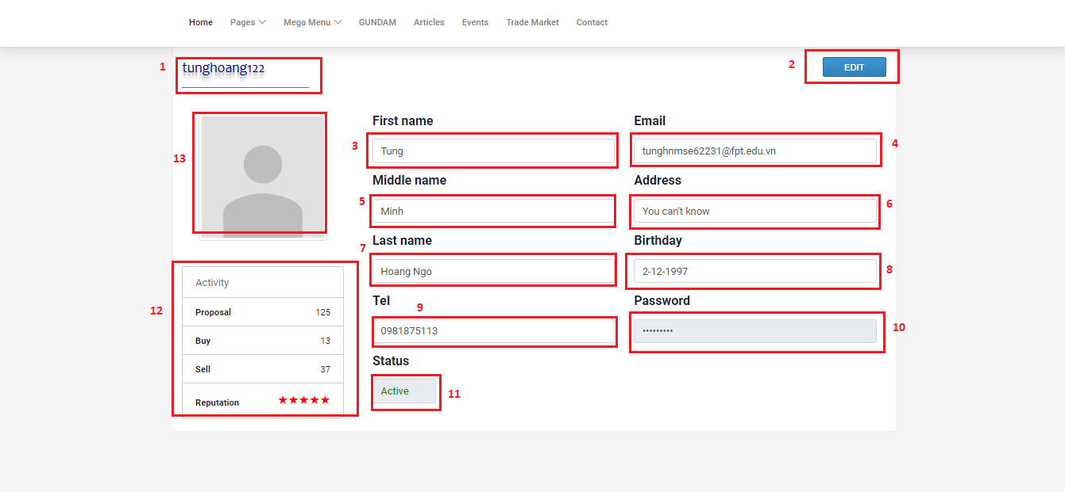

**Fields**

|  |  |  |  |  |  |  |  |
| --- | --- | --- | --- | --- | --- | --- | --- |
| **No** | **Field Name** | **Description** | **Read only** | **Mandatory** | **Control Type** | **Data Type** | **Length** |
| 1 | Username | User’s username for login | Yes | Yes | Label | String | <= 50 |
| 3 | Firstname | User’s firstname | Yes | Yes | Text input | String | <= 50 |
| 4 | Email | User’s email | Yes | Yes | Text input | String | <=50 |
| 5 | Middlename | User’s middle name | Yes | No | Text input | String | <=50 |
| 6 | Address | User’s address | Yes | No | Text input | String | <= 250 |
| 7 | Lastname | User’s lastname | Yes | Yes | Text input | String | <= 50 |
| 8 | Birthday | User’s birthday | Yes | No | DateTimePicker | String | <= 20 |
| 9 | Tel | User’s mobile number | Yes | No | Text input | String | 10-11 |
| 10 | Password | User’s password | Yes | Yes | Text input | String | <= 50 |
| 11 | Status | User’s status | Yes | Yes | Text input | String | N/A |
| 12 | Statistic | User’s statistics and ratings | Yes | Yes | N/A | String | N/A |
| 13 | Avatar | User’s image | Yes | Yes | Img | Img | N/A |

**Buttons/Hyperlinks**

|  |  |  |  |  |
| --- | --- | --- | --- | --- |
| **No** | **Function** | **Description** | **Validation** | **Outcome** |
| 2 | Edit | Redirect to edit page | N/A | Edit page is shown |

**5.4.1.2. Edit profile**

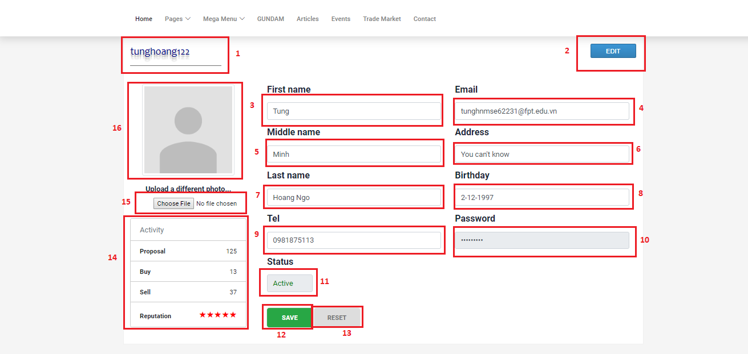

**Fields**

|  |  |  |  |  |  |  |  |
| --- | --- | --- | --- | --- | --- | --- | --- |
| **No** | **Field Name** | **Description** | **Read only** | **Mandatory** | **Control Type** | **Data Type** | **Length** |
| 1 | Username | User’s username for login | Yes | Yes | Label | String | <= 50 |
| 3 | Firstname | User’s firstname | No | Yes | Text input | String | <= 50 |
| 4 | Email | User’s email | No | Yes | Text input | String | <=50 |
| 5 | Middlename | User’s middle name | No | No | Text input | String | <=50 |
| 6 | Address | User’s address | No | No | Text input | String | <= 250 |
| 7 | Lastname | User’s lastname | No | Yes | Text input | String | <= 50 |
| 8 | Birthday | User’s birthday | No | No | DateTimePicker | String | <= 20 |
| 9 | Tel | User’s mobile number | No | No | Text input | String | 10-11 |
| 10 | Password | User’s password | Yes | Yes | Text input | String | <= 50 |
| 11 | Status | User’s status | Yes | Yes | Text input | String | N/A |
| 14 | Statistic | User’s statistics and ratings | Yes | Yes | N/A | String | N/A |
| 16 | Avatar | User’s image | No | Yes | Img | Img | N/A |

**Buttons/Hyperlinks**

|  |  |  |  |  |
| --- | --- | --- | --- | --- |
| **No** | **Function** | **Description** | **Validation** | **Outcome** |
| 2 | Edit | Redirect to edit page | N/A | Edit page is shown |
| 12 | Save | Send edit profile with values | Email must match the required format  All required fields must be filled out  Phone number is string of number  Email must not be duplicate in database  Length of all field’s values must be in range | Profile page is shown |
| 13 | Reset | All fields are reset to the beginning values | N/A | All fields are reset to the beginning values |
| 15 | Choose file | Update avatar | Check valid type of file image | Success: avatar is updated with the selected image from user  Fail: show error message |

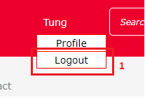 **5.4.1.3. Logout**

**Buttons/Hyperlinks**

|  |  |  |  |  |
| --- | --- | --- | --- | --- |
| **No** | **Function** | **Description** | **Validation** | **Outcome** |
| 1 | Logout | Logout from system, remove session | N/A | Homepage is shown |

**5.4.2. Mobile application**

**5.5. Administrator**

**5.5.1. Web application**

**5.5.1.1. Create model**

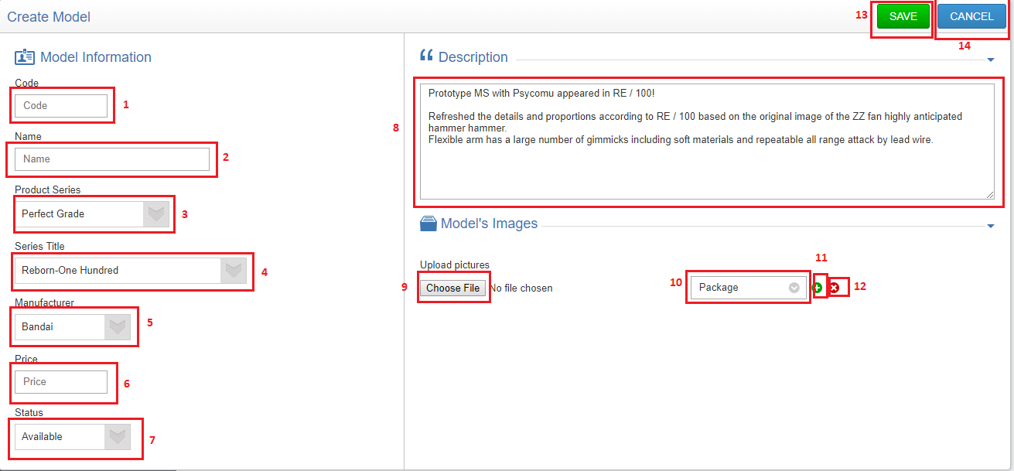

**Fields**

|  |  |  |  |  |  |  |  |
| --- | --- | --- | --- | --- | --- | --- | --- |
| **No** | **Field Name** | **Description** | **Read only** | **Mandatory** | **Control Type** | **Data Type** | **Length** |
| 1 | Code | Model’s code | No | Yes | Text input | String | <= 50 |
| 2 | Name | Model’s name | No | Yes | Text input | String | <= 50 |
| 3 | Product Series | Model’s product series | No | Yes | Dropdown list | String | N/A |
| 4 | Series Title | Model’s series title | No | Yes | Dropdown list | String | N/A |
| 5 | Manufacturer | Model’s manufacturer | No | Yes | Dropdown list | String | N/A |
| 6 | Price | Model’s price | No | No | Text input | String | <= 20 |
| 7 | Status | Model’s status | No | Yes | Dropdown list | String | N/A |
| 8 | Description | Model’s description | No | No | Text input | String | <= 350 |
| 10 | Type of image | Type of image | No | Yes | Dropdown list | String | <= 50 |

**Buttons/Hyperlinks**

|  |  |  |  |  |
| --- | --- | --- | --- | --- |
| **No** | **Function** | **Description** | **Validation** | **Outcome** |
| 9 | Choose image | Choose model’s image | Check valid type of file image | Image name is shown next by |
| 11 | Add more images | System displays 1 new row with the following lables and fields in a horizontal line:   * Import image: input type file * Image type: dropdown list * “+”: button * “-”: button | N/A | New row with the following lables and fields in a horizontal line:   * Import image: input type file * Image type: dropdown list * “+”: button * “-”: button |
| 12 | Remove image | System removes the selected rows, includes:   * Import image: input type file * Image type: dropdown list * “+”: button | N/A | System removes the selected rows, includes:   * Import image: input type file * Image type: dropdown list * “+”: button |
| 13 | Save | Send create model command | All required fields must be input  Invalid format of code  Duplicate model’s code  Length of fields’s value must be in range | Success: model information is saved to database and display model detail page  Fail: show error message |
| 14 | Cancel | Cancel creating model | N/A | Search model page is displayed |

**5.5.1.1. Edit model**

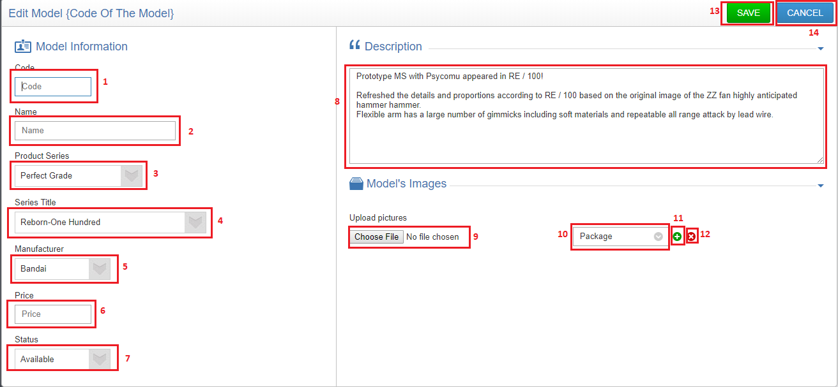

**Fields**

|  |  |  |  |  |  |  |  |
| --- | --- | --- | --- | --- | --- | --- | --- |
| **No** | **Field Name** | **Description** | **Read only** | **Mandatory** | **Control Type** | **Data Type** | **Length** |
| 1 | Code | Model’s code | No | Yes | Text input | String | <= 50 |
| 2 | Name | Model’s name | No | Yes | Text input | String | <= 50 |
| 3 | Product Series | Model’s product series | No | Yes | Dropdown list | String | N/A |
| 4 | Series Title | Model’s series title | No | Yes | Dropdown list | String | N/A |
| 5 | Manufacturer | Model’s manufacturer | No | Yes | Dropdown list | String | N/A |
| 6 | Price | Model’s price | No | No | Text input | String | <= 20 |
| 7 | Status | Model’s status | No | Yes | Dropdown list | String | N/A |
| 8 | Description | Model’s description | No | No | Text input | String | <= 350 |
| 10 | Type of image | Type of image | No | Yes | Dropdown list | String | <= 50 |

**Buttons/Hyperlinks**

|  |  |  |  |  |
| --- | --- | --- | --- | --- |
| **No** | **Function** | **Description** | **Validation** | **Outcome** |
| 9 | Choose image | Choose model’s image | Check valid type of file image | Image name is shown next by |
| 11 | Add more images | System displays 1 new row with the following lables and fields in a horizontal line:   * Import image: input type file * Image type: dropdown list * “+”: button * “-”: button | N/A | New row with the following lables and fields in a horizontal line:   * Import image: input type file * Image type: dropdown list * “+”: button * “-”: button |
| 12 | Remove image | System removes the selected rows, includes:   * Import image: input type file * Image type: dropdown list * “+”: button | N/A | System removes the selected rows, includes:   * Import image: input type file * Image type: dropdown list * “+”: button |
| 13 | Save | Send edit model command | All required fields must be input  Invalid format of code  Duplicate model’s code  Length of fields’s value must be in range | Success: model information is saved to database and display model detail page  Fail: show error message |
| 14 | Cancel | Cancel creating model | N/A | Search model page is displayed |

**5.5.1.3. Delete model**

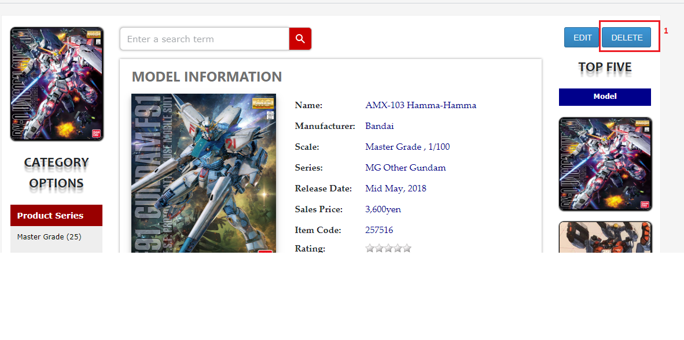

**Buttons/Hyperlinks**

|  |  |  |  |  |
| --- | --- | --- | --- | --- |
| **No** | **Function** | **Description** | **Validation** | **Outcome** |
| 1 | Delete model | Send delete model command | N/A | The selected model is delete and search model page is shown |

**5.5.1.4. Search account**

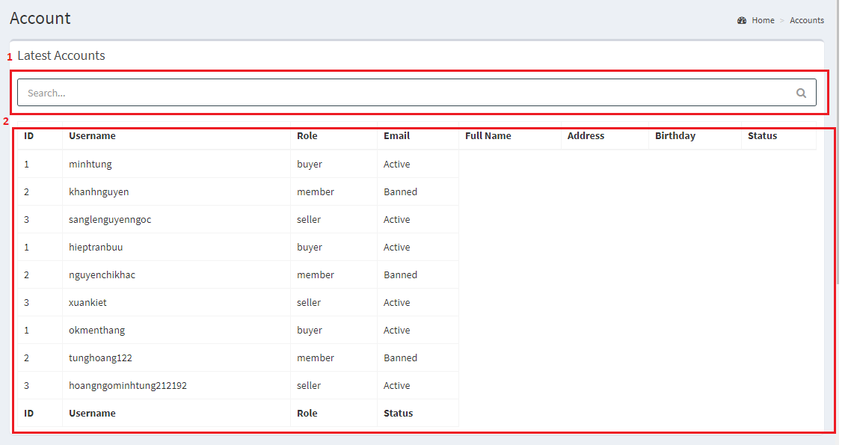

**Fields**

|  |  |  |  |  |  |  |  |
| --- | --- | --- | --- | --- | --- | --- | --- |
| **No** | **Field Name** | **Description** | **Read only** | **Mandatory** | **Control Type** | **Data Type** | **Length** |
| 1 | Search field | Search accounts | No | No | Text input | String | N/A |
| 2 | Account information | Account’s information | No | Yes | N/A | String | N/a |

**5.5.1.5. Ban/unban/edit account**

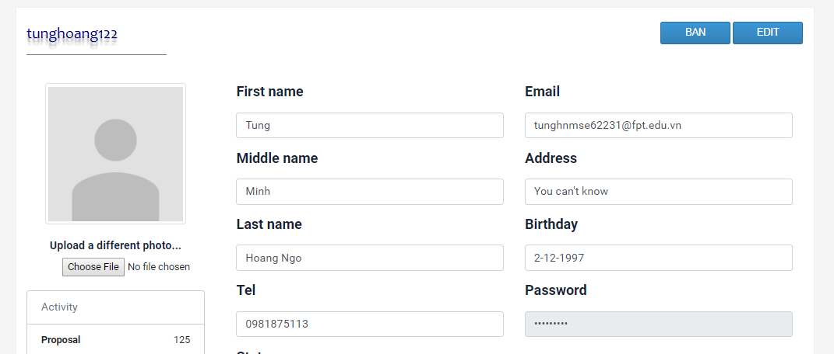

**5.5.2. Mobile application**

**6. Database Design**

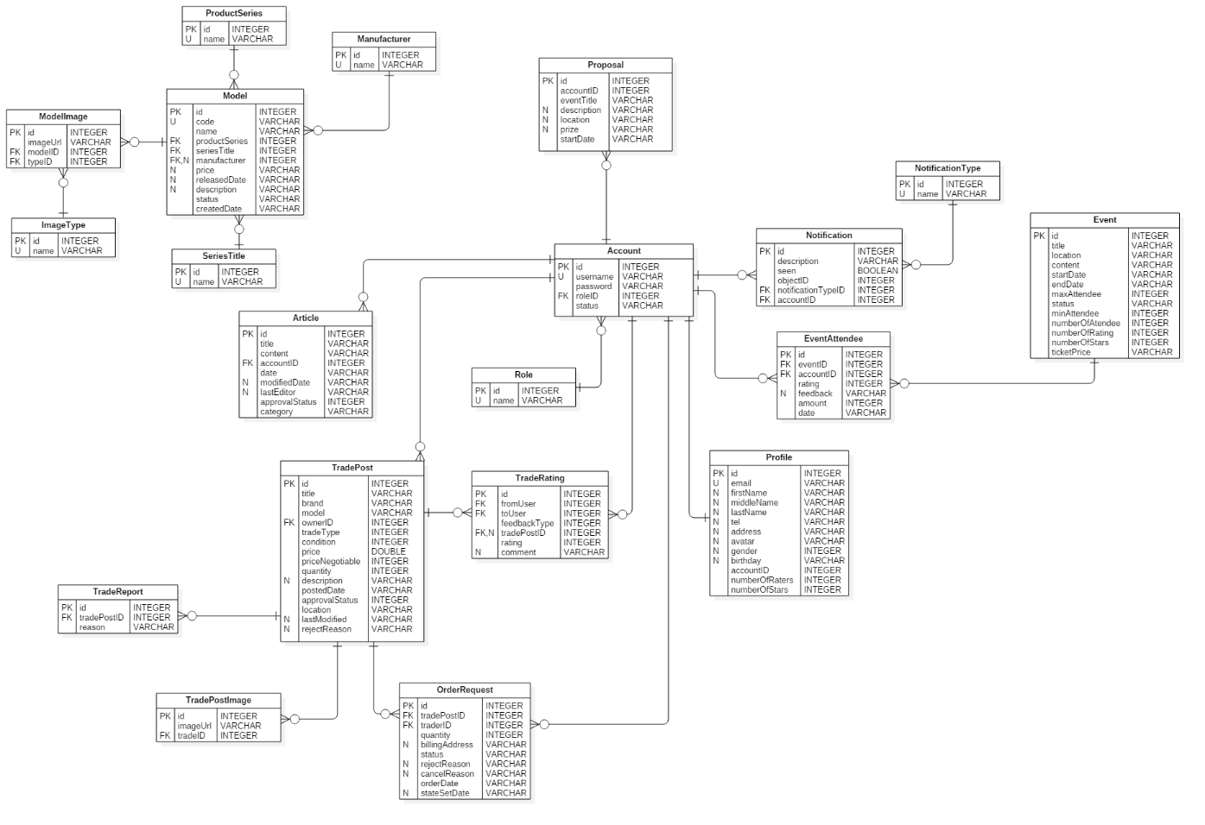 **6.1. Entity Relationship Diagram (ERD)**

**6.2. Data Dictionary**

|  |  |
| --- | --- |
| **Entity Data Dictionary** | |
| **Entity name** | **Description** |
| Model | Contain model information |
| SeriesTitle | Contain series title information, this is a type of model’s category |
| ProductSeries | Contain product series information, this is a type of model’s category |
| Manufacturer | Contain model’s manufacturer information |
| ModelImage | Contain model’s images |
| ImageType | Contain model’s image type |
| Article | Contain article information which is posted by authenticated users |
| Proposal | Contain proposal information which is posted by members |
| Account | Contain account information |
| Profile | Contain user’s profile information |
| Role | Contain role information |
| Event | Contain event information, which is created by administrator |
| EventAttendee | Contain information about event’s attendee, we also use this table to contain user’s evaluation about the events |
| Notification | Contain notification information |
| NotificationType | Contain types of notification |
| TradePost | Contain trade post information, which is created by buyer/seller |
| TradeRating | Contain user’s evaluation about the exchange |
| TradePostImage | Contain trade post’s images |
| TradeReport | Contain information about user’s report on exchange |
| OrderRequest | Contain member’s order request to trade posts |

**7. Algorithms**

**E. System Implementation & Test**

**1. Introduction**

**1.1. Overview**

This section provides in detail all necessary information about implementation information of **GWA** which includes physical database design, system state machine diagram and testing procedures which includes test plans, test cases and test result.

**1.2. Test Approach**

We use black box test approach to estimate our system quality. It’s the most appropriate testing method for the system to test all functions from a user’s point of view and help in exposing discrepancies in the specifications. Our testers don’t need to know how the software has been implemented, tests can be conducted by a body independent from the developers, allowing for an objective perspective and the avoidance of developer-bias.

**2. Database Relationship Diagram**

**2.1. Physical Diagram**

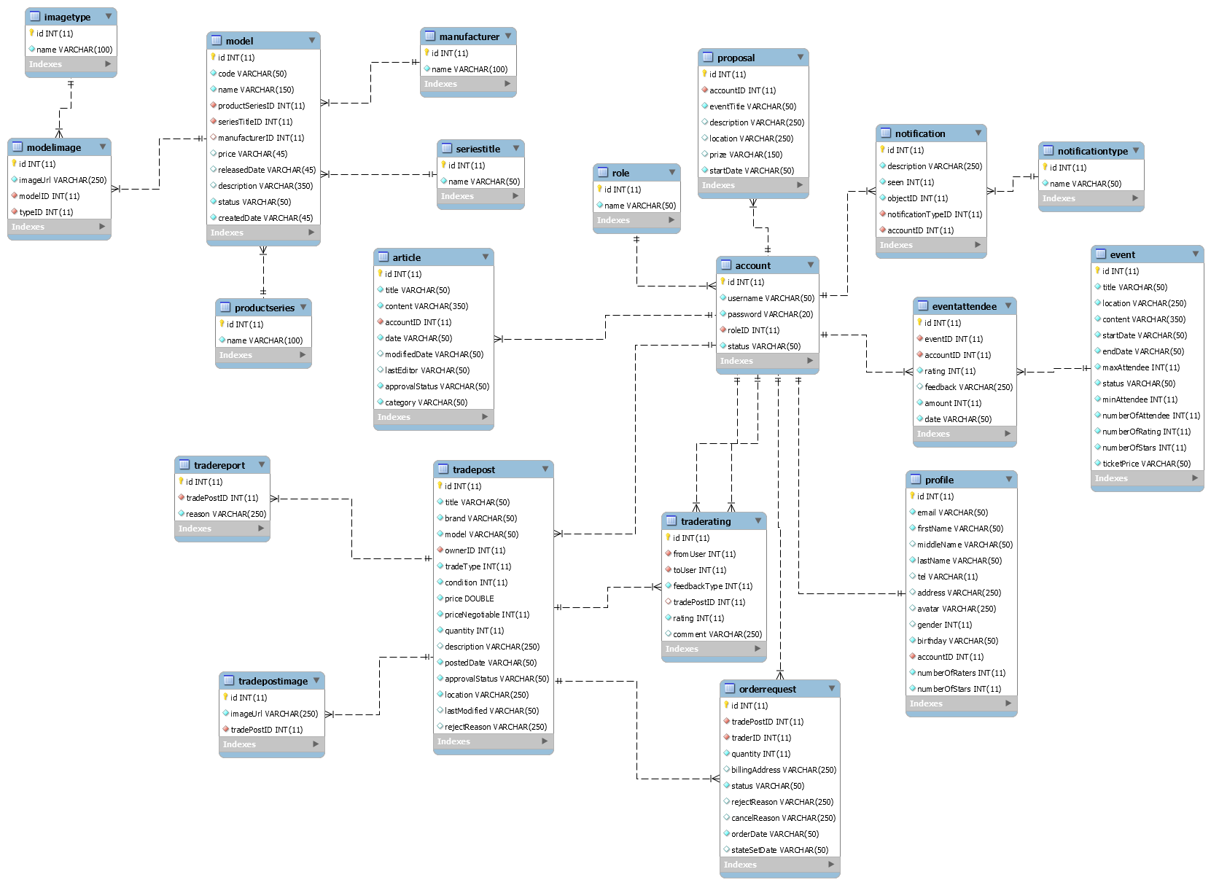

**2.2. Data dictionary**

|  |  |
| --- | --- |
| **Data dictionary: describe content of all tables** | |
| **Table name** | **Description** |
| model | Table which contains model information |
| seriesitle | Table which contains series title information, this is a type of model’s category |
| productseries | Table which contains product series information, this is a type of model’s category |
| manufacturer | Table which contains model’s manufacturer information |
| modelimage | Table which contains model’s images |
| imagetype | Table which contains model’s image type |
| article | Table which contains article information which is posted by authenticated users |
| proposal | Table which contains proposal information which is posted by members |
| account | Table which contains account information |
| profile | Table which contains user’s profile information |
| role | Table which contains role information |
| event | Table which contains event information, which is created by administrator |
| eventattendee | Table which contains information about event’s attendee, we also use this table to contain user’s evaluation about the events |
| notification | Table which contains notification information |
| notificationtype | Table which contains types of notification |
| tradepost | Table which contains trade post information, which is created by buyer/seller |
| traderating | Table which contains user’s evaluation about the exchange |
| tradepostimage | Table which contains trade post’s images |
| tradereport | Table which contains information about user’s report on exchange |
| orderrequest | Table which contains member’s order request to trade posts |

|  |  |  |  |
| --- | --- | --- | --- |
| **Entity name** | **Attributes** | **Description** | **Null** |
| model | id {pk} | Auto increment unique identifier | No |
| code | Model code | No |
| name | Model name | No |
| productSeriesID{fk} | Model’s product series | No |
| seriesTitleID {fk} | Model’s series title | No |
| manufacturerID | Model’s manufacturer | Yes |
| price | Model’s price | Yes |
| releasedDate | Model’s released date | Yes |
| description | Model’s description | Yes |
| status | Model’s status | No |
| createdDate | Model’s created date | No |
| productseries | id {pk} | Auto increment unique identifier | No |
| name | Unique name of product series | No |
| seriestitle | id {pk} | Auto increment unique identifier | No |
| name | Unique name of series title | No |
| manufacturer | id {pk} | Auto increment unique identifier | No |
| name | Unique name of manufacturer | No |
| modelimage | id {pk} | Auto increment unique identifier | No |
| imageUrl | Url of images | No |
| modelID {fk} | Model which images belong to | No |
| typeID {fk} | Type of images | No |
| imagetype | id {pk} | Auto increment unique identifier | No |
| name | Unique name of image type | No |
| account | id {pk} | Auto increment unique identifier | No |
| username | Unique username of user | No |
| password | Account password to login | No |
| roleID {fk} | Account’s role | No |
| status | Account status | No |
| role | id {pk} | Auto increment unique identifier | No |
| name | Unique name of role | No |
| proposal | id {pk} | Auto increment unique identifier | No |
| accountID {fk} | Proposal owner | No |
| eventTitle | Proposal event’s title | No |
| description | Proposal description | Yes |
| location | Proposal event’s location | Yes |
| prize | Proposal event’s prize | Yes |
| startDate | Proposal event start date | No |
| article | id {pk} | Auto increment unique identifier | No |
| title | Article title | No |
| content | Article content | No |
| accountID {fk} | User who posts the articles | No |
| date | Article posted date | No |
| modifiedDate | Article modified date | Yes |
| lastEditor | Article’s last editor | Yes |
| approvalStatus | Article’s approval status | No |
| category | Article’s category | No |
| notification | id {pk} | Auto increment unique identifier | No |
| description | Notification description | No |
| seen | Status seen | No |
| objectID | To save id of content object | No |
| notificationTypeID {fk} | Type of notification | No |
| accountID {fk} | User whom the notification is sent to | No |
| notificationtype | id {pk} | Auto increment unique identifier | No |
| name | Unique name of notification type | No |
| event | id {pk} | Auto increment unique identifier | No |
| title | Event title | No |
| location | Event location | No |
| content | Event’s content | No |
| startDate | Event start date | No |
| endDate | Event end date | No |
| maxAttendee | Event’s max attendee | No |
| status | Event’s status | No |
| minAttendee | Event’s min attendee | No |
| numberOfAttendee | Event’s number of attendee, this attribute is to improve query performance | No |
| numberOfRating | Event’s number of raters, this attribute is to improve query performance | No |
| numberOfStars | Event’s number of star ratings, this attribute is to improve query performance | No |
| ticketPrice | Event’s ticket price | No |
| eventattendee | id {pk} | Auto increment unique identifier | No |
| eventID {fk} | ID of event | No |
| accountID {fk} | Event’s attendee | No |
| rating | Event’s rating which is evaluated by user | No |
| feedback | Feedback of user about event | Yes |
| amount | Number of tickets that a user register | No |
| date | Date when user registers for event | No |
| profile | id {pk} | Auto increment unique identifier | No |
| email | User’s email | No |
| firstName | User’s firstname | No |
| middleName | User’s middleName | Yes |
| lastName | User’s lastname | No |
| tel | User’s mobile number | Yes |
| address | User’s address | Yes |
| avatar | User’s avatar image | Yes |
| gender | User’s gender | Yes |
| birthday | User’s birthday | No |
| accountID {fk} | Profile owner | No |
| numberOfRaters | Number of users who rate this user, this attribute is to improve query performance | No |
| numberOfStars | Number of star ratings from users, this attribute is to improve query performance | No |
| tradepost | id {pk} | Auto increment unique identifier | No |
| title | Trade post title | No |
| brand | Sale product’s brand | No |
| model | Sale product name | No |
| ownerID {fk} | User who posts this trade post | No |
| tradeType | Type of trade post: buyer/seller | No |
| condition | Condition of trade post | No |
| price | Sale product’s price | No |
| priceNegotiable | Price that may be negotiable between traders | No |
| quantity | Sale product quantity | No |
| description | Trade post description | Yes |
| postedDate | Date when trade post is created | No |
| approvalStatus | Trade post approval status by administrator | No |
| location | Trade post location | No |
| lastModified | Trade post’s last modified | Yes |
| rejectReason | Trade post’s reject reason by admin | Yes |
| tradereport | id {pk} | Auto increment unique identifier | No |
| tradePostID {fk} | ID of the trade post which is reported by user | No |
| reason | Report reason | No |
| tradepostimage | id {pk} | Auto increment unique identifier | No |
| imageUrl | Url of image | No |
| tradePostID {fk} | Trade post which images belong to | No |
| traderating | id {pk} | Auto increment unique identifier | No |
| fromUser {fk} | User who evaluates | No |
| toUser {fk} | User who is evaluated | No |
| feedbackType | To check whether the evaluations is from trade owner to user or users to trade owner | No |
| tradePostID {fk} | This attribute is used when user evaluates a trade post | Yes |
| rating | Trade post rating | No |
| comment | User’s feedback about trade post | Yes |
| orderrequest | id {pk} | Auto increment unique identifier | No |
| tradePostID {fk} | The trade post which user request order to | No |
| traderID {fk} | User who requests order to trade post | No |
| quantity | Product order quantity | No |
| billingAddress | Address that is negotiable for exchange | Yes |
| status | Order request status | No |
| rejectReason | This attribute is used when trade post owner reject traders after accepted their order request | Yes |
| cancelReason | This attribute is used when trade post owner cancel user’s order request to trade post | Yes |
| orderDate | Date of order request | No |
| stateSetDate | This attribute is used when trade post owner reject or cancel order request, if reject, this attribute will belong to reject concept. If cancel, this attribute will belong to cancel concept | Yes |

**3. Performance Measures**

Website can locate the user’s location in 2 seconds max

**4. Test plan**

The purpose of this section is to verify and ensure that GWA meets its requirements and design specification. The following part will describe which features to be tested and which will not.

**4.1. Features to be tested**

**Web and mobile application:**

* Search models and view detail
* Crawl models, articles
* Proposal to open event
* Register for event
* Post for trade/exchange
* Request order to a trade post

**4.2. Features not to be tested**

Functions are not listed above won’t be tested.

**5. System Testing Test Case**

**5.1. Communication Diagram**

**5.1.1. Manipulate crawling**

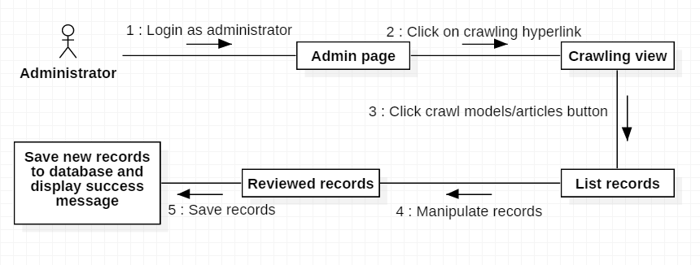

**5.1.2. Search for model information**

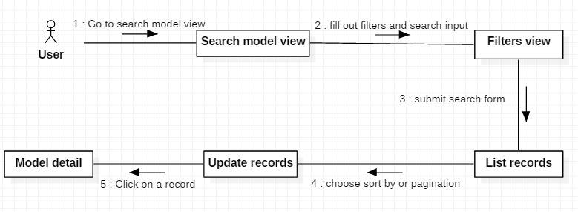

**5.1.3. Manipulate trade post**

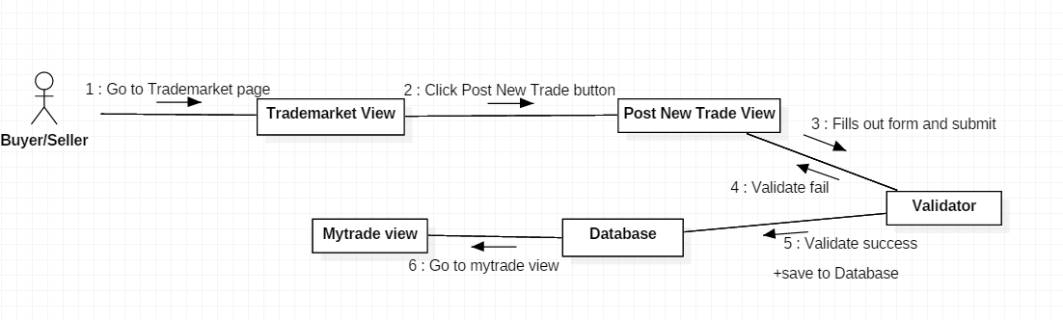

**5.1.4. Request order to trade post for exchange**

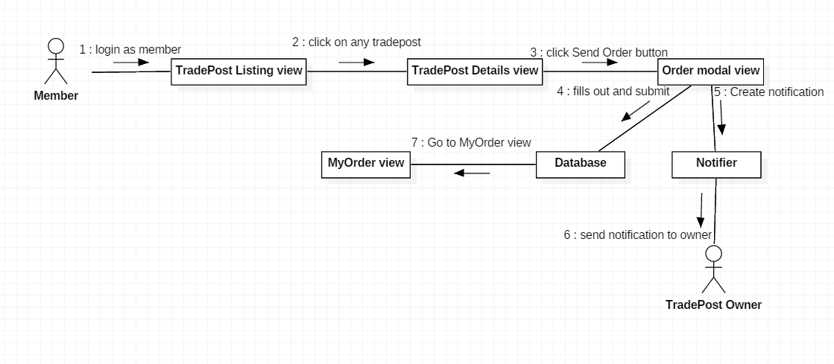

**5.1.5. Register for event**

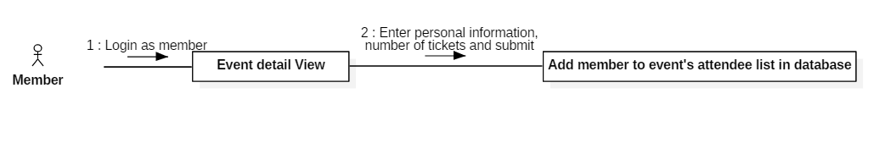

**5.1.6. Create articles**

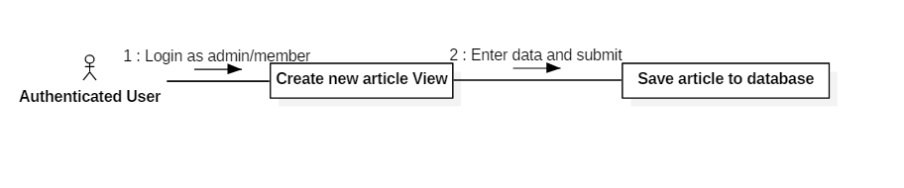

**5.2. Web and Mobile Application Test case**

**5.2.1. Manipulate crawling**

|  |  |  |  |  |  |
| --- | --- | --- | --- | --- | --- |
| **ID** | **Test Case Description** | **Test Case Procedure** | **Expected output** | **Result** | **Test Date** |
| AMC1 | Crawl models | 1. Login with role “Admin” 2. Go to “Crawling” view. 3. Click “crawl model” or “crawl articles” button. | List of crawling models/articles records is displayed |  |  |
| AMC2 | Review records | 1. CRUD records | The selected record information is updated when admin submit |  |  |
| AMC3 | Save records | 1. Click “SAVE” button | Save new records to database and display success message on the view |  |  |

**5.2.2. Search for model information**

|  |  |  |  |  |  |
| --- | --- | --- | --- | --- | --- |
| **ID** | **Test Case Description** | **Test Case Procedure** | **Expected output** | **Result** | **Test Date** |
| SFM1 | Search for model information with filters | 1. Go to “Search Model” view. 2. Fill out the search form with filters 3. Click search button | List of matching records are shown with filters sort by and pagination |  |  |
| SFM2 | Choose filter sorts by and pagination | 1. Choose sort by options or pagination | Updated list records follow the filters and pagination |  |  |
| SFM3 | Show model detail information | 1. Click on a record’s “More information” button | The selected model detail page is shown |  |  |

**5.2.3. Manipulate trade post**

|  |  |  |  |  |  |
| --- | --- | --- | --- | --- | --- |
| **ID** | **Test Case Description** | **Test Case Procedure** | **Expected output** | **Result** | **Test Date** |
| MTP1 | Post New Trade with valid data. | 1. Click “Post new trade” button. 2. Fills out form with valid data and submit 3. Click “Post your trade” button. | Go to My trade view. |  |  |
| MTP2 | Post New Trade with invalid data. | 1. Click “Post new trade” button. 2. Fills out form with invalid data and submit 3. Click “Post your trade” button. | Stay at Post new trade view and show error message for invalid data. |  |  |

**5.2.4. Order to trade post for exchange**

|  |  |  |  |  |  |
| --- | --- | --- | --- | --- | --- |
| **ID** | **Test Case Description** | **Test Case Procedure** | **Expected output** | **Result** | **Test Date** |
| OTT1 | Send order with valid quantity | 1. Click “Send Order” button on trade post details view. 2. Enter valid quantity 3. fills out Trader information form 4. Click submit | Go to My order view |  |  |
| OTT2 | Send order with invalid quantity | 1. Click “Send Order” button on trade post details view. 2. Enter invalid quantity 3. fills out Trader information form 4. Click submit | Stay at send order modal view and show error message for invalid quantity.. |  |  |

**5.2.5. Register for event**

|  |  |  |  |  |  |
| --- | --- | --- | --- | --- | --- |
| **ID** | **Test Case Description** | **Test Case Procedure** | **Expected output** | **Result** | **Test Date** |
| RE1 | Register with a valid card | 1. Enter card number and all required information 2. Click on “Register” | Save information to database and a Popup shows up saying “Registration complete” |  |  |
| RE2 | Register with a invalid card | 1. Enter card number and all required information 2. Click on “Register” | Popup shows saying “Card is invalid!” |  |  |
| RE3 | Register with the amount of tickets exceeding the remaining tickets available | 1. Enter all required information with the number of tickets higher than the amount of remaining tickets for that event 2. Click on “Register” | Popup shows saying The number of tickets you’ve entered exceeds the remaining tickets amount! ” |  |  |

**5.2.6. Create articles**

|  |  |  |  |  |  |
| --- | --- | --- | --- | --- | --- |
| **ID** | **Test Case Description** | **Test Case Procedure** | **Expected output** | **Result** | **Test Date** |
| PA1 | Post an article | 1. Enter data in all fields 2. Click on “Submit” | Save information to database and a Popup shows up saying “Article submitted! Please wait for admin’s approval!” |  |  |